Sensemaking in Cape Cod’s Local Environment
For High School Life Science Course

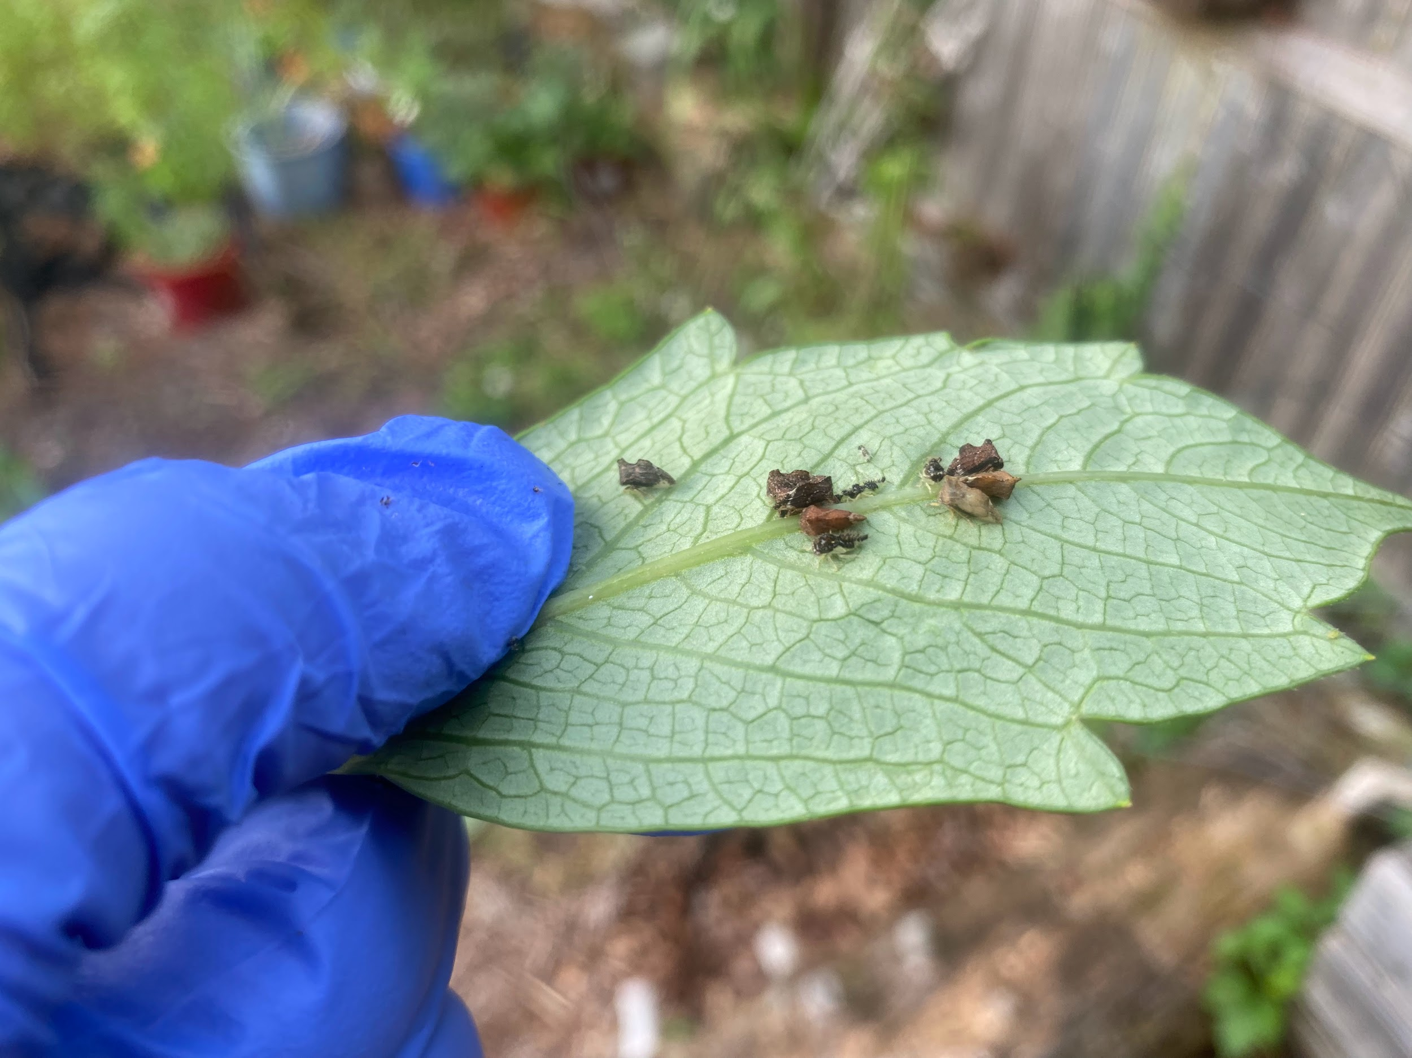

A collaboration with the Cape Cod Regional STEM Network © 2023
For personal or classroom use only. Please cite source and use copyright and Cape Cod Regional STEM Network logo when reproducing. Any opinions, findings, conclusions, or recommendations expressed in this material are those of the author(s) and do not necessarily reflect the views of Cape Cod Regional STEM Network or the Brotherton Foundation.

Overview of Curriculum:

The following assorted lessons were created for life science students in grade 9. The lessons were developed by Elizabeth Hanchuruck through her 2023 Teacher-in-Residence with the Barnstable Clean Water Coalition in Osterville, MA.

From the experience with the Barnstable Clean Water Coalition it was evident that the interconnectedness of Nature is profound. The changes in one environment can make an incredible impact on others through this interconnectedness. The impact of Humans on the Environment also plays a role in altering the resilience Nature can often demonstrate. When in nature, and with my field experiences with BCWC, an overarching theme was “sensemaking” no matter what type of environment was. I was hopeful in creating sensemaking experiences in lessons that will bolster student thinking.

Lesson 1 is all about exploring Symbiosis through sensemaking activities. Lesson 2 is all about surveying biodiversity and exploring invasive species through sensemaking activities. Lesson 3 is focused on pollution’s role in environments and sensemaking around a nutrient (in this case Nitrogen) also being a pollutant due to human activity. Lesson 4 is the planned activities for the CC STEM Network awarded field trip through the Teacher in Residence program. It focuses on students participating in a biodiversity survey and observing progress of a restoration project, which will provide hope for students looking at local projects designed to lessen historical human impact.

All of these assorted lessons were designed from experiences with BCWC and questions for further investigation through observing and visiting their field projects. Barnstable Clean Water Coalition is very committed and busy in projects educating the community on lessening human impact, bog restoration of 55 acres on the Marstons Mills River watershed, the Massachusetts Oyster Project with an educational upweller, promoting ecological landscaping, various monitoring and data collection at varying aquatic sites and local properties. Elizabeth Hanchuruck worked closely with the staff of the BCWC including Luke Cadrin and Livia Graham.

The lessons all have connected Life Science (Biology) Massachusetts State Standards.

State Life Science Standards: https://www.doe.mass.edu/frameworks/scitech/2016-04.pdf

Lesson 1: Symbiosis Sensemaking

Overview: Lesson 1 is all about exploring Symbiosis through sensemaking activities.
Essential Questions:

State Standards: HS-LS2-1. Analyze data sets to support explanations that biotic and abiotic factors affect ecosystem carrying capacity.

Clarification Statements:
• Examples of biotic factors could include relationships among individuals (e.g., feeding relationships, symbioses, competition) and disease.
• Examples of abiotic factors could include climate and weather conditions, natural disasters, and availability of resources.
• Example data sets can be derived from simulations or historical data.

Transfer
At the end of this unit, students will be able to…

D. Differentiate between the three types of symbiotic relationships present within an ecosystem.
E. When given an example, identify which type of symbiosis is present and explain the roles of each species involved.
F. Explain the importance of symbioses to at least 2 different types of environments.

How will the teacher know that the lesson objectives have been met?

Formative Assessment ideas:
Each learning activity is a formative assessment where teachers can check in with students to clarify student learning and re-explain if there are student misconceptions. The ones I use for formative assessments (proof of ongoing learned understanding) include Handout 20 and class discussion commentary throughout.

Summative Assessment ideas:
The true summative assessment is on a quiz or test, but for this lesson, the summative assessment is the closing activity where they prove their understanding using the dramatic role play assignment or the ant symbiosis around the world slides.

Timing: One to two 45-60 minute classes depending on student needs and dynamics including level of curiosity.

Materials: Lesson materials & handouts, videos, projector, paper, writing utensils, white board, technology for students to record role play if that is chosen (chromebook cameras/personal phones)

Lesson 1: Activities
Activity | Teacher is… | Students are… | Materials
Viewing the garden videos and class discussion | Showing the videos and photos while sharing some noticings of the overall health of the dahlia plants in the garden.  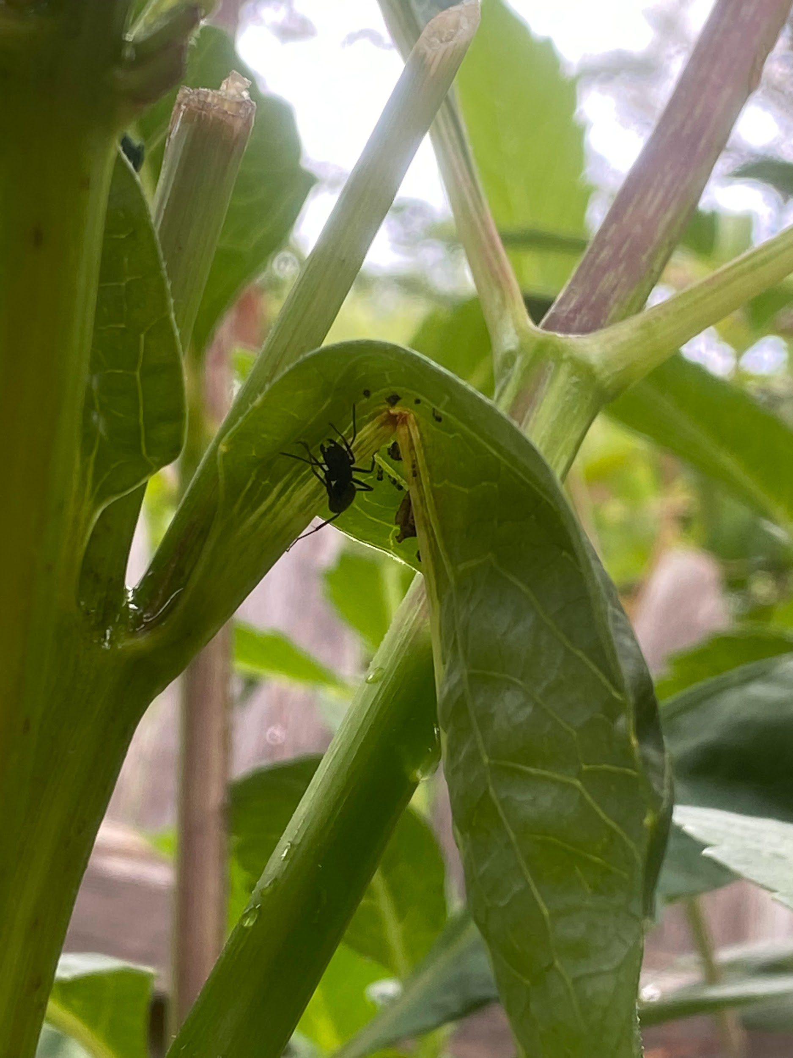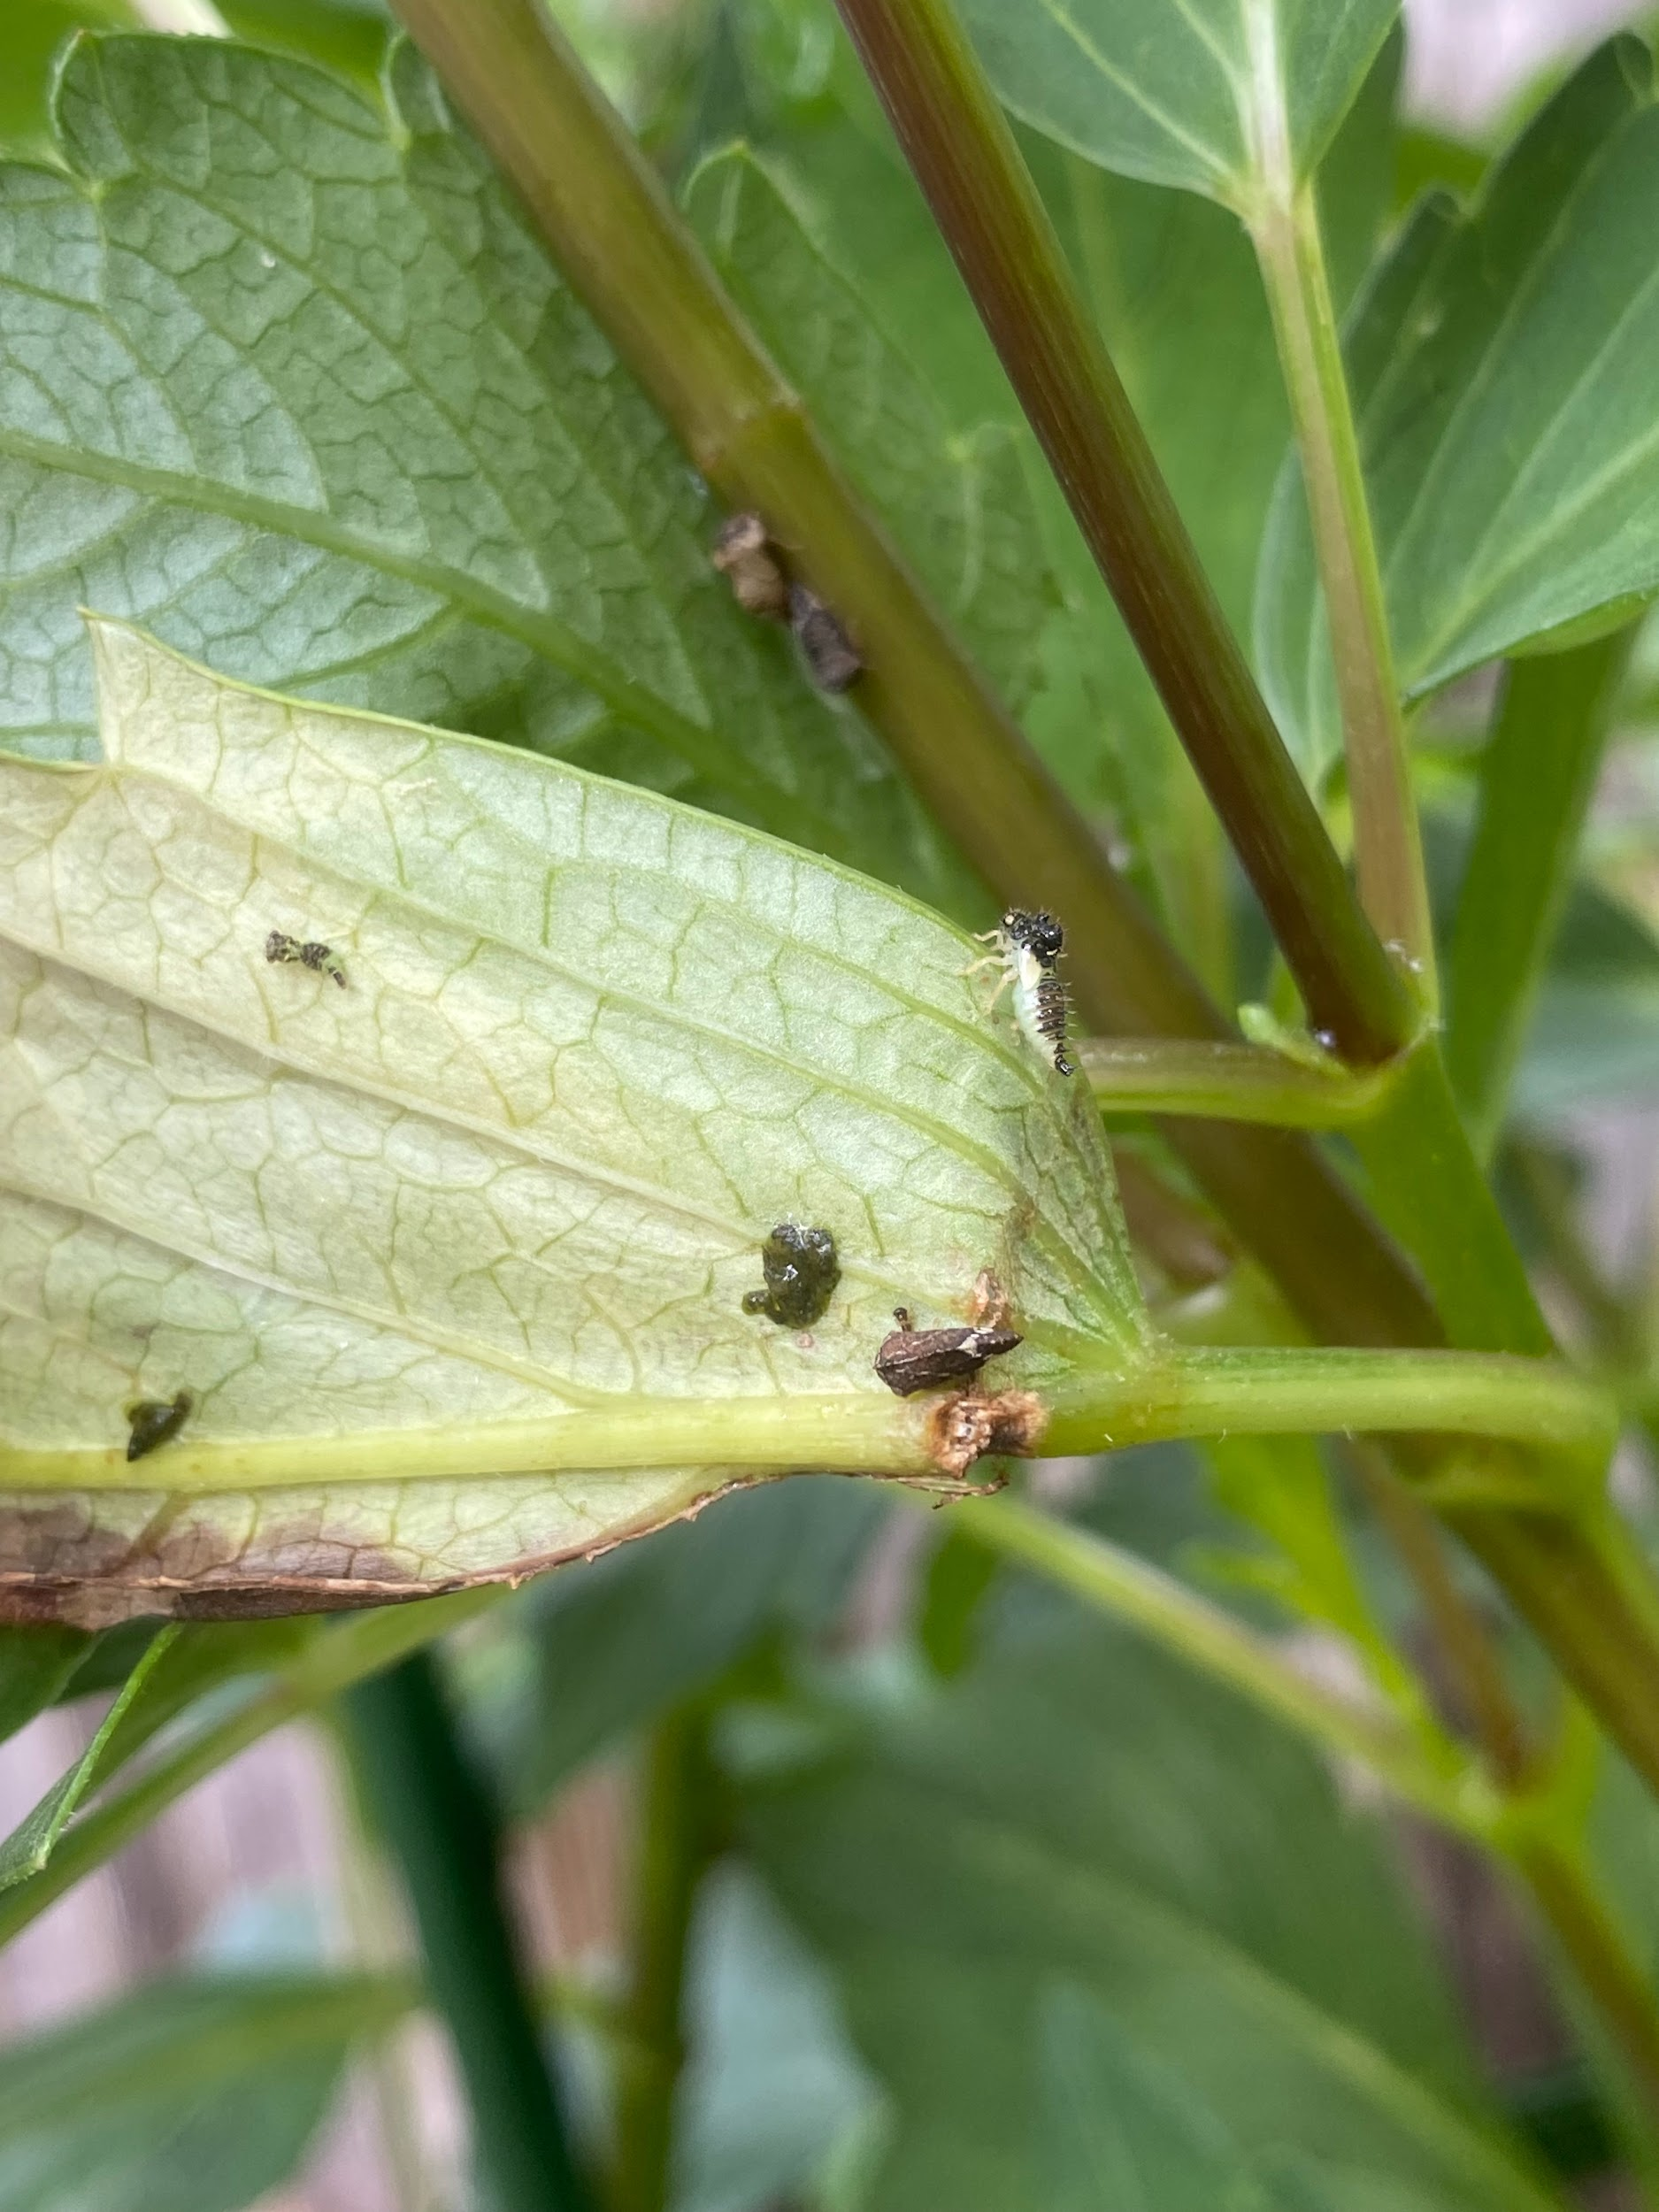  (All pictures and video clips are my own from my personal Dahlia garden) | Watching the videos, writing down observations, sharing out ideas on what they think they are seeing and perhaps what type of relationships are being seen between the organisms.  Videos:  https://drive.google.com/file/d/1X2mKTtQQJ0EDIXMXXPvVmPcoxmdRQynp/view?usp=drive_link  https://drive.google.com/file/d/15FCZNIy6PUDmdAcNZ03dxHtWfOUhL1g1/view?usp=drive_link  https://drive.google.com/file/d/15NNFg9eRIrlwH4BPmxjq17_4O4uPfsvj/view?usp=drive_link  https://drive.google.com/file/d/15FCZNIy6PUDmdAcNZ03dxHtWfOUhL1g1/view?usp=drive_link | Videos, projector, paper, writing utensils
Determination of what further information we need to test some ideas on what relationships we are observing with organisms on the dahlias in Mrs. H’s garden. | Note taking on the board to capture student ideas, questions, and further information needed. | Sharing out thoughts and ideas in a class discussion | White board
Handout on 3 examples of each type of Symbiosis to complete while utilizing resources provided. | Teacher is reviewing the instructions and expectations.  Instructions include completing the handout using slides, the read aloud book: What’s Eating You: Parasites- the inside story by Nicola Davies, the independent exploring of the book: Animal Sidekicks: Amazing stories of symbiosis in animals and plants by Macken Murphy  Teacher will also share the pictures of the real authors and illustrators to encourage students to reflect on careers with science connections.  Teacher will circulate and assist students.  Teacher will do a read aloud of the What’s Eating You by Nicola Davies book. | Students are listening/reading instructions for the activity.  After instructions, students will choose to utilize the materials: class slides, Animal Sidekicks by Macken Murphy, while having the opportunity to document their learning either through writing or illustrating examples of each type of symbiosis that are student chosen.  Students will share out on big poster paper their favorite symbiosis example.  Students will likely add examples for Parasitism from the read aloud to their Handout 20. | 1a. Symbiosis Examples  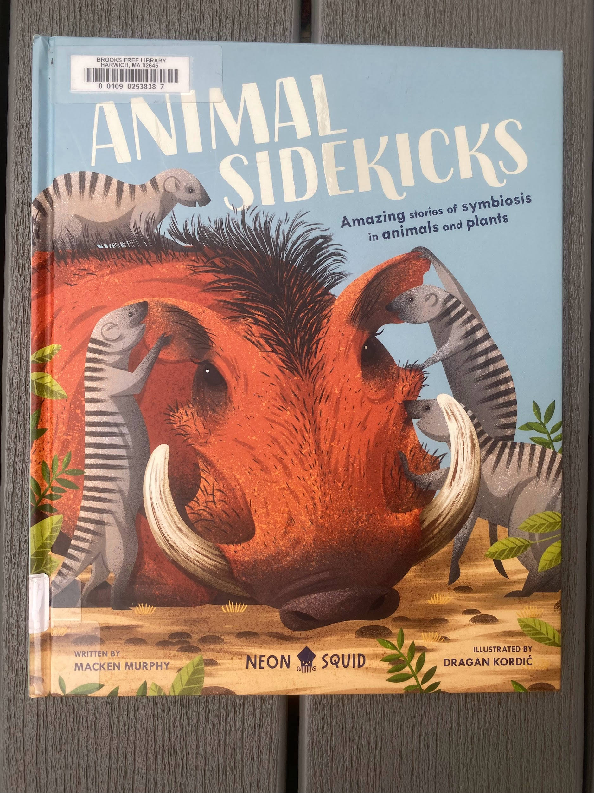  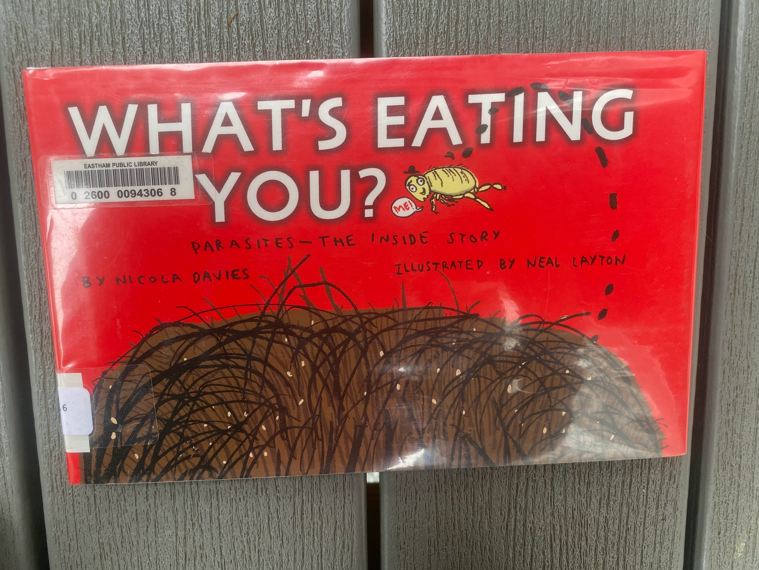
Revisit the Dahlia Symbiosis opener pictures and videos | Teacher asks what type of relationships students think they see. Teacher provides more information on leaf hoppers and ants on dahlias and their relationship. | Students participate in class discussion.  If students are still missing symbiosis examples on their Handout 20 they may include the ant and leaf hopper relationship.
Options for assessment:  Students may choose either symbiosis dramatic role play assignment, or put together a slides assignment from ant symbiotic examples from around the world. | Teacher will present options and expectations for completion timeline. | Students will choose and complete the assignment. | 1b.Symbiotic Role Play Assignment  1c.  Ant Symbiosis from around the world

Lesson 1: Tips, Strategies, and Suggestions
Most students will casually flip through the Animal Sidekicks by Macken Murphy and that is OK! There are beautifully depicted examples in that book.

The reason I do a read aloud with high school students using the What’s Eating You by Nicola Davies book is because they typically have little reason to actually read it. It is fascinating and has great detailed information and examples they otherwise may avoid reading on their own.

All books are available using the CLAMS library network, but I also am going to put in a grant application for a class set so students may read along and not by limited by sharing supplies.

Some students need encouragement to write/ add wording for their pictures in Handout 20. They often say “well I already drew it, I shouldn’t have to write anything”. I typically ask them to explain their thinking behind the illustration in an abbreviated version or turn their picture into a self explaining comic/cartoon of sorts.

Lesson 2: Biodiversity Accounting & Invasive Species Sensemaking

Overview: Lesson 2 is all about surveying biodiversity and exploring invasive species through sensemaking activities.

Essential Questions:
How can a species be identified as native, non-native, or invasive?
How is an invasive species defined and what are some examples of how they arrive in new locations?
How can an invasive species negatively impact a habitat?

State Standards: HS-LS2-2. Use mathematical representations to support explanations that biotic and abiotic factors affect biodiversity, including genetic diversity within a population and species diversity within an ecosystem.

Clarification Statements:
• Examples of biotic factors could include relationships among individuals (feeding relationships, symbiosis, competition) and disease.
• Examples of abiotic factors could include climate and weather conditions, natural disasters, and availability of resources.
• Examples of mathematical representations include finding the average, determining trends, and using graphical comparisons of multiple sets of data.

Transfer
At the end of this unit, students will be able to…

A. Identify factors that determine and describe habitats and niches.
B. Explain how competition shapes communities.

G.Describe several benefits of biodiversity as a natural resource.
H. Explain how the disappearance of one species affects other species.
I. Identify human-caused species loss as one of the major current threats to biodiversity.

H. Compare and contrast native species, non-native species, and invasive species.
I. Describe several characteristics of invasive species and explain how they are introduced to new habitats.
J. Explain several ways that an invasive species can negatively impact a habitat.

How will the teacher know that the lesson objectives have been met?
Formative Assessment ideas:
Some pre-conceptions, misconceptions, and clarifications can result from the opener/sensemaking questions and class discussion.

Reminding students of the definitions of words that help us understand biodiversity will also help identify student struggles and learning that is taking place as they are partaking in the Handout 22 stations activities.
Summative Assessment ideas:
There is an after activity reflection that includes the following questions:

- What would happen to the biodiversity of your ecosystem if there were a fire through that area?
- What would happen to the biodiversity of your ecosystem if one population of producers died?
- What would happen to the biodiversity of your ecosystem if a population of secondary consumers died?
- How does biodiversity affect the health of an ecosystem?
These questions are asked to extend learning and promote thinking about biodiversity.

Timing: One to two 45-60 minute classes depending on student needs and dynamics including level of curiosity.

Materials: Projector, Student Handout 22, Merlin Bird ID app downloaded to devices, and handout for Merlin Bird ID log.

Lesson 2: Activities
Activity | Teacher is… | Students are… | Materials
Opener/ Sensemaking | Presenting the Questions:  “How do invasive species arrive to new locations?”  “How do invasive species out-compete native species?”  “Do invasive species cause harm besides population/competition effects?” | Making note on paper of their clarifying questions if more detail is needed to formulate a response. Then students will participate in a class discussion with the three questions being the focus. | Projector, Student handout with questions.
Stations/ Gallery Walk to do biodiversity assessment | Teacher presents the directions for the station activity, what materials are there to be used at each station, what expectations there are for completing Handout 22 to guide them through the stations. Then the teacher is circulating the room assisting and encouraging participation and completion of Handout 22 | Students are listening/reading the directions and familiarizing themselves with Handout 22.  Students are then visiting each station and observing the 4 different environments while completing Handout 22 to guide them through observing and considering biodiversity and invasive species characteristics and impact. | 2a. Invasive Species and Biodiversity Sensemaking
Going outside to use the Merlin Bird ID app | Teacher presents the Merlin Bird ID app and limitations using this as a biodiversity survey method | Students will practice ID’ing birds present in the area using the Merlin Bird ID app. | 2b. Merlin Bird ID app Handout

Lesson 2: Tips, Strategies, and Suggestions
Include tips, strategies, and suggestions

Note: Previous to this lesson Competition would have been taught through lessons and hands on activities. Also, students will have already studied population dynamics, population growth, and limiting factors. This lesson is part of a bigger unit sequence that includes biodiversity pre-teaching activities that include notes, textbook work, and much practice looking at different ecosystems and comparing biodiversity. One example is looking at species found in Minnesota and Costa Rica and comparing.

The four stations include images blown up on poster paper of different biomes to consider and observe. The stations could include outside quadrats to survey. The quadrats we use on campus for the pollinator garden to survey plant and insect diversity are pvc stakes with twine to outline a quadrat square that is one square meter. The stations can be designed for what best suits the teacher and students. The stations can also include samples of habitats like a decomposing log, sample from a local dock scraping, etc. Guides can be official book guides, picture guides or using google ID to help ID different organisms.

The Merlin Bird ID app Log sheet is used throughout the year and will also be used on the Lesson 4: Field Trip to see Bog Restoration Project and do a biodiversity survey at Fuller Farm.

Additional Vocab Definitions utilized:

Invasive species | Any non-native species whose introduction causes, or is likely to cause, economic harm, environmental harm, or harm to human health.
Native species | A species that occurs naturally in a specific geographic area.
Non-native species | A species that does not occur naturally in a specific geographic area.

Lesson 3: Nitrogen Cycling & Pollution Sensemaking

Overview: Lesson 3 is focused on pollution’s role in environments and sensemaking around a nutrient (in this case Nitrogen) also being a pollutant due to human activity.

Essential Questions:
Can a nutrient be a pollutant?
How are different types of pollution similar yet unique?
How is pollution defined?

State Standards: HS-LS2-6. Analyze data to show ecosystems tend to maintain relatively consistent numbers and types of organisms even when small changes in conditions occur but that extreme fluctuations in conditions may result in a new ecosystem. Construct an argument supported by evidence that ecosystems with greater biodiversity tend to have greater resistance to change and resilience.

Clarification Statement:
• Examples of changes in ecosystem conditions could include modest biological or physical changes, such as moderate hunting or a seasonal flood; and extreme changes, such as volcanic eruption, fires, the decline or loss of a keystone species, climate changes, ocean acidification, or sea level rise.

HS-LS2-7. Analyze direct and indirect effects of human activities on biodiversity and ecosystem health, specifically habitat fragmentation, introduction of non-native or invasive species, overharvesting, pollution, and climate change. Evaluate and refine a solution for reducing the impacts of human activities on biodiversity and ecosystem health.

Clarification Statement:
• Examples of solutions can include captive breeding programs, habitat restoration, pollution mitigation, energy conservation, and ecotourism.

Transfer
At the end of this unit, students will be able to…

M .List a few types of pollution: air, light, noise, radioactive, soil, thermal and water.
N. Distinguish between point source pollution and nonpoint source pollution.
O. Explain the process of biological magnification of a pollutant as it is passed up the food chain.
P. When given data, calculate the number of times a pollutant is magnified as it moves up the food chain.
R. Describe a few solutions that humans have created to help with their impacts.
S. Determine and defend whether a nutrient can act as a pollutant.

How will the teacher know that the lesson objectives have been met?
Formative Assessment ideas:
Handout 24 the opener will allow teachers to identify misunderstandings and room for exploration and learning. Handout 25 has multiple areas to take the formative assessment approach and utilize student work surrounding the essential questions.
Summative Assessment ideas:
Eventually students will partake in Lesson 4, the field trip and will look at the human impact and bog restoration project. They will also partake in a watershed activity to visualize land topography and water emptying into waterways where Nitrogen loading becomes problematic. An end of unit assessment with a traditional test and MCAS at the end of their sophomore year will also have questions that incorporate them demonstrating their learning surrounding these topics and science content.

Timing: One to two 45-60 minute classes depending on student needs and dynamics including level of curiosity.

Materials: Projector, Handout 24: Pollution Types Card Sort, Handout 25: Can a nutrient be a pollutant?, various samples of nutrients/pollutants, The Great Stink: How Joseph Bazalgette Solved London’s Poop Pollution Problem by Colleen Paeff, Monster in the Water: Fighting Back Against Harmful Algal Blooms by Dylan D’Agate.

Lesson 3: Activities
Activity | Teacher is… | Students are… | Materials
Opener to Pollution Sensemaking  Card sort | Providing materials and circulating to keep students on task and participating.  This opening activity can be done independently or in pairs or small groups depending on class dynamics and resources available. | Matching pictures, definitions with types of pollution through a card sort activity. This can be tailored to the teacher’s preferences so image cards are left empty (also to avoid copyright infringement for the publishing of this lesson through CC STEM Network) | 3a. Card Sort Types of Pollution and Pollution Vocabulary
Independent thought and then class discussion | The question will be announced aloud, “Can a nutrient be a pollutant?”, the teacher will review a venn diagram and expectations. | Students will complete the venn diagram and can either share out or share out in a small group. Revisions are welcome as students deepen their thinking surrounding the words “nutrient” and “pollutant”. | 3b. Can a nutrient be a pollutant?
Samples for each table to view, and discuss. | Teacher will present different materials to small groups of students.  Different materials will include a small bag of plant fertilizer, a sealed container of dog poop, a sealed container of grass clippings, car washing soap, sealed and labeled puddle water from the end of a street, a picture of a car exhaust, a labeled diagram of a septic system, bottle of motor oil, household paint. | Students will discuss what they are observing and whether it should be considered a nutrient, a pollutant, or both. | Various samples in sealed containers, with safety instructions from teacher.  Can a nutrient be a pollutant?
Possible extension | Teachers could do a read-aloud or use the two children’s books resources to extend student learning. Also various short video clips from Barnstable Clean Water Coalition are included in the document. | Students would be listening to the read-alouds and participating in a follow-up conversation. | Can a nutrient be a pollutant?  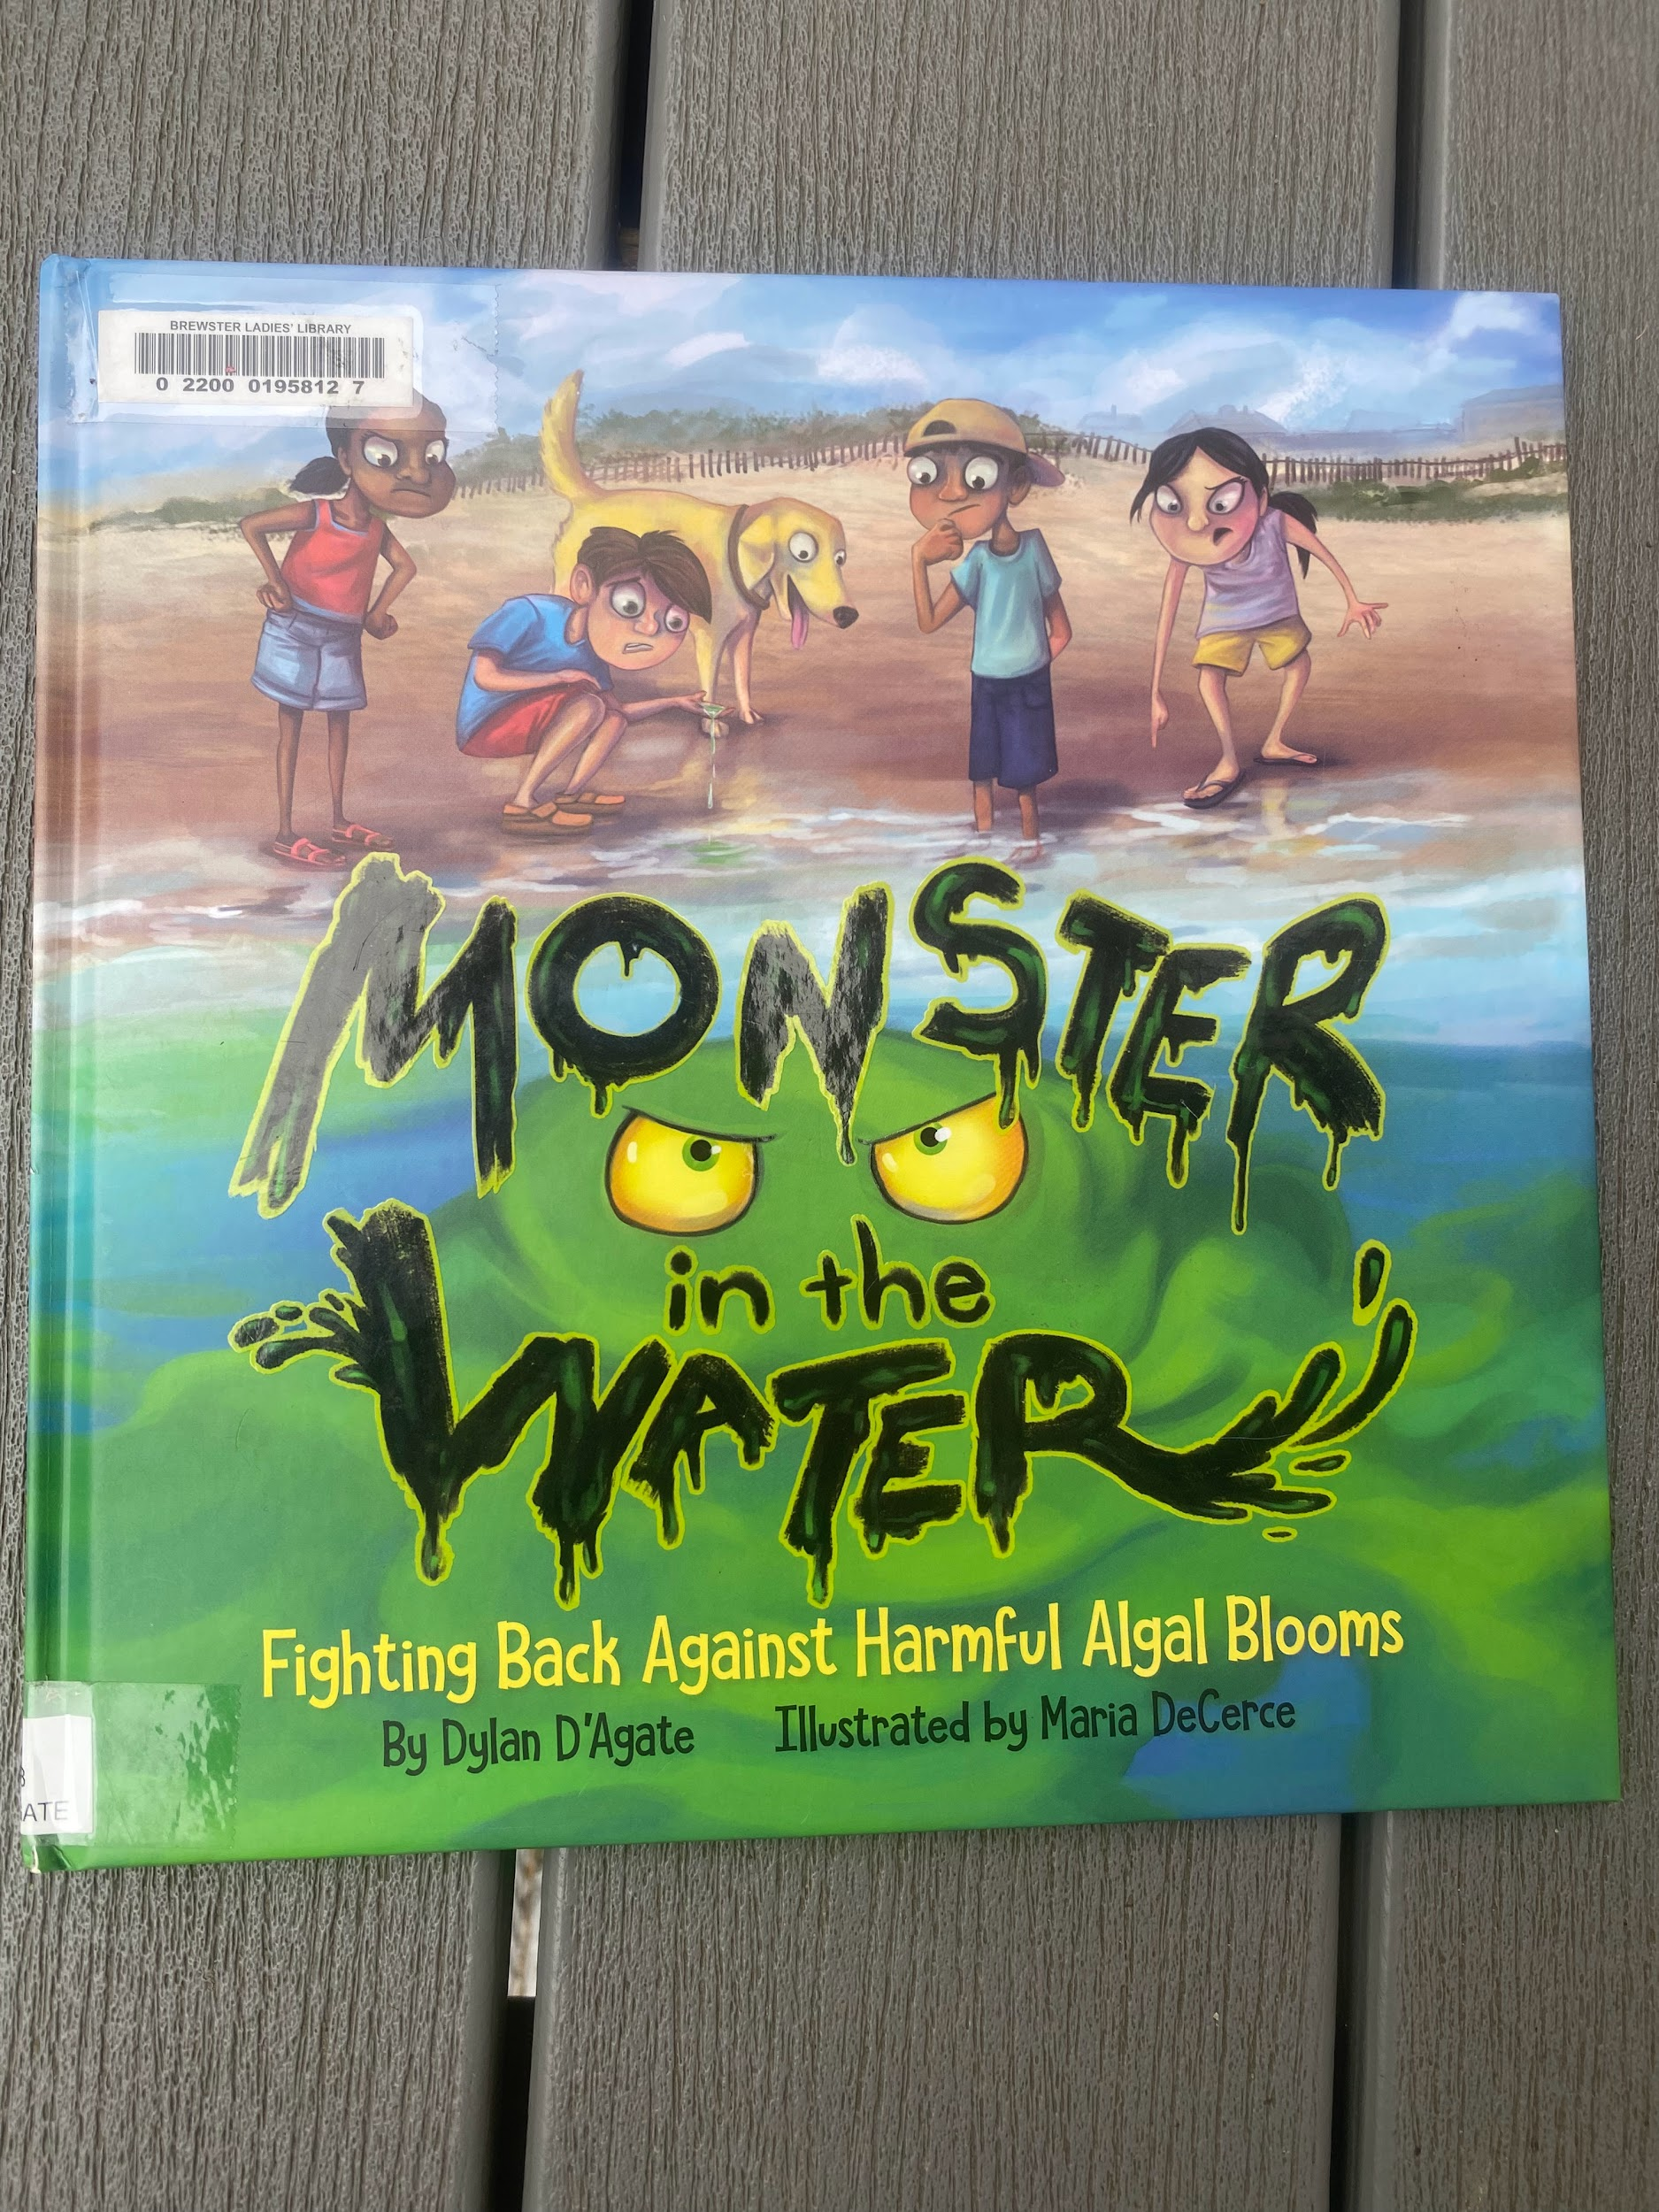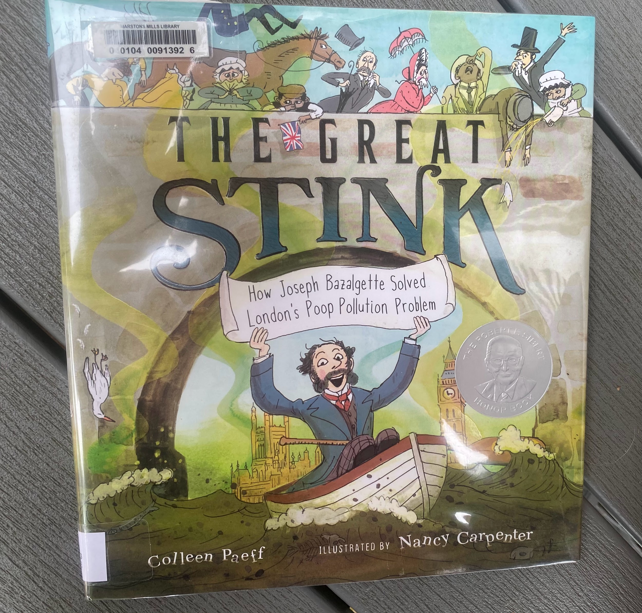

Lesson 3: Tips, Strategies, and Suggestions
Include tips, strategies, and suggestions
This lesson focuses on Nitrogen as a nutrient and locally as a pollutant to our local environment and watersheds. It may be done in sequence or just parts could be utilized to enhance learning.

Lesson 4: Field Trip to see Bog Restoration Project (a partnership project between Barnstable Clean Water Coalition and Barnstable Land Trust) and do a biodiversity survey at Fuller Farm (owned and operated by Barnstable Land Trust)

Overview: Lesson 4 is the planned activities for the CC STEM Network awarded field trip through the Teacher in Residence program. It focuses on students participating in a biodiversity survey and observing progress of a restoration project, which will provide hope for students looking at local projects designed to lessen historical human impact.

Essential Questions:
What are some things happening locally to lessen the impact of the human increase of Nitrogen entering the environment in and around the Town of Barnstable?

Using different surveying techniques, what is the biodiversity at two different field sites visited?

What different habitats were observed and what challenges do species have to overcome to live there?

What examples of competition were observed at the field sites?

What benefits are there from doing a wetland restoration?

State Standards:

HS-LS2-1. Analyze data sets to support explanations that biotic and abiotic factors affect ecosystem carrying capacity.

Clarification Statements:
• Examples of biotic factors could include relationships among individuals (e.g., feeding relationships, symbioses, competition) and disease.
• Examples of abiotic factors could include climate and weather conditions, natural disasters, and availability of resources.
• Example data sets can be derived from simulations or historical data.

HS-LS2-6. Analyze data to show ecosystems tend to maintain relatively consistent numbers and types of organisms even when small changes in conditions occur but that extreme fluctuations in conditions may result in a new ecosystem. Construct an argument supported by evidence that ecosystems with greater biodiversity tend to have greater resistance to change and resilience.

Clarification Statement:
• Examples of changes in ecosystem conditions could include modest biological or physical changes, such as moderate hunting or a seasonal flood; and extreme changes, such as volcanic eruption, fires, the decline or loss of a keystone species, climate changes, ocean acidification, or sea level rise.

HS-LS2-7. Analyze direct and indirect effects of human activities on biodiversity and ecosystem health, specifically habitat fragmentation, introduction of non-native or invasive species, overharvesting, pollution, and climate change. Evaluate and refine a solution for reducing the impacts of human activities on biodiversity and ecosystem health.

Clarification Statement:
• Examples of solutions can include captive breeding programs, habitat restoration, pollution mitigation, energy conservation, and ecotourism.

Transfer
At the end of this unit, students will be able to…

A. Identify factors that determine and describe habitats and niches.
B. Explain how competition shapes communities.

G.Describe several benefits of biodiversity as a natural resource.
H. Explain how the disappearance of one species affects other species.
I. Identify human-caused species loss as one of the major current threats to biodiversity.

H. Compare and contrast native species, non-native species, and invasive species.
I. Describe several characteristics of invasive species and explain how they are introduced to new habitats.
J. Explain several ways that an invasive species can negatively impact a habitat.

How will the teacher know that the lesson objectives have been met?
Formative Assessment ideas:
Each station has a different style and the level of activity/involvement varies. There are many reflective parts of Handout 26 that can be used as a formative assessment.
Summative Assessment ideas:
With so many underlying themes the field trip guided by Handout 26 really is quite summative in nature. Students will have been exposed to all content topics previously and this is an exploratory field experience.

Timing: One full field trip day to include a hike, lesson activities, and lunch break. We would leave school at 8:30am and leave the field trip sites by 1:00pm.

Materials: Bus, 2 field sites, Handout 26: Field Trip Log Handout, Merlin Bird ID app Handout, Aerial photo Maps, watershed activity supplies listed below, Native seed planting materials listed below (soil needed).

Lesson 4: Activities
Activity | Teacher is… | Students are… | Materials
Visiting the Bog restoration Property in Marstons Mills Part 1:  Travel to the bogs that are in the beginning stages of being restored. Students will assess biodiversity of birds using the Merlin Bird ID app and log sheet. Students will also partake in photo journaling the “before” of the restoration project. Students could later, as an extension, design educational signage for the future restored wetland’s visitors. Students will be provided a map of the bog properties and document where the water flows directionally on the map. | Assisting students, fielding questions, encouraging students in journaling during their visit. | Will be documenting their visit observations on a handout.  Students will be using the Merlin Bird ID app and handout documenting biodiversity at 2 different portions of the bogs. This can be used as a baseline before restoration.  Students will add the direction of water flow to the aerial photo map using arrows. | 4. Field Trip Log Handout  Merlin Bird ID app Handout  Aerial photo maps of the bog restoration property (Due to copyright issues, this resource cannot be linked)
Visiting the Bog restoration Property in Marstons Mills Part 2:  Luke Cadrin will present an overview of the project and what critical parts will be included to reduce Nitrogen flowing into the Marstons Mills River from the watershed. | Assisting students, fielding questions, encouraging students in journaling during their visit. | Will be documenting their visit observations on a handout.  Students will add their drawings to the aerial map of what will be added where. | 4. Field Trip Log Handout  Aerial photo maps of the bog restoration property (Due to copyright issues, this resource cannot be linked)
Outside station Fuller Farm #1:  Wearing waders for tick protection and poison ivy precaution, there will be a designated area to partake in a biodiversity survey of insects using nets. | After introducing the activities and Kelly Barber from Barnstable Land Trust. | Students will utilize the table on Handout 26 for the insect biodiversity survey. | 4. Field Trip Log Handout
Outside station Fuller Farm #2:  Guided walk/hike with land manager Kelly Barber with a focus on the history, restoration and management plans of the property, and combating invasive species. Students will also collect seeds to utilize in the inside stations. | Teachers will help guide conversation and encourage students to complete Handout 26 while collecting seeds. | Students will utilize the journaling prompts on Handout 26 for guided hike. | 4. Field Trip Log Handout
Outside station Fuller Farm #3:  At three different locations, using the Merlin Bird ID app students will be participating in a biodiversity survey on the Fuller Farm property using the Merlin Bird ID log sheet. | Teachers will help guide conversation and assist students to complete Merlin logs at 3 different locations. | Students will be using the Merlin Bird ID app and handout documenting bird biodiversity at 3 different locations on the hike around Fuller Farm. | Merlin Bird ID app Handout
Inside station Fuller Farm #1:  How a watershed works with spray bottles.  Looking at maps of the 3 Bays watershed, place arrows showing the flow of water considering topography. | Teacher will guide activity using trashbags, sprinkles, food dye, and confetti as “nutrients/pollutions sources” | Students will participate as rain clouds and watch how topography affects runoff on the watershed. Students will really experience this visual and hands on activity, and hopefully think more about how “we all live downstream” and how human’s impact the local Marston’s Mills River Watershed. | Trashbags, boxes with crumpled papertowels inside to make topography, spray bottles for students administering precipitation, following this lesson idea: https://pbskids.org/plumlanding/educators/activities/build_a_watershed_ed.html
Inside station Fuller Farm #2:  Helping restore meadow habitat with seed prepping (milk jugs for cold stratifying native seeds collected from the outside portion of the field trip with guidance and direction by Kelly Barber) | Teacher will provide materials and walk through the process of creating milk jug cold stratification for native plant seeds. | Students will be doing the prepping and planting. Students become part of the active restoration project. | Native seeds in milk jugs is a widely used technique for cold stratification of native plants. There are many resources to use as a guide, but this one is used for this activity with students: https://sustainability.yale.edu/sites/default/files/files/Milk%20Jug%20Wildflower%20Propagation.pdf
Inside station Fuller Farm #3:  Seed adaptations: inspection of different seeds under the stereomicroscope and testing seed dispersal with a fan. Students will be drawing their favorite seed and determining which seed has the greatest distance of dispersal using wind. | Teachers will provide the opportunity and stereomicroscopes to observe seeds | Students will look at the seeds collected under the stereomicroscopes and document using Handout 26. Students will also test 3 different types of seeds to see which travels the greatest distance using a fan. | 4. Field Trip Log Handout
After the field trip, I will be revisiting the essential questions and having a class discussion to summarize learning experiences.  What are some things happening locally to lessen the impact of the human increase of Nitrogen entering the environment in and around the Town of Barnstable?  Using different surveying techniques, what is the biodiversity at two different field sites visited?  What different habitats were observed and what challenges do species have to overcome to live there?  What examples of competition were observed at the field sites?  What benefits are there from doing a wetland restoration? | Teacher is leading class discussion | Students are participating and sharing out in class discussion to reflect on the field trip. | Projector

Lesson 4: Tips, Strategies, and Suggestions
Include tips, strategies, and suggestions

I feel like I can better fill this in when I actually get to try the field trip with real students! I am happy to share back after with improvements and edits!

