Sea Sensors Project
High School Engineering and Computer Science

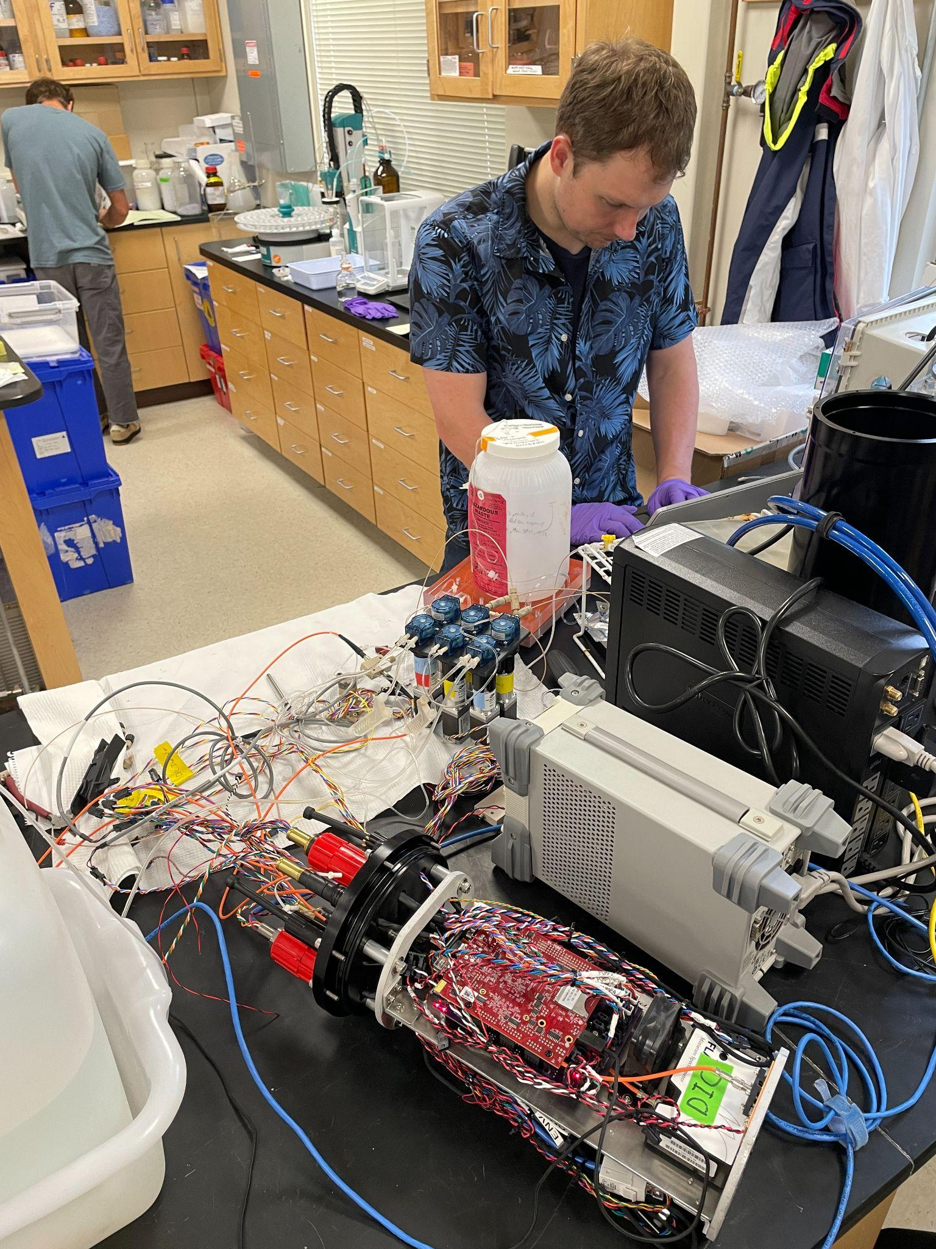
A collaboration with the Cape Cod Regional STEM Network © 2023
For personal or classroom use only. Please cite source and use copyright and Cape Cod Regional STEM Network logo when reproducing. Any opinions, findings, conclusions, or recommendations expressed in this material are those of the author(s) and do not necessarily reflect the views of Cape Cod Regional STEM Network or the Brotherton Foundation.

Curriculum Overview

Stage 1: Desired Results
Essential Questions

- What is the purpose of underwater sensors, and how do they contribute to our understanding of the underwater environment?

- How can we design sensors that are sensitive to underwater conditions?

- What principles of physics and biology need to be considered when designing sensors for underwater vehicles?

- How can the engineering design process be applied to create effective and reliable underwater vehicle sensors?

- How might advancements in sensor technology contribute to further exploration and understanding of underwater environments in the future?

Enduring Understandings
- Students will understand the iterative nature of the engineering design process, including the importance of defining problems, generating solutions, and testing prototypes.
- Students will develop an awareness of the impact of human activities on underwater ecosystems and the importance of designing sensors that minimize negative effects on the environment.
- Students will recognize the interdisciplinary nature of engineering by integrating principles from physics, biology, and technology to create effective underwater sensors.
- Students will appreciate the role of technology in addressing real-world challenges, such as monitoring and collecting data in underwater environments, and how innovation can contribute to scientific exploration.
- Students will value effective communication and collaboration skills as they work in teams to design, build, and test underwater vehicle sensors.
Transfer
At the end of this unit, students will be able to…

- Students will demonstrate a comprehensive understanding of the engineering design process and its application in creating underwater vehicle sensors.

- Students will engage in innovative problem-solving, adapting their designs based on testing outcomes and refining prototypes to enhance the functionality and reliability of their underwater vehicle sensors.

- Students will develop and demonstrate effective presentation and communication skills, articulating their design process, decisions, and the scientific principles behind their underwater sensors to their peers.

- Students will engage in critical reflection on the successes and challenges encountered during the project, fostering a deeper understanding of the engineering design process and their individual and collective contributions.

Stage 2: Evidence
Formative Assessment ideas:
- Throughout the design process, students will test their designs for fit and functionality

Summative Assessment ideas:

- Students will test their sensors on a SeaPerch or similar ROV, present their designs in class, and reflect on their experience with the design process.

Stage 3: Learning Plan
Lesson Number |  | Lesson Name | Brief description
1 |  | Iterative design process | Students will gain some familiarity with the design process, including an overview and use of the steps of design.
2 |  | Design for 3D printing | Students will create 3D model with CAD software that includes exterior geometry and interior geometry and the object’s that they design can be interfaced with existing object.
3 |  | Pull Up Resistor | Students will build a circuit that uses a pull up resistor to allow a push button switch to be used in electric circuit and recognized by microcontroller.
4 |  | Voltage Divider | Students will build a circuit that can be used with resistance sensors to gather analog data. When resistance sensor gives data, it can be stored or visualized.

Lesson 1: Iterative Design Process
Lesson 1: Overview
Lesson Overview:  Students will gain some familiarity with the design process, including an overview and use of the steps of design. | Lesson Objectives:  At the end of the unit, students will be able to…  - Explain the design process and its usefulness  - Share a plan design process to make a 3D object that meets certain criteria

Lesson 1: Overview and Structure
1. Engaging Opener:

- Begin with a thought-provoking question or a brief video related to the importance of underwater vehicles and sensor technology
- Facilitate a class discussion on the challenges of solving problems and introduce the concept of design thinking.

2. Overview of the Iterative Design Process:

- Provide a clear and concise overview of the iterative design process, breaking down the key steps: problem definition, ideation, prototyping, testing, and iteration.
- Share a graphic illustrating the design process (quick google search should work here).

3. Discussion on Design Challenges:

- Share the design challenge for the sea sensors project.
- Ask students to brain storm types of information an underwater ROV may need to collect.
- Let students know that their designs will include a pull-up resistor and voltage divider and that their designs should incorporate these aspects.
- Emphasize the importance of clearly defining the problem before jumping into solutions.

4. Group Activity: Applying Design Steps:

- Divide students into small groups.
- Guide them through applying the design steps to the sea sensors problem: problem definition, ideation (brainstorming solutions), and initial prototyping.
- Students should define their own problem including what kind of information they will want their sensor to collect.

5. Team Collaboration

- In their small groups, students collaborate to develop their initial designs, fostering teamwork and communication skills.
- Circulate among groups to offer guidance and facilitate discussions.

6. Reflection and Discussion (15 minutes):

- Bring the class back together for a reflection on their initial design choices.
- Discuss the challenges encountered, decisions made, and potential areas for improvement.
- Facilitate a group discussion on the concept of iteration, highlighting its importance in refining designs based on testing and feedback.
- Encourage students to share their thoughts on the iterative process and its role in continuous improvement.

7. Introduction to Prototyping Tools

- Briefly introduce basic prototyping tools and materials that will be used in the project: CAD, pull-up resistor and voltage divider.

8. Setting Expectations

- Conclude the lesson by setting expectations for the project.
- Emphasize that this is just the beginning of the design process and that continuous improvement is a key aspect of successful engineering.
- Ask groups to set team norms.

Lesson 1: Tips, Strategies, and Suggestions

Lesson 2: Design for 3D printing
Lesson 2: Overview
Lesson Overview:  Students will create a 3D model with CAD software that includes exterior geometry and interior geometry and the object’s that they design can be interfaced with existing object. | Lesson Objectives:  At the end of the lesson, students will be able to…  - Explain 3D printing basics, including terminology, processes, and material considerations.  - Apply design thinking principles to develop a detailed 3D printing design for the underwater vehicle sensor component  - Collaborate within teams to create innovative and detailed 3D printing designs, incorporating iterative design processes, attention to detail, and reflecting on choices to enhance overall project goals.

Lesson 2: Structure
1. Introduction to CAD Software

- Depending on student experience with the software, students may need an overview of Computer-Aided Design (CAD) software and highlighting the specific features they can use in their design.
2. Provide examples of interior / exterior geometry.

- Discuss the concepts of exterior and interior geometry in 3D modeling.
- Provide examples to illustrate the difference between the outer surface (exterior) and internal components (interior) within a 3D model.
- Emphasize features such as hollowing, adding internal structures, or creating spaces within the 3D model.

4. Practice

- Allow students to practice creating the exterior geometry of a simple object using the CAD software.
- Circulate to provide guidance, answer questions, and ensure that students grasp fundamental concepts.

5. During this lesson (or another), provide examples of interfacing 3D models with existing objects or systems.
- Discuss the importance of compatibility and seamless integration in design projects.

6. Peer Review and Feedback:
- Conduct a peer review session where students share their 3D models and provide constructive feedback to their peers.
- Encourage discussions on challenges faced and innovative solutions.
- Ask students to set individual goals for further improvement in 3D modeling skills.

This lesson sequence will vary depending on student experience with CAD and previous coursework.

Lesson 2: Tips, Strategies, and Suggestions
https://warwick.ac.uk/fac/sci/wmg/about/outreach/resources/tinkercad/getting_started_with_cad_lesson_plan.pdf

Lesson 3: Pull Up Resistor
Lesson 3: Overview
Lesson Overview:  Students will build a circuit that uses a pull up resistor to allow a push button switch to be used in an electric circuit and recognized by microcontroller. | Lesson Objectives:  By the end of this lesson, students will be able to:  - Build a circuit integrating a pull-up resistor, push button switch, and microcontroller, demonstrating proficiency in wiring and understanding the fundamental components.  - Explain how pull-up resistors ensure stable voltage levels in a circuit, enabling recognition of push button switch states by the microcontroller.  - Share explanation of how to incorporate a pull-up resistor into design.

Lesson 3: Activites
- Overview and introduction

- Briefly introduce the components: pull-up resistors, push button switches, and microcontrollers. Discuss their individual functions and the significance of their interaction in electronic circuits.

- Provide a concise explanation of how pull-up resistors function in circuits, emphasizing their role in maintaining a stable voltage and facilitating microcontroller recognition of push button states.

- Hands-on building time

- Students will need time to practice with the resistors, switches, and microcontrollers as well as time to incorporate into their design.

- Feedback and reflection
- Provide students an opportunity to reflect on the challenges with this aspect of the project, as well as opportunities for how they can incorporate into their sensor design.

Lesson 3: Tips, Strategies, and Suggestions
Voltage Pull Up - Button
Build a circuit that allows the Microbit to sense the press of a button.

https://www.teachwithict.com/pushbtton.html

Programming the Microbit to sense
https://makecode.microbit.org/
Button Test Code - https://makecode.microbit.org/S99617-71369-26903-92764

Lesson 4: Voltage Divider

Lesson 4: Overview
Lesson Overview:  Students will build a circuit that can be used with resistance sensors to gather analog data. When a resistance sensor gives data, it can be stored or visualized. | Lesson Objectives:  At the end of the lesson, students will be able to…  - Build a circuit that can be used with resistance sensors to gather analog data  - Reflect on design process and teamwork collaboration

Lesson 3: Activites
- Overview and introduction

- Briefly introduce the voltage divider
  - https://www.youtube.com/watch?v=JGXdi7XcQi8

- Provide students with an example they can test out, as well as examples of various pieces of information students will want to test for

- Hands-on building time

- Students will need time to develop their own voltage dividers, incorporating into the project.

- Feedback and reflection
- Provide students an opportunity to reflect on the challenges with this aspect of the project, as well as opportunities for how they can incorporate into their sensor design.

Lesson 4: Tips, Strategies, and Suggestions
Make a circuit that uses the voltage divider technique to allow resistive sensors to give feedback to a microbit microcontroller.

Card
Binder clips
Jumper wires
Aluminum/copper tape
Microbit/programming cable
Makecode - https://makecode.microbit.org/S64829-36076-29555-21355
Expansion board for Microbit https://wiki.keyestudio.com/Ks0360_Keyestudio_Sensor_Shield_V2_for_BBC_micro:bit

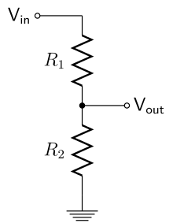

https://quadstore.in/2020/10/03/microbit-lesson-11-photoresistor-light-sensor/
https://cdn.sparkfun.com/assets/resources/4/4/input_photoresister.pdf
https://learn.adafruit.com/micro-bit-lesson-4-sensing-light-and-temperature?view=all

Voltage Divider explained - https://www.youtube.com/watch?v=JGXdi7XcQi8

Voltage Divider testing code - https://makecode.microbit.org/S64829-36076-29555-21355

