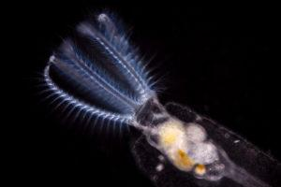
Rotifers in Biology -High School Biology

In this Unit biology students will see the relevance of rotifers throughout the study of biology. Connections will be made during major units throughout the year to the research being conducted by Dr. Kristin Gribble and her fellow scientists at the Marine Biological Laboratory in Woods Hole, Massachusetts. The lessons focus on the Science and Engineering Practices, along with key standards relating to cellular structure and function, genetics, evolution and ecology. Lessons are written to be used in a hybrid model and/or remotely during the 2020-2021 school year, but can be utilized in the future in person as well.

This unit relates rotifers to scientific investigation, cellular structure and function, genetics, evolution and ecology.
Students will make observations, and then collect and analyze data from a virtual experiment studying rotifer behavior. They will also use online databases to compare DNA sequences from rotifers and humans to better understand the relevance of rotifer experiments to biomedical research. In addition, students will learn about the presence of rotifers all around us and the role of rotifers in the environment and analyze potential effects of human behavior on rotifer populations.

At the end of the unit students should have an appreciation for the use of rotifers as a model organism for biomedical research, as in Dr. Gribble’s lab, as well as environmental studies which are being done in other labs at MBL.

A collaboration with the Cape Cod Regional STEM Network© 2020
For personal or classroom use only. Please cite source and use copyright and Cape Cod Regional STEM Network logo when reproducing. This material is based upon work supported by the National Science Foundation under Grant No. 134760. Any opinions, findings, conclusions, or recommendations expressed in this material are those author(s) and do not necessarily reflect the views of the Nation

Please provide us some background information on the unit development. In order to help others who are interested in this topic understand a bit more about what you created, we will write a short introduction to each unit and provide some images, in addition to posting the completed units on the Cape Cod Regional STEM Network website (www.capecodstemnetwork.org). Please help us by answering the questions below after you have completed your unit.

- Who helped to create this unit?

Names | School (Grade/course taught)
Susan West | Barnstable High School (High School/Honors Biology)

- What were some sources of inspiration for this unit?

Working with Dr. Kristin Gribble at the Marine Biological Laboratory learning about the lab's research on rotifers. Much of their funding comes from NSF and NIH and I was excited to show that rotifers which live all around us are being used in biomedical and environmental research.

- In your own words, what are you hoping students learn—big picture—through this unit?

Students will learn what model organisms are and how they are used in biomedical research. They will see their relevance to science by conducting a virtual experiment, performing a basic BLAST to compare DNA sequences between rotifers and humans, and analyze the effect of environmental changes on the aquatic food web.

One of my favorite teaching quotes from Victor Hugo, “Where the telescope ends, the microscope begins. Which of the two has the grander view?” I hope these lessons bring out a sense of wonder and curiosity about the world around us.

- What might students find exciting in this unit?
First of all, I hope students will be excited about these little creatures. I tried to capture how cool they are in the videos but if students can observe them under the microscope themselves I think they will be more excited.

- What science standards or real-world content did you strive to emphasize?
This unit incorporates a number of the 2016 Massachusetts Life Science Standards and also focuses heavily on the Science Practices.

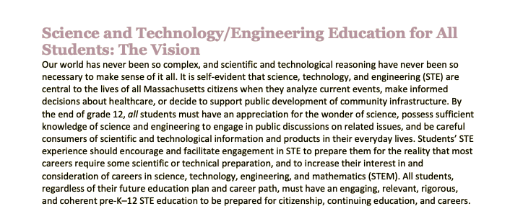

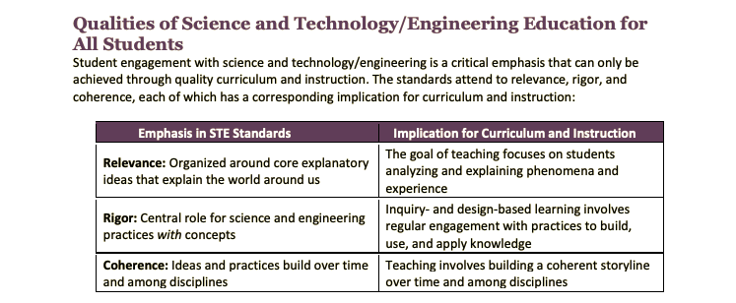
(Massachusetts Curriculum Framework for Science and Technology/Engineering, 2016)

- How would you say that this unit “matters” to the STEM community? Or to our community on Cape Cod? Or to the larger community?
This unit bridges together the biology curriculum being taught in introductory high school courses to the work being done at the Marine Biological Laboratory in Woods Hole. These connections are significant because this institution provides employment opportunities and is a leader in scientific research throughout the world. The contributions made to biomedical research is a highlight of the work that was not known before the internship experience and worth sharing with the Cape Cod community along with the other more ecologically related work being done in Woods Hole.
- What’s the most important lesson you learned as you created this?
It was much harder than I thought to capture the rotifers on camera. I used a ton of trial and error to figure out how to hook up a special camera to the microscopes but was still not able to get the quality of video I hope for in order to make the Phototaxis Lab fully virtual. I guess I learned that some activities don’t translate to remote learning as well as I’d hoped.

- Anything else you would like fellow teachers or others to know about this unit?
Many of the objectives of this unit are related to the Science Practices. Students will learn to “do science” as much as any content standard. Opportunities to apply math skills and use critical thinking are woven into the lessons

Table of Contents

 | Page
Title Page and Overview | 1
Background Information | 3
Stage 1 Desired Results | 8
Stage 2 Evidence | 11
Stage 3 Learning Plan | 12
Lesson 1: What are Rotifers? Methods, Measurements & Microscopes | 14
Lesson 2: How do Rotifers fit into the food web? | 16
Lesson 3: Virtual Lab--What is the effect of food availability on response to light in Rotifers? | 20
Lesson 4: What is a model organism? Use of Rotifers in Biomedical Research | 23
Lesson 5: Comparing DNA Sequences to Determine Evolutionary Relationships between Organisms(in this case Rotifers and Humans) | 25
Lesson 6: The Rotifer’s Unique Life Cycle--Sexual and Asexual Reproduction | 27
Information to Support Teacher Learning | 29
List of Unit Resources | 30

Stage 1 Desired Results
MA STE Standards  Review from Middle School Standards:  8.MS-LS3-1. Develop and use a model to describe that structural changes to genes (mutations) may or may not result in changes to proteins, and if there are changes to proteins there may be harmful, beneficial, or neutral changes to traits.  8.MS-LS8.MS-LS3-2. Construct an argument based on evidence for how asexual reproduction results in offspring with identical genetic information and sexual reproduction results in offspring with genetic variation. Compare and contrast advantages and disadvantages of asexual and sexual reproduction.  8.MS-LS48.MS-LS4-4. Use a model to describe the process of natural selection, in which genetic variations of some traits in a population increase some individuals’ likelihood of surviving and reproducing in a changing environment. Provide evidence that natural selection occurs over many generations.  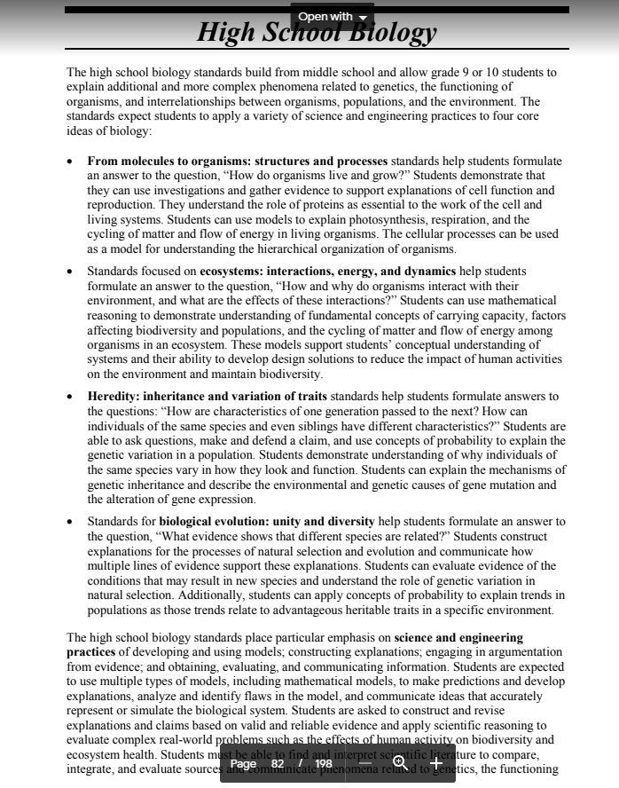  Plus specifically (from HS Biology Standards):  LS1. From Molecules to Organisms: Structures and Processes  HS-LS1-1. Construct a model of transcription and translation to explain the roles of DNA and RNA that code for proteins that regulate and carry out essential functions of life.  HS-LS1-2. Develop and use a model to illustrate the key functions of animal body systems, including (a) food digestion, nutrient uptake, and transport through the body; (b) exchange of oxygen and carbon dioxide; (c) removal of wastes; and (d) regulation of body processes.  LS2. Ecosystems: Interactions, Energy, and Dynamics  HS-LS2-1. Analyze data sets to support explanations that biotic and abiotic factors affect ecosystem carrying capacity.  HS-LS2-4. Use a mathematical model to describe the transfer of energy from one trophic level to another. Explain how the inefficiency of energy transfer between trophic levels affects the relative number of organisms that can be supported at each trophic level and necessitates a constant input of energy from sunlight or inorganic compounds from the environment. Clarification Statement: • The model should illustrate the “10% rule” of energy transfer and show approximate amounts of available energy at each trophic level in an ecosystem (up to five trophic levels).  LS3. Heredity: Inheritance and Variation of Traits  HS-LS3-1. Develop and use a model to show how DNA in the form of chromosomes is passed from parents to offspring through the processes of meiosis and fertilization in sexual reproduction.  HS-LS3-4(MA). Use scientific information to illustrate that many traits of individuals, and the presence of specific alleles in a population, are due to interactions of genetic factors and environmental factors  LS4. Biological Evolution: Unity and Diversity  HS-LS4-1. Communicate scientific information that common ancestry and biological evolution are supported by multiple lines of empirical evidence, including molecular, anatomical, and developmental similarities inherited from a common ancestor (homologies), seen through fossils and laboratory and field observations.  Clarification Statement: • Examples of evidence can include the work of Margulis on endosymbiosis, examination of genomes, and analyses of vestigial or skeletal structures.  HS-LS4-2. Construct an explanation based on evidence that Darwin’s theory of evolution by natural selection occurs in a population when the following conditions are met: (a) more offspring are produced than can be supported by the environment, (b) there is heritable variation among individuals, and (c) some of these variations lead to differential fitness among individuals as some individuals are better able to compete for limited resources than others.  Clarification Statement: • Emphasis is on the overall result of an increase in the proportion of those individuals with advantageous heritable traits that are better able to survive and reproduce in the environment. | ESSENTIAL QUESTIONS  - What role do rotifers serve in the aquatic food chain?  - What role do rotifers serve as model organisms for scientific research?  - What adaptations do rotifers have to survive in extreme environments?
UNDERSTANDINGS
Students will understand that…
- Rotifers function as primary consumers in aquatic food chains.
- Rotifers are used in scientific research to serve as model organisms for ecological and biomedical research.
- Rotifers have adapted to live in various extreme environments, including many around Cape Cod.

Students will be skilled at…..
- Applying the science practices through experimentation, documentation and class discussions.
- Relating the role of rotifers in ecology and biomedical research to units of study throughout the year.
TRANSFER
Students will be able to independently use their learning to…
- Apply science and math practices in their learning.
- Use critical thinking and problem-solving strategies to approach complex topics.
- Make connections between biology,current topics and their everyday life.
 | Cross-Curricular Connections
Stage 2 Evidence
Formative Assessment Ideas:
Photos and drawings, data sharing and analysis using Google Sheets, Edpuzzle
Summative Assessment Ideas:
Lab Reports; Spreadsheets, Graphs and Presentations

Stage 3 Learning Plan
Summary of Key Learning Events and Instruction (see below)

Introductory Lesson  Lesson that introduces the content. More teacher directed | Constructing Lesson  Lessons that engage students in building and linking together understanding. Guided/collaborative. Student/teacher or partners/small group | Practice Lesson  Lessons or activities that students can complete relatively independently | Assessment Lesson  Formative: Check-ins along the way to see if students “get it”  Summative: Students showing what they know, when you feel they are ready

Stage 3 Learning Plan
Summary of Key Learning Events and Instruction

Lesson Name | Type (Introductory, Constructing, Practice, and Assessment) | Content Addressed | Standards Included (by number)
- What are Rotifers? Methods, Measurements & Microscopes | Introductory | Microscope Use, Units of Measurements, Science Practices, Adaptations | HS-LS1-2.
- How do Rotifers fit into the food web? | Constructing | Ecological Roles, Effects of Abiotic and Biotic Factors on Populations | 8.MS-LS3-1., HS-LS2-4
- Lab--What is the effect of food availability on response to light in Rotifers? | Constructing & Practice | Science Practices, Microscope Use, Data Analysis | HS-LS4-2, HS-LS3-4(MA )
- What is a model organism? Use of Rotifers in Biomedical Research | Introductory & Constructive | Science Practices, Body Systems | HS-LS1-2,HS-LS1-1.
- Using Biochemical Evidence to Determine Evolutionary Relationships | Introductory, Constructive & Practice | Evolutionary Relationships, Phylogenetic Trees, DNA and Amino Acid Sequences(The Central Dogma: DNA-->RNA-->Protein), Using Genetic Databases to Determine Relationships and Construct Phylogenetic Trees | 8.MS-LS3-1., HS-LS4-1.HS-LS1-1.,
- The Rotifer’s Unique Life Cycle--Sexual and Asexual Reproduction | Constructive & Practice | Reproduction, Cell Division, Adaptation | 8.MS- 8-LS3-2 HS-LS4-2 ,HS-LS3-4(MA)

Lesson 1: ___What are Rotifers? Methods, Measurements & Microscopes________

Overview of the Lesson: What will students be doing?

Students will be reviewing the characteristics of life and units of measurement. They will then view rotifers(either live or using the provided video) and identify characteristics of life seen in the rotifers.

Time (minutes): 2 45 minute periods
Standard(s): What standards (s) will be the focus of the lesson?
- HS-LS1-2. Develop and use a model to illustrate the key functions of animal body systems, including (a) food digestion, nutrient uptake, and transport through the body; (b) exchange of oxygen and carbon dioxide; (c) removal of wastes; and (d) regulation of body processes.

Essential Question(s): What essential questions will be addressed in this lesson?
- How do microliters and micrometers relate to other familiar units of measurement?
- What characteristics of life can be observed in rotifers using a microscope?
Science Objectives
- Observe rotifers using a compound light microscope.
- Identify characteristics of life and provide evidence for observations and inferences.
Language Objectives and/or Targeted Academic Language
- micrometers, microliters, micropipette, observation, inference
Instructional Materials/Resources/Tools
- none needed if using provided microscope, various volumes of liquid shown in image below, meter stick, ruler for demos
Assessment: How will you know that the students got it?
Individual written responses in lab activity, oral responses during discussion
Science and Engineering Practices included (put the included ones in bold):
1. Asking questions (for science) and defining problems (for engineering)
2. Developing and using models
3. Planning and carrying out investigations
4. Analyzing and interpreting data
5. Using mathematics and computational thinking
6. Constructing explanations (for science) and designing solutions (for engineering)
7. Engaging in argument from evidence
8. Obtaining, evaluating, and communicating information
Lesson Overview:
- Review characteristics of life and use microscopes(or video) to observe these in rotifers.
Opening/Engagement:
- Show animation Animated Life: Seeing the Invisible highlighting Leewenhoek’s work with microscopes and “animalcules.”
- Short Learning Module on Characteristics of Life(CK-12 with questions to assess student understanding)
https://www.ck12.org/biology/characteristics-of-life/lesson/Characteristics-of-Life-BIO/
- Edpuzzle Characteristics of Life
During the Lesson:
- Demo: Units of Volume/Unit Conversion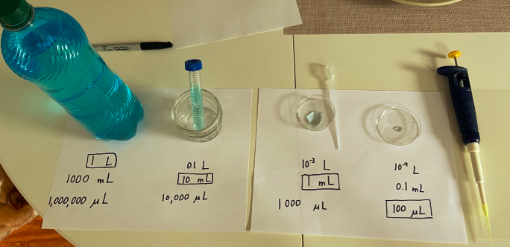

- Students can do some quick research to determine the average size of the Rotifer and algae they eat. Review units and relative sizes(meter, centimeter, millimeter, micrometer.)
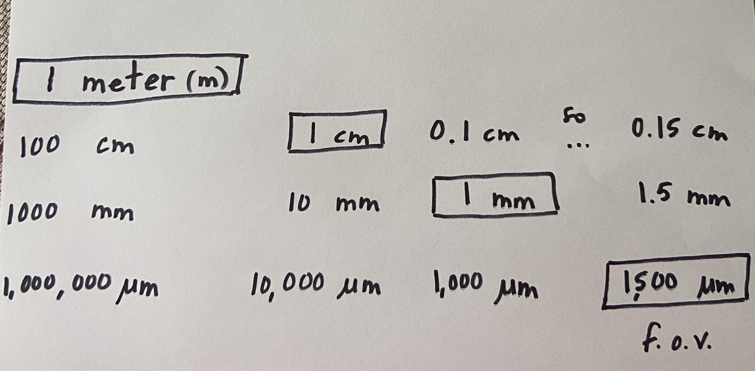
6. Use compound microscopes to observe live rotifers or video recording and make observations showing
evidence of the characteristics of life. Activity Handout

Lesson Closing:
Discuss the size of the rotifers under the low power magnification. Show how to estimate the size based on the size of the field of view(usually 1500 um) and estimated number of organisms that fit across the field.
Have students share the observations they made and evidence for characteristics they identified.
Instructional Tips/Strategies/Suggestions for Teacher: What other ideas would you like to highlight? What grouping strategies are important? What are adjustments for struggling learners, enrichment, or for students who are English Learners?
Watching the live organisms would be preferable but at this time running labs may not be possible. The rotifers can be raised by purchasing the resting cysts and algae, Instant Ocean is also needed to provide the correct tonicity for the culture.

Lesson 2: __How do Rotifers fit into the food web?_____________

Overview of the Lesson: What will students be doing?
Students will be reviewing food chains and food webs, then using the internet to research how rotifers fit into aquatic food webs. They will create a diagram of an aquatic food web and an energy pyramid, applying the 10% rule of energy transfer. Finally they will make predictions about how carrying capacity can be affected by abiotic and biotic factors.

Time (minutes): 2 45 minute periods
Standard(s): What standards (s) will be the focus of the lesson?
- HS-LS2-1. Analyze data sets to support explanations that biotic and abiotic factors affect ecosystem carrying capacity.
- HS-LS2-4. Use a mathematical model to describe the transfer of energy from one trophic level to another. Explain how the inefficiency of energy transfer between trophic levels affects the relative number of organisms that can be supported at each trophic level and necessitates a constant input of energy from sunlight or inorganic compounds from the environment.
Clarification Statement: • The model should illustrate the “10% rule” of energy transfer and show approximate amounts of available energy at each trophic level in an ecosystem (up to five trophic levels).
Essential Question(s): What essential questions will be addressed in this lesson?
- How do rotifers fit into aquatic food webs?
- How can an energy pyramid be diagrammed from a food chain including rotifers as the primary consumers?
- What biotic and abiotic factors could affect the rotifer carrying capacity in an ecosystem?
Science Objectives
- Create an aquatic food web that includes rotifers.
- Create an energy pyramid that includes a food chain from the aquatic food web and rotifers as the primary consumers.
- Predict how biotic and abiotic factors could affect the rotifer carrying capacity in an ecosystem, including a lab culture.
Language Objectives and/or Targeted Academic Language
- biotic, abiotic, carrying capacity, producer, primary consumer, secondary consumer, tertiary consumer, food chain, food web, energy pyramid, 10% rule
Instructional Materials/Resources/Tools
- internet, paper, markers or colored pencils
Assessment: How will you know that the students got it?
Diagrams--food web, energy pyramid, predictions during discussion and in exit ticket
Science and Engineering Practices included (put the included ones in bold):
1. Asking questions (for science) and defining problems (for engineering)
2. Developing and using models
3. Planning and carrying out investigations
4. Analyzing and interpreting data
5. Using mathematics and computational thinking
6. Constructing explanations (for science) and designing solutions (for engineering)
7. Engaging in argument from evidence
8. Obtaining, evaluating, and communicating information
Lesson Overview:
- Students will review food chains and food webs and then research and create an aquatic food web that contains the two key organisms, rotifers and their algal food source used in Dr. Gribble’s lab.
- Students will also create an energy pyramid using one food chain from the food web. Rotifers will serve as the primary consumer. The 10% rule will be applied to the pyramid.
- Effects of biotic and abiotic factors on rotifer populations will be discussed. Predictions will be made and supported with evidence.
Opening/Engagement:
- Edpuzzle Food Webs
- EdpuzzleLabeling Food Chains and Food Webs

During the Lesson:
- Create a Food Web that includes at least ten species: Must include Brachionus manjavacas and Tetraselmis suecica
- Create an Energy Pyramid applying the 10% rule using one Food Chain from the food web.

https://www.slideshare.net/ibnusahidhir/microbial-food-web-manipulation-in-pond-water-for-healthy-shrimphttps://www.slideshare.net/ibnusahidhir/microbial-food-web-manipulation-in-pond-water-for-healthy-shrimp
Lesson Closing
- Make Predictions: Effects of Changes in Populations on Brachionus manjavacas
Provide scenarios that could affect the size of the rotifer population and have students predict what would happen and support their prediction.
Discuss growth rate(R=2)of the rotifer population in the culture and relate to the carrying capacity of an ecosystem(even the centrifuge tube qualifies!)

Students can complete an exit ticket addressing one limiting factor in the aquatic food web or in the classroom rotifer culture on the carrying capacity.

Instructional Tips/Strategies/Suggestions for Teacher: What other ideas would you like to highlight? What grouping strategies are important? What are adjustments for struggling learners, enrichment, or for students who are English Learners?
none here

Lesson 3: _Lab--What is the effect of food availability on response to light in Rotifers?__________

Overview of the Lesson: What will students be doing?

In this lesson, the response to light(phototaxis) of rotifers which have been Fed or Unfed for two days will be compared using a dissecting microscope.

In addition, the studies on correlation between aging and phototactic response done in Dr. Gribble’s lab will be discussed and compared to data collected in this lab.

Ideally students would be running the whole experiment in person. The quality of video using available microscope adapters did not allow me to film the phototaxis of rotifers to give students the chance to experience the movement of the rotifers and collect data themselves. A class set of data has been provided in order to allow this to be run fully remote.

In schools running on a hybrid model, it would be preferable to run the lab in class and then use remote days to discuss and analyze the data. Students will be observing the response of rotifers to light and collecting data. They can then add their individual data to a class spreadsheet using Google sheets and perform calculations and data analysis.

Time (minutes): 2 60 minute class periods
Standard(s): What standards (s) will be the focus of the lesson?
- HS-LS1-2. Develop and use a model to illustrate the key functions of animal body systems, including (a) food digestion, nutrient uptake, and transport through the body; (b) exchange of oxygen and carbon dioxide; (c) removal of wastes; and (d) regulation of body processes.
- HS-LS3-4(MA). Use scientific information to illustrate that many traits of individuals, and the presence of specific alleles in a population, are due to interactions of genetic factors and environmental factors

Essential Question(s): What essential questions will be addressed in this lesson?
- Why is the response to light important for survival in Rotifers?
- What is the effect of nutrition on the response to light(phototaxis) in Rotifers?
- What is the effect of aging on phototaxis in rotifers?
Science Objectives
- Investigate the effect of nutrition on response to light in rotifers.
- Analyze class data collected from phototaxis investigation using google sheets.
- Discuss the research done in the Gribble Lab to determine effect of maternal age on phototaxis in rotifers.
Language Objectives and/or Targeted Academic Language
- response, stimulus, phototaxis, aging, eyespot, average, percentage
Instructional Materials/Resources/Tools
- see lab investigation for complete list
Assessment: How will you know that the students got it?
Lab report including spreadsheets, graphs, and conclusion questions
Science and Engineering Practices included (put the included ones in bold):
1. Asking questions (for science) and defining problems (for engineering)
2. Developing and using models
3. Planning and carrying out investigations
4. Analyzing and interpreting data
5. Using mathematics and computational thinking
6. Constructing explanations (for science) and designing solutions (for engineering)
7. Engaging in argument from evidence
8. Obtaining, evaluating, and communicating information

Notes about Science and Engineering Practices included:
This lesson focuses heavily on the science practices and provides a great opportunity to discuss the process of science and connect to the research being done at MBL with rotifers.
Lesson Overview:
- Discussion of Phototaxis and Lab Setup and Procedure, Collection of and/or analysis of data
Opening/Engagement:
- What is Phototaxis? Why is it important for the survival of Rotifers? (Refer to diagram of rotifer with eyespots, role of Rotifers in food chain as primary consumers, and natural selection)
- Demonstrate use of micropipette if having students use microscopes to run experiment in person. https://www.youtube.com/watch?v=Jfqafjt4q6U&feature=youtu.be

During the Lesson:
- Lab: Effect of Nutrition on Phototaxis in Rotifers

Lesson Closing
- Share Graphs of Phototaxis in Aging Rotifers, Discuss Results and Compare to Lab Data

(From an email from Dr. Kristin Gribble, regarding a class set of data collected during a session she ran with students in her lab:

Class Phototaxis in Rotifer Data Set
Effects of Metabolic Regulators on Phototaxis(Gribble Lab)
I’ve attached two spreadsheets with phototaxis data. One is from the lab done with UChicago Lab School (high school) students. There were two treatments, fed and starved. Each lab group had either fed rotifers (B group) or starved rotifers (A group). Each group ran three replicates with no light source applied to the slide (control) and another three replicates with the light on at one end. The groups entered their data into the spreadsheet, and we calculated the percent for each. You can see that there is a lot of variability between replicates and between groups. I think that’s due to having inexperienced students handle the rotifers; they are kind of figuring it out as they go.

The second spreadsheet gives the results for a test of three drugs over aging. The control shows the age-related decline in phototaxis. You can see that glycerol delayed that decline (phototaxis was still high at late age), and Trolox had a similar effect. Acarbose did not rescue phototaxis in old age.

Note that for phototaxis, anything above 50% indicates a tendency to swim toward the light. Below 50% is a tendency to swim toward the dark. We sometimes change the percent measurements to a “phototaxis index,” where positive numbers from 0 to 1 are positive phototaxis, and negative numbers -1 to 0 are negative phototaxis. This can be easier to understand than the percentage, where 50% seems like a high number, but actually means that the rotifers are evenly split between the light and dark halves of the slide. The second spreadsheet shows the phototaxis index calculation and calculates the PI for the control group.

Class Phototaxis in Rotifer Data Set
Effects of Metabolic Regulators on Phototaxis(Gribble Lab)

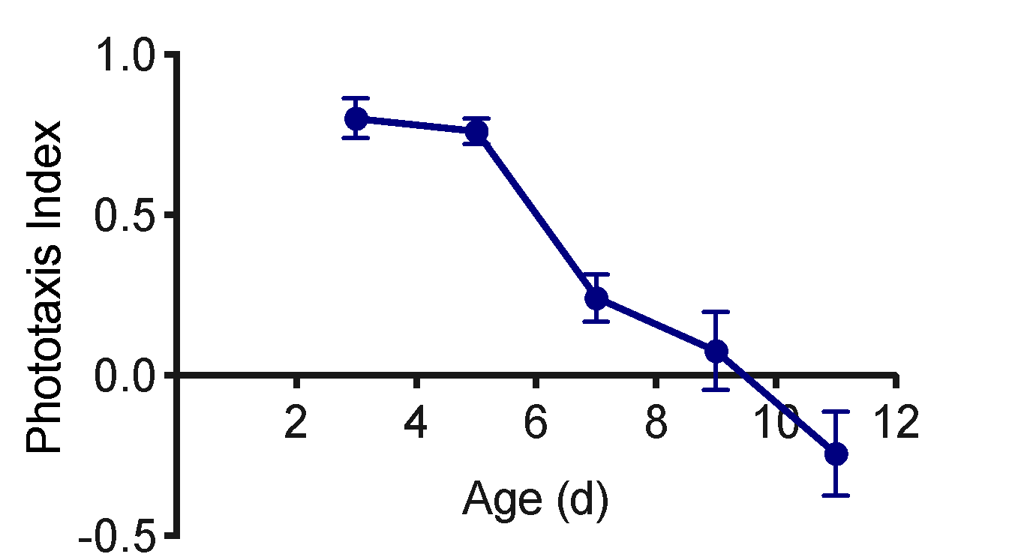from Dr. Gribble’s Research

Instructional Tips/Strategies/Suggestions for Teacher: What other ideas would you like to highlight? What grouping strategies are important? What are adjustments for struggling learners, enrichment, or for students who are English Learners?

Materials to order that are not typically in Biology labs: rotifer culture, Instant Ocean, 3 well printed microscope slides, sieve net

Lesson 4: _____What is a model organism? Use of Rotifers in Biomedical Research______

Overview of the Lesson: What will students be doing?

Students will learn about the use of model organisms in biomedical research, and learn about the role of rotifers in biomedical research at Dr. Gribble’s lab at the Marine Biological Laboratory in Woods Hole, Massachusetts.

Time (minutes): 45 minutes
Standard(s): What standards (s) will be the focus of the lesson?
- HS-LS1-2. Develop and use a model to illustrate the key functions of animal body systems, including (a) food digestion, nutrient uptake, and transport through the body; (b) exchange of oxygen and carbon dioxide; (c) removal of wastes; and (d) regulation of body processes.
Essential Question(s): What essential questions will be addressed in this lesson?
- What are model organisms?
- How are rotifers used as model organisms in biomedical research?
Science Objectives
- Investigate the role of model organisms in biomedical research.
- Connect Dr. Gribble’s research with rotifers to the use of model organisms in biomedical research.
Language Objectives and/or Targeted Academic Language
- model organism, biomedical research, NIH(National Institute of Health) and Human Genome Project
Instructional Materials/Resources/Tools
- videos and article
Assessment: How will you know that the students got it?
Class discussion and exit ticket.
Science and Engineering Practices included (put the included ones in bold):
1. Asking questions (for science) and defining problems (for engineering)
2. Developing and using models
3. Planning and carrying out investigations
4. Analyzing and interpreting data
5. Using mathematics and computational thinking
6. Constructing explanations (for science) and designing solutions (for engineering)
7. Engaging in argument from evidence
8. Obtaining, evaluating, and communicating information
Lesson Overview:
- This is a short lesson to connect Dr. Gribble’s work to biomedical research, as her work is largely funded by NIH and rotifers are a relatively new model organism used in this type of research. The use of model organisms in general is helpful in understanding biomedical research and we have traditionally mentioned Drosophila during genetics and sometimes zebrafish or C. elegans during other units.
Opening/Engagement:
- Show video clip Why do scientists use model organisms?

During the Lesson:
- Show video clip Model Organisms in Biomedical Research
- Show video clip Lessons from the Human Genome Project
- Read and discuss this article about Dr. Gribble’s work with rotifers as model organisms: https://www.statnews.com/2019/08/01/rotifer-unsung-invertebrate-teaching-us-about-aging/
Lesson Closing
Have students complete exit ticket/google form explaining in their own words how rotifers can be useful in biomedical research.

Instructional Tips/Strategies/Suggestions for Teacher: What other ideas would you like to highlight? What grouping strategies are important? What are adjustments for struggling learners, enrichment, or for students who are English Learners?

Sentence starters could be provided for struggling learners and ELs, students could discuss closing question with a partner prior to writing their response. Additional papers by Dr. Gribble could be provided to advanced students and they could report what they learned orally or in writing.

Lesson 5: ____Using Biochemical Evidence to Determine Evolutionary Relationships between Organisms_________

Overview of the Lesson: What will students be doing?

Time (minutes): 3-4 45 minute periods
Standard(s): What standards (s) will be the focus of the lesson?
- HS-LS1-1. Construct a model of transcription and translation to explain the roles of DNA and RNA that code for proteins that regulate and carry out essential functions of life.
- HS-LS4-1. Communicate scientific information that common ancestry and biological evolution are supported by multiple lines of empirical evidence, including molecular, anatomical, and developmental similarities inherited from a common ancestor (homologies), seen through fossils and laboratory and field observations.
Clarification Statement: • Examples of evidence can include the work of Margulis on endosymbiosis, examination of genomes, and analyses of vestigial or skeletal structures.
Essential Question(s): What essential questions will be addressed in this lesson?
- What is the relationship between DNA, RNA and Protein?
- How can databases be used to compare biochemical sequences such as DNA and Protein?
- How are evolutionary relationships determined using Biochemical Evidence?
Science Objectives
- Explain the relationship between DNA, RNA and Protein sequences.
- Use a database to search for and compare DNA sequences.
- Use biochemical evidence to create a phylogenetic tree.
Language Objectives and/or Targeted Academic Language
- database, genome, cladogram, phylogenetic tree, biochemical evidence, evolutionary relationship
Instructional Materials/Resources/Tools
- Internet
Assessment: How will you know that the students got it?
Individual completion of questions and phylogenetic trees; class discussion.
Science and Engineering Practices included (put the included ones in bold):
1. Asking questions (for science) and defining problems (for engineering)
2. Developing and using models
3. Planning and carrying out investigations
4. Analyzing and interpreting data
5. Using mathematics and computational thinking
6. Constructing explanations (for science) and designing solutions (for engineering)
7. Engaging in argument from evidence
8. Obtaining, evaluating, and communicating information
Lesson Overview:
- The “Central Dogma” will be reviewed--DNA to RNA to Protein. Students will then learn about the Human Genome Project and sequencing. They can then learn how to use DNA evidence to build a phylogenetic tree. Finally, they can watch a demonstration of how to search for DNA or Protein sequences using a database and then create a phylogenetic tree that relates rotifers, humans, Drosophila and C. elegans.
Opening/Engagement:
- Edpuzzle "DNA to Protein"
- Show video clip(7 min) National DNA Day: Human Genome Project, Sequencing and Medicine

During the Lesson:
- Reading on Evolutionary Relationships
- Show video clip(First 4:30 minutes) Comparing DNA Sequences to Determine Evolutionary Relationships
- Activity with Questions: Tree Building with DNA Evidence with Questions (from Biology Corner)
- Demonstration: Using Databases to search for DNA and Protein sequences/Determining Evolutionary Relationships and IndividuallyCreating a Phylogenetic Tree
--this will allow students to see the specific sequences more closely than the previous activity
--other databases are available but NCBI is usually used in AP Biology so this gives them an introduction to how it can be used.
--After watching the teacher demonstrate how to compare sequences(video provided), students can create a simple tree, remembering that usually multiple genes would be compared to provide more evidence about the relationships between organisms.

Brachionus manjavacas NCBI Protein Search page Brachionus manjavacas NCBI Nucleotide Search Page
Lesson Closing
- Exit ticket/Google Form: Submit a photo of your phylogenetic tree and answer the following in complete sentences.
Use evidence to explain why you drew the tree the way you did. What does the tree show about the relationships between the four organisms related to this protein? Based on the phylogenetic tree that you created, which of the three model organisms shows a closer relationship to humans?
Instructional Tips/Strategies/Suggestions for Teacher: What other ideas would you like to highlight? What grouping strategies are important? What are adjustments for struggling learners, enrichment, or for students who are English Learners?

Lesson 6: ____The Rotifer’s Unique Life Cycle--Sexual and Asexual Reproduction_____________

Overview of the Lesson: What will students be doing?
Relating what they have learned about sexual vs. asexual reproduction,mitosis and meiosis and related terms to the Rotifer Life Cycle

Time (minutes): 45 minutes
Standard(s): What standards (s) will be the focus of the lesson?
- HS-LS4-2. Construct an explanation based on evidence that Darwin’s theory of evolution by natural selection occurs in a population when the following conditions are met: (a) more offspring are produced than can be supported by the environment, (b) there is heritable variation among individuals, and (c) some of these variations lead to differential fitness among individuals as some individuals are better able to compete for limited resources than others.
Clarification Statement: • Emphasis is on the overall result of an increase in the proportion of those individuals with advantageous heritable traits that are better able to survive and reproduce in the environment.
Essential Question(s): What essential questions will be addressed in this lesson?
- What unique adaptations do some rotifers have related to their reproductive life cycles?
Science Objectives
- Compare and contrast the rotifer reproductive life cycles with that of the human.
- Relate sexual and asexual reproduction to rotifer life cycles.
- Using diagrams, identify when mitosis and meiosis are used and when haploid and diploid cells are present in rotifer life cycles.
Language Objectives and/or Targeted Academic Language
sexual and asexual reproduction life cycle mitosis meiosis haploid diploid
Instructional Materials/Resources/Tools
- Diagrams
Assessment: How will you know that the students got it?
Exit ticket questions--compare and contrast human and rotifer life cycles, label and explain a diagram, explain the unique life cycle of some rotifers
Science and Engineering Practices included (put the included ones in bold):
1. Asking questions (for science) and defining problems (for engineering)
2. Developing and using models
3. Planning and carrying out investigations
4. Analyzing and interpreting data
5. Using mathematics and computational thinking
6. Constructing explanations (for science) and designing solutions (for engineering)
7. Engaging in argument from evidence
8. Obtaining, evaluating, and communicating information

Lesson Overview:
- Students will review types of cell division and reproduction and then compare/contrast these processes in rotifers and humans.
Opening/Engagement:
- Show video comparing Asexual and Sexual Reproduction

During the Lesson:
- Show video Comparing Mitosis and Meiosis in Humans
- Read article that discusses reproductive life cycles in Rotifers: Wallace article
- Share and discuss diagrams of Rotifer and Human Reproductive life cycles.

Lesson Closing
- Exit ticket questions--compare and contrast human and rotifer life cycles, label and explain a diagram, explain the unique life cycle of some rotifers.
Instructional Tips/Strategies/Suggestions for Teacher: What other ideas would you like to highlight? What grouping strategies are important? What are adjustments for struggling learners, enrichment, or for students who are English Learners?

Information to Support Teaching Learning
What additional resources can support teachers in developing background understanding of content or ideas in this unit?
- Gribble Lab at the MBL(Marine Biological Laboratory) in Woods Hole, MA
https://www.mbl.edu/jbpc/staff/gribble/people/
- Highlights of Gribble Lab research
https://www.statnews.com/2019/08/01/rotifer-unsung-invertebrate-teaching-us-about-aging/
https://www.mbl.edu/blog/offspring-of-older-mothers-are-more-responsive-to-aging-interventions-study-finds/
https://www.mbl.edu/blog/why-are-the-offspring-of-older-mothers-less-fit-to-live-long-and-prosper/
https://www.mbl.edu/blog/lifespan-extension-at-low-temperatures-is-genetically-controlled-study-suggests/

List of Unit Resources (in lesson sequence)
What additional resources can support the teaching and learning of this unit? What resources can support the teacher in implementing the unit?
Rotifer Resources and Guides
https://planktonnet.awi.de/index.php?contenttype=image_details&itemid=57847#content
https://www.canadiannaturephotographer.com/rberdan_protozoa.html
Culturing Rotifer Tips https://youtu.be/XnaRsRnN0ho

