- Images 1-2 were filtered by creative common license permission via google

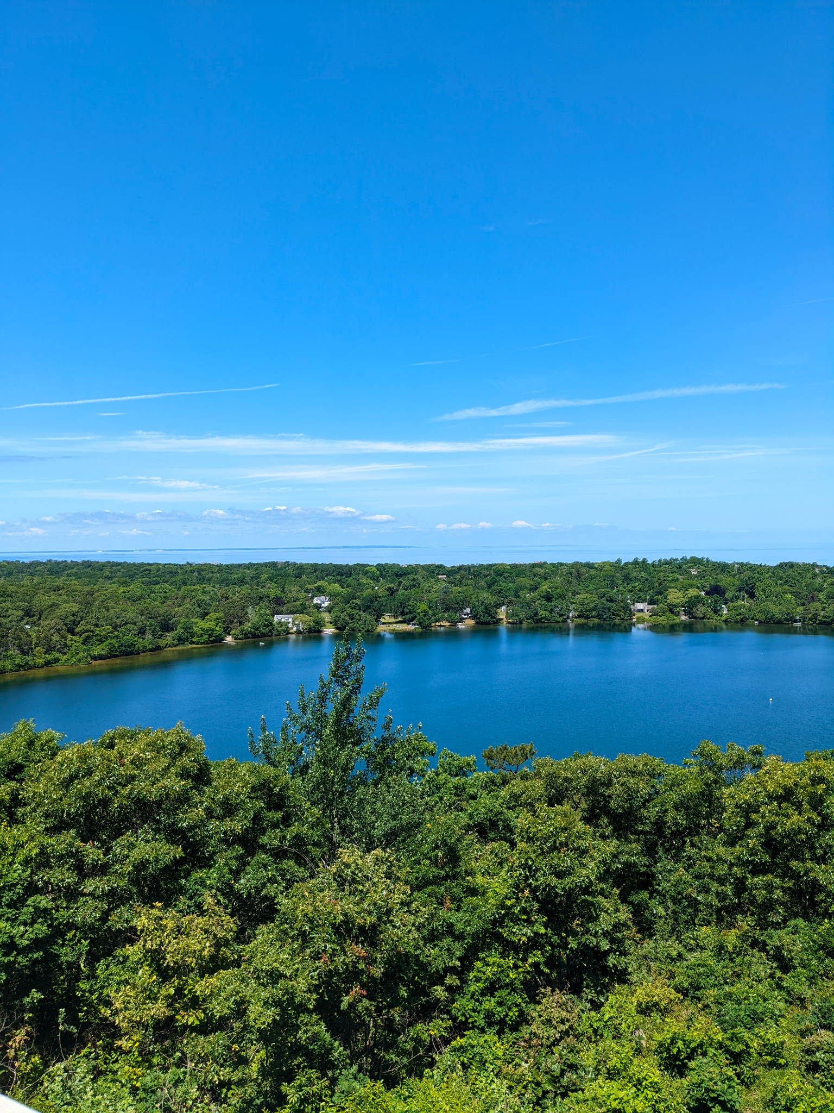

https://commons.wikimedia.org/wiki/File:View_of_Dennis_from_Scargo_Tower.jpg

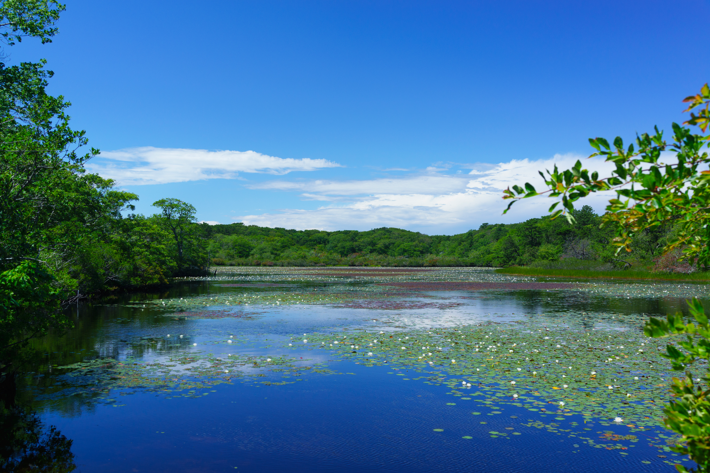
https://commons.wikimedia.org/wiki/File:Beech_forest_lilly_pond,_cape_cod_national_seashore_provincetown_%2820025832316%29.jpg

