Materials for Gallery Walk
- Interactive Map - will need computer set up
Association to Preserve Cape Cod Cyanobacteria Monitoring Map

- Video about Monitoring Program on Cape Cod

- Printed/computer display text from CDC about harmful effects to people/animals

- Animal alert poster from the CDC

- Article from Cape Cod Times

- Image from Association to Preserve Cape Cod Cyanobacteria

- Images 3- 4 were filtered by creative common license permission via google

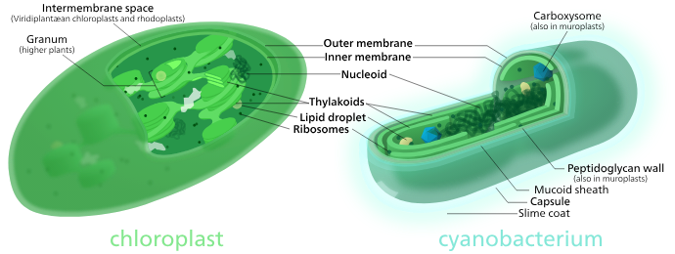
https://commons.wikimedia.org/wiki/File:Chloroplast-cyanobacterium_comparison.svg
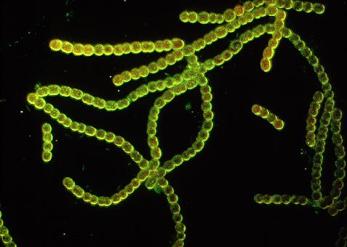

https://www.memphremagog.org/en/cyanobacteria

