Lesson 1: Introduction to Model Organisms
Table Talk/ Think-Pair-Share

I. Photos to Use:
(Display on board for all students to see)

1.  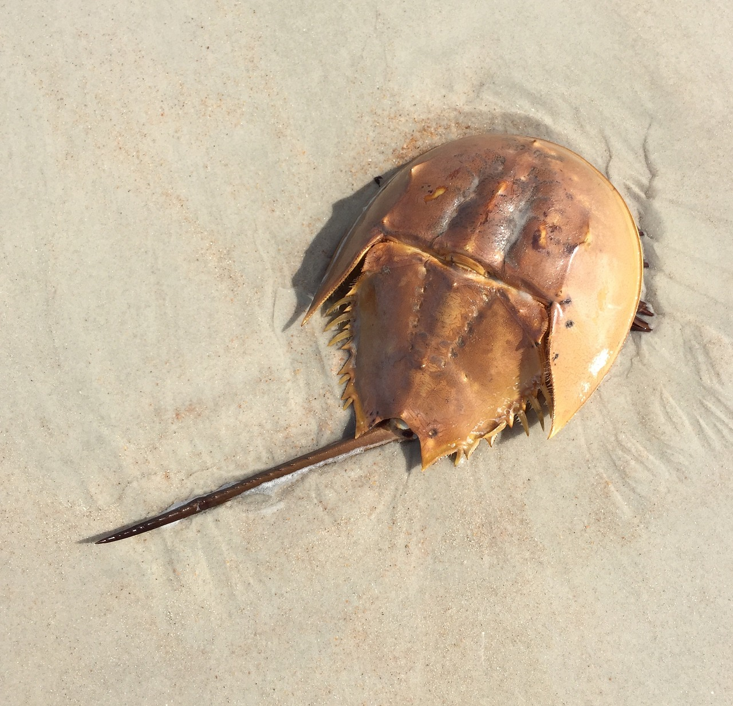 | 2.  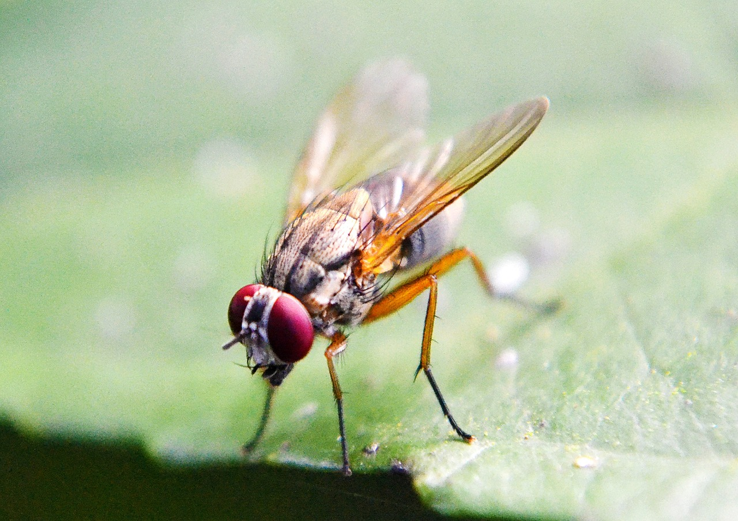 | 3. 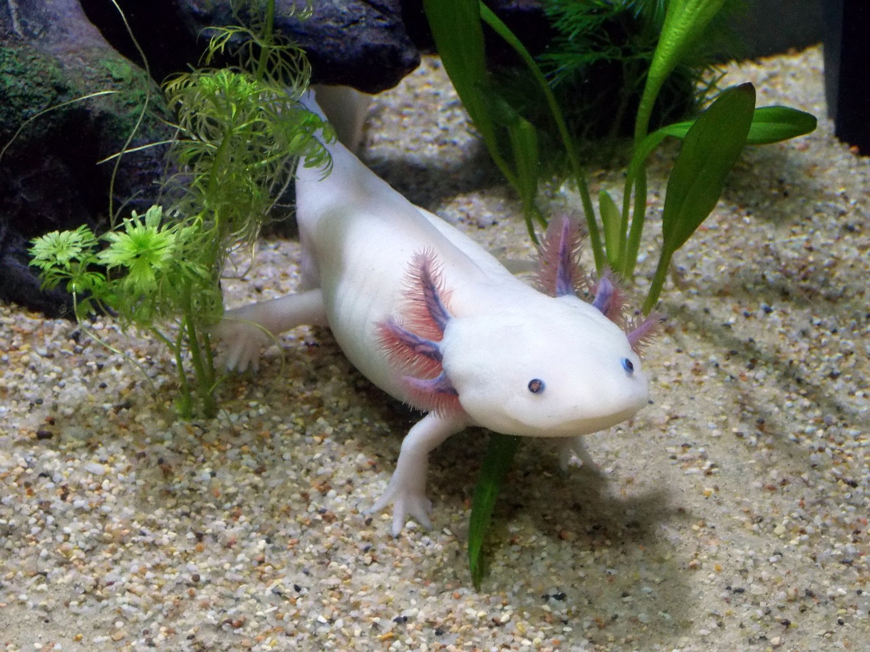
4. 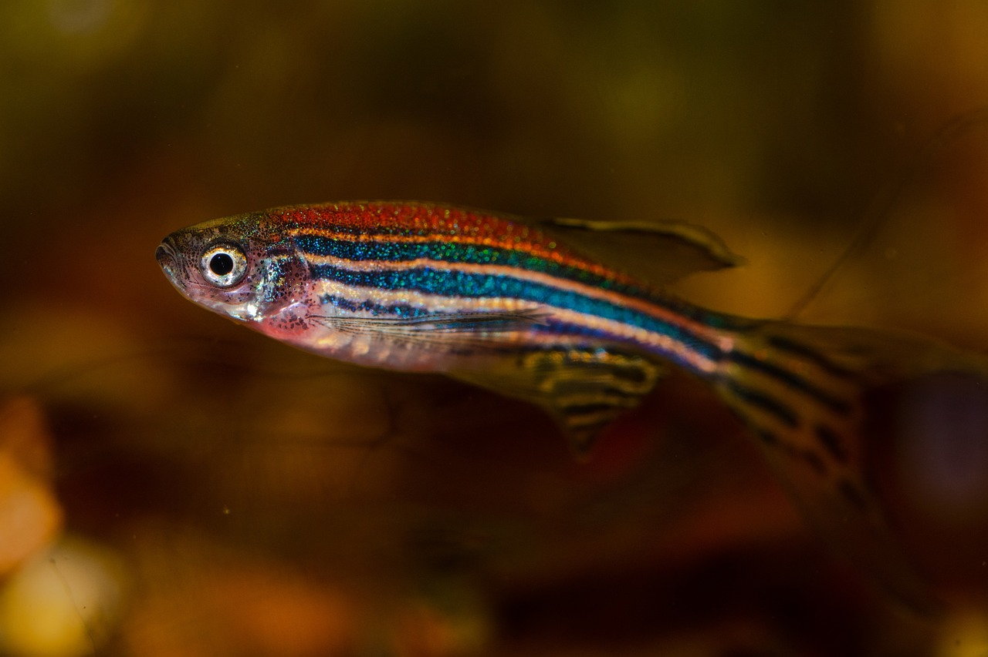 | 5. 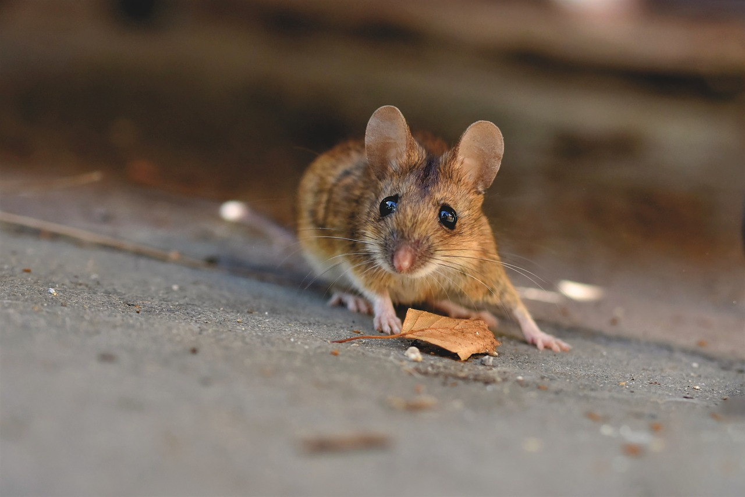 | 6.  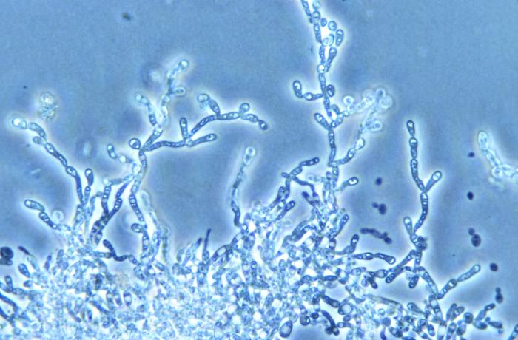
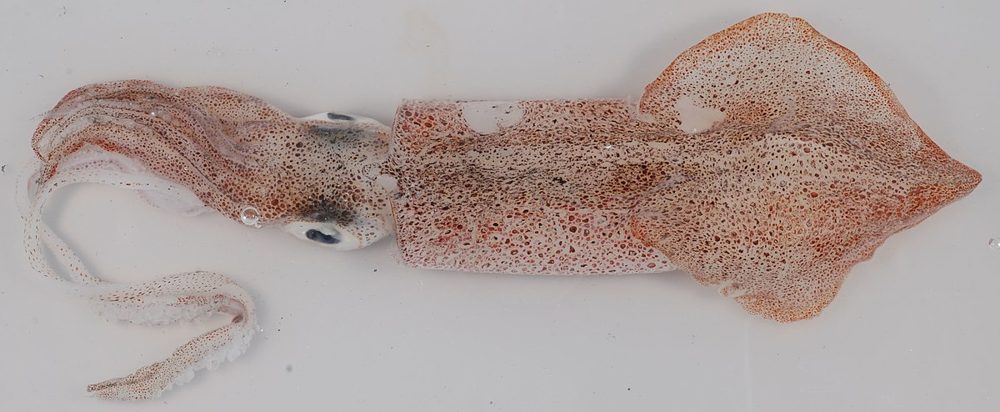  7. | 8. 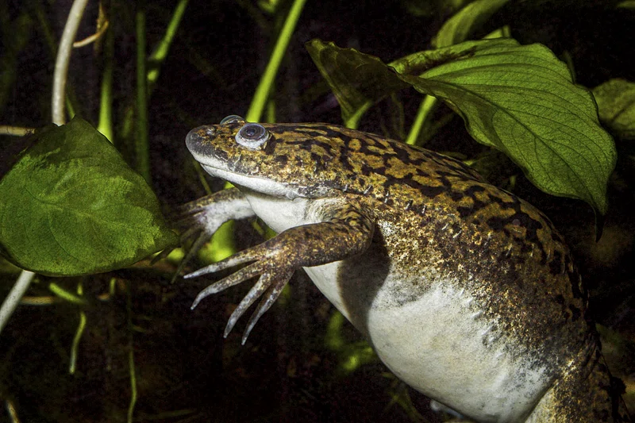 | 9. 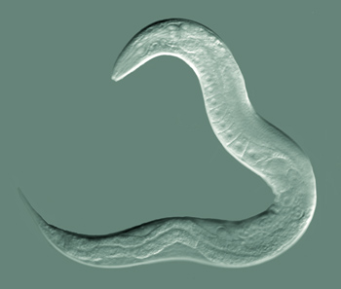

II. Questions to Pose:
(Allow students to discuss each question and write down answers in their notebooks)

- Can you name any of the species you see in the photos?
- What physical characteristics do the organisms in the photos have in common? Which characteristics are unique to each?
- How do you think any or all of these organisms are similar to humans?
- All of these organisms are important to biological science and they are referred to as “model organisms.” What do you think this term means?

III. Photo Information:
(Reveal the identities of the organisms to students)

1.  Organism: Atlantic Horseshoe Crab  (Limulus polyphemus)  Photo Source: Pixabay-Pexels | 2.  Organism: Fruit Fly  (Drosophila melanogaster)  Photo Source: Pixabay- Nuzree | 3.  Organism: Axolotl  (Ambystoma mexicanum)  Photo Source: Pixabay- LaDameBucolique
4.  Organism: Zebrafish  (Danio rerio)  Photo Source: Pixabay-  Kuznetsov_Peter | 5.  Organism: Mouse  (Mus musculus)  Photo Source:  Pixabay- Ralphs_Fotos | 6.  Organism: Yeast (Saccharomyces cerevisiae)  Photo Source: CDC/Dr. Hardin
7.  Organism: Longfin Inshore Squid (Doryteuthis pealeii)  Photo Source: Wikimedia Commons- Smithsonian Environmental Research Center | 8.  Organism: Western Clawed Frog (Xenopus tropicalis)  Photo Source: Rawpixel- Smithsonian Institution | 9.  Organism: Nematode Worm  (Caenorhabditis elegans)  Photo Source: Wikimedia Commons- Bob Goldstein

