Redox Applications in Wastewater Treatment
IB Chemistry- Grades 11/12
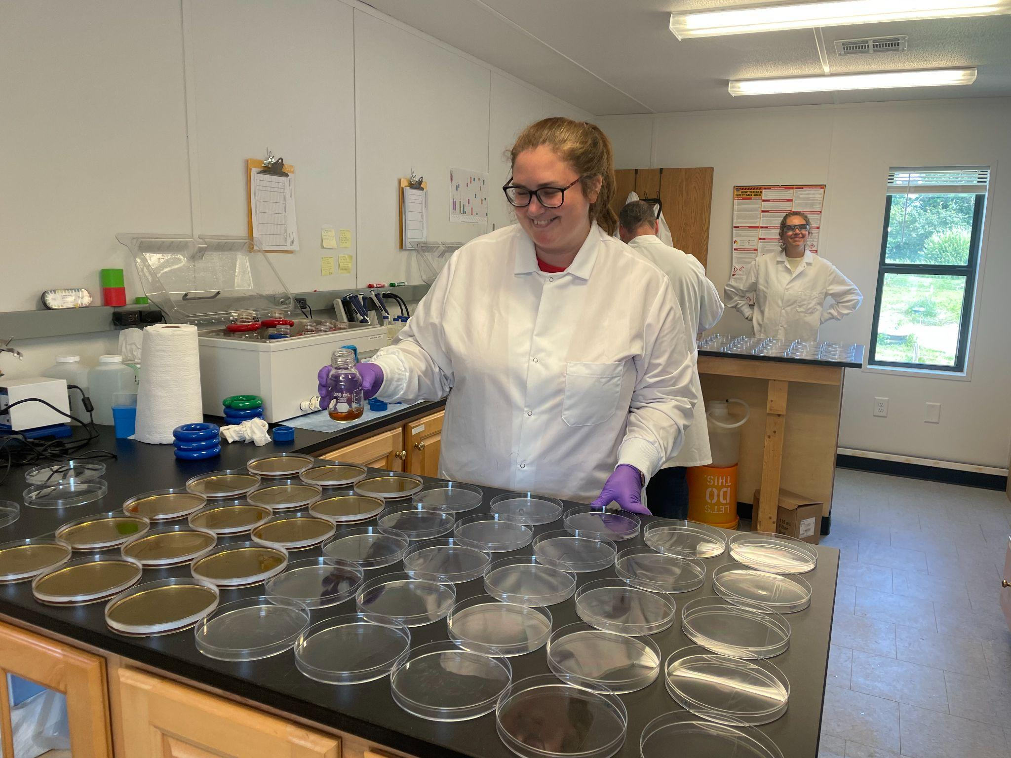

This unit connects oxidation-reduction reactions to real-world applications. It includes practice with balancing redox reactions, as well as the introduction of and practice with Winkler Method problems. Additionally, electrochemical cells are introduced and practiced at the Standard Level. Real world connections include nitrogen and phosphorus cycling as well as some information on waste management. A water quality-related exam revision sheet is also available.

A collaboration with the Cape Cod Regional STEM Network © 2023
For personal or classroom use only. Please cite source and use copyright and Cape Cod Regional STEM Network logo when reproducing. Any opinions, findings, conclusions, or recommendations expressed in this material are those of the author(s) and do not necessarily reflect the views of Cape Cod Regional STEM Network or the Brotherton Foundation.

Unit Overview

Prior to this unit, students should
- Have an understanding of oxidation states, redox reactions, and balancing redox reactions with the half reaction method, BUT they still need practice with these techniques.

At the end of this unit, students should
- Be comfortable balancing redox reactions and identifying oxidation states
- Able to independently calculate dissolved oxygen and BOD using the Winkler method
- Able to explain eutrophication and its potential causes
- Able to diagram galvanic and electrolytic cells
- Able to answer questions about the function of galvanic and electrolytic cells
- Able to predict products of galvanic and electrolytic cells
- Able to ask questions pertaining to the chemistry of wastewater treatment

Summative Assessments
- Students will complete the quiz
- The one part of Topic 9 from the 2016 Guide that is not covered here is the activity series because we covered it when we introduced types of reactions, however the rest of Topic 9 is represented here.
- Teachers may want to augment this assignment with a more traditional test and further practice with electrochemical cells. At our school, tests are written using old IB questions which we would not be able to publish here. Instead, a summative quiz is shared.

Curricular connections

2016 Guide (last test date 2024)
IB Topic 9/19 – Redox processes
9.1 Oxidation and reduction
Essential idea: Redox (reduction–oxidation) reactions play a key role in many chemical and biochemical processes.
Understandings (Key Ideas)
Oxidation and reduction can be considered in terms of oxygen gain/hydrogen loss, electron transfer or change in oxidation number.
Oxidation states should be represented with the sign given before the number, +2 not 2+.
The oxidation state of hydrogen in metal hydrides (-1) and oxygen in peroxides (-1) should be known
An oxidizing agent is reduced and a reducing agent is oxidized.
Variable oxidation numbers exist for transition metals and for most main-group
non-metals.

The activity series ranks metals according to the ease with which they undergo oxidation
The Winkler Method can be used to measure biochemical oxygen demand (BOD), used as a measure of the degree of pollution in a water sample.
Applications and skills (Stuff you should know how to do)
Deduction of the oxidation states of an atom in an ion or a compound.
Deduction of the name of a transition metal compound from a given formula, applying oxidation numbers represented by Roman numerals.
Identification of the species oxidized and reduced and the oxidizing and reducing agents, in redox reactions.
Deduction of redox reactions using half-equations in acidic or neutral solutions.
Deduction of the feasibility of a redox reaction from the activity series or reaction data
Solution of a range of redox titration problems.
Application of the Winkler Method to calculate BOD.
9.2 Electrochemical cells
Essential idea: Voltaic cells convert chemical energy to electrical energy and electrolytic cells convert electrical energy to chemical energy.
Understandings (Key Ideas)
Voltaic (Galvanic) cells convert energy from spontaneous, exothermic chemical processes
to electrical energy.

Oxidation occurs at the anode (negative electrode) and reduction occurs at the cathode (positive electrode) in a voltaic cell.
Electrolytic cells convert electrical energy to chemical energy, by bringing about non-spontaneous processes.
Oxidation occurs at the anode (positive electrode) and reduction occurs at the cathode (negative electrode) in an electrolytic cell.
Applications and skills (Stuff you should know how to do)
Construction and annotation of both types of electrochemical cells.
Explanation of how a redox reaction is used to produce electricity in a voltaic cell and how current is conducted in an electrolytic cell.
Distinction between electron and ion flow in both electrochemical cells
Performance of laboratory experiments involving a typical voltaic cell using two metal/metal-ion half-cells.
Deduction of the products of the electrolysis of a molten salt.

2025 Guide

R3.2.1 Content
Reactivity 3.2.1—Oxidation and reduction can be described in terms of electron transfer, change in oxidation state, oxygen gain/loss or hydrogen loss/gain.
Deduce oxidation states of an atom in a compound or an ion.
Identify the oxidized and reduced species and the oxidizing and reducing agents in a chemical reaction.
Include examples to illustrate the variable oxidation states of transition element ions and of most main group non-metals.
Include the use of oxidation numbers in the naming of compounds.
Structure 3.1—What are the advantages and limitations of using oxidation states to track redox changes?
Structure 2.3—The surface oxidation of metals is often known as corrosion. What are some of the consequences of this process?

R3.2.2 Content
Reactivity 3.2.2—Half-equations separate the processes of oxidation and reduction, showing the loss or gain of electrons.
Deduce redox half-equations and equations in acidic or neutral solutions.
Tool 1, Inquiry 2—Why are some redox titrations described as “self-indicating”?

R3.2.5 Content
Reactivity 3.2.5—Oxidation occurs at the anode and reduction occurs at the cathode in electrochemical cells.
Identify electrodes as anode and cathode, and identify their signs/polarities in voltaic cells and electrolytic cells, based on the type of reaction occurring at the electrode.

R3.2.6 Content
Reactivity 3.2.6—A primary (voltaic) cell is an electrochemical cell that converts energy from spontaneous redox reactions to electrical energy.
Explain the direction of electron flow from anode to cathode in the external circuit, and ion movement across the salt bridge.
Construction of primary cells should include: half-cells containing metal/metal ion, anode, cathode, electric circuit, salt bridge.
Reactivity 1.3—Electrical energy can be derived from the combustion of fossil fuels or from electrochemical reactions. What are the similarities and differences in these reactions?

R3.2.8 Content
Reactivity 3.2.8—An electrolytic cell is an electrochemical cell that converts electrical energy to chemical energy by bringing about non-spontaneous reactions.
Explain how current is conducted in an electrolytic cell.
Deduce the products of the electrolysis of a molten salt.
Construction of electrolytic cells should include: DC power source connected to anode and cathode, electrolyte.
Structure 2.1—Under what conditions can ionic compounds act as electrolytes?

Stage 3: Learning Plan
Lesson | Overview | Materials
1 | - Introduction to water, nitrogen, and phosphorus cycles  - Practice  - balancing redox reactions  - disproportionation  - Oxidation numbers  - Also includes some independent work/homework to introduce eutrophication and BOD | Please email events@capcodstemnetwork if you would like a copy of the slides for this lesson.  Phosphorus and Nitrogen
2 | - Discussion of eutrophication  - Introduction and practice with  - BOD  - Winkler Method (with a review of ppm/concentration calculations) | 2 slides  2 Winkler
3 | - Overview of wastewater treatment  - Note: if you are working with the 2025 IB Guide, increase emphasis on separation of a mixture  - One innovative/alternative septic system approach is to treat the system as a large electrochemical cell, so pause wastewater discussion to go over cells  - Key features of galvanic/voltaic cells | 3 slides  3 Part 3 Notes  3HW Introduction to ElectrochemistryThis is an easy introductory homework. It may be helpful prior to this lesson or to reinforce the lesson for Standard Level students.  3 Practice diagramming a voltaic cell  This can be used for practice, or textbook questions might help at this point too for repetition.
4 | - Key features of electrolytic cells  - Comparison between voltaic and electrolytic cells | 4 slides  Part 4 Notes  4 Electrochemical Cell Comparison
5 | - With the slides  - Connect previous lessons to wastewater treatment  - Introduce idea of electrochemical cells being applied to real world problems  - Electrochemical cell practice: Have students write galvanic on one paper and electrolytic on another. They can hold up their answers as you go through the slides. Correct any misconceptions.  - If needed, students can then fill in the cell comparison chart from the previous lesson again from memory (checking if stuck).  - Students have time to work on a Corrosion worksheet (it pairs with some instructional YouTube videos) | Please email events@capecodstemnetwork.org if you would like access to the slides for this lesson.  5 Electrochemical cell practice  5 Corrosion
6 | - Summative Quiz | 6 slide  6RedoxQuiz

Notes on other Water/TOK connections
- Additional water quality connections can be made in many other areas across the IB Chemistry curriculum. For example, here is a HL2 midterm review resource that tackles many topics through the lens of water quality at Joint Base Cape Cod Otis Review.
- For students testing in 2024
  - Each option has an environmental connection. This year, I have students who have elected to study options A, B, and D. Focusing on these topics immediately after this unit may lead to deeper understanding of the environmental connections. Here are reading questions for the Kognity text that can be used if you decide to do the same.
  - For students testing in 2025 and beyond, the options have been removed. Some of the environmental connections have been maintained. The new IB Chemistry Guide has an increased emphasis on separation of a mixture, and separation of wastewater can be explored in more depth to support that connection.

