Building pH Sensors
Physics, Chemistry, Environmental Science, High School

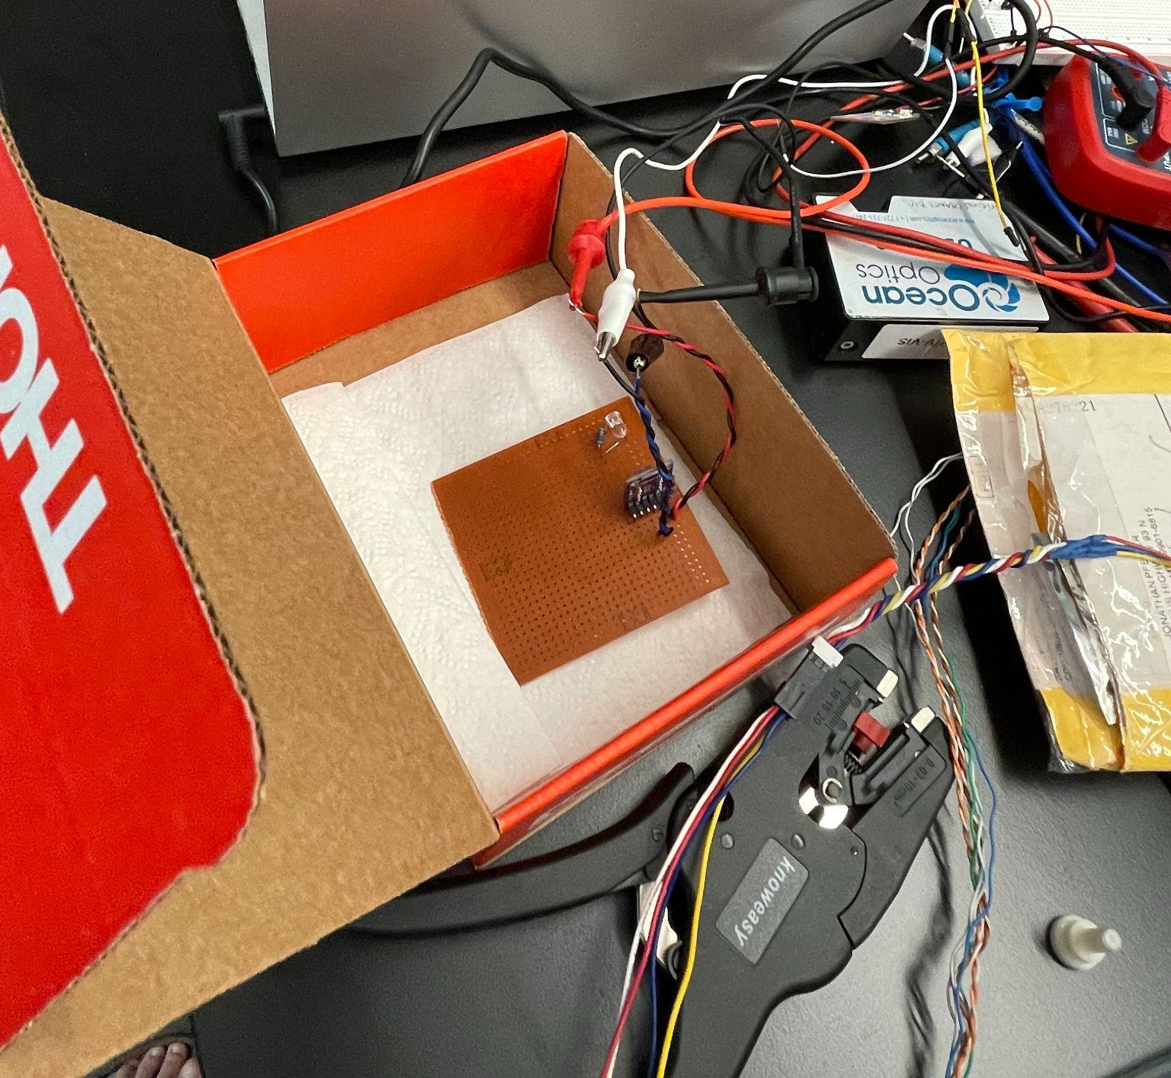

A collaboration with the Cape Cod Regional STEM Network © 2023
For personal or classroom use only. Please cite source and use copyright and Cape Cod Regional STEM Network logo when reproducing. Any opinions, findings, conclusions, or recommendations expressed in this material are those of the author(s) and do not necessarily reflect the views of Cape Cod Regional STEM Network or the Brotherton Foundation.

Curriculum Overview

Stage 1: Desired Results
Essential Questions

- What do scientists do at Woods Hole Oceanographic Institute?
- How sensors contribute to our understanding of the environment?
- How do we measure the factors such as pH in the ocean?

Enduring Understandings

- Scientists at Woods Hole Oceanographic Institute engage in cutting-edge research to explore and understand the complexities of the ocean.
- Sensors play a crucial role in enhancing our understanding of the environment by providing data. The measurement of factors like pH in the ocean involves the use of specialized sensors.

- Scientists and engineers work together to design equipment that is used to develop an understanding of the ocean

Transfer
At the end of this unit, students will be able to…
- Explain what pH is, how scientists measure it, including how a spectrophotometer works
- Explain the importance of measuring pH
- Share a pH sensor they built in teams
- Create a calibration curve and use it to determine the pH of an unknown sample

Stage 2: Evidence
Formative Assessment ideas:
- Formative assignments throughout the unit will keep students on track, such as the Beer’s Law assignment and the lab instructions
Summative Assessment ideas:
- At the end of the unit, students will bring their pH sensors to AVAST center in Woods Hole and share their project with scientists after touring the facility

Stage 3: Learning Plan
Lesson Number |  | Lesson Name | Brief description
1 |  | Project Overview and Review | Students learn about sensors and how we use them, including how they are used at WHOI. Students review key concepts such as pH, spectroscopy, and the environmental impact of ocean acidification..
2 |  | Beer’s Law Simulation | In this lesson, students will use a PHET simulation to explore the relationship between absorption, transmittance, and color.
3-6 |  | Building and Testing Sensors | Over a few lessons, students will build their sensors, create a calibration curve, and then test a sample of salt water to determine the pH. Students will also learn about the different indicators used at WHOI.
7-8 |  | Project Presentation and Field Trip

Lesson 1: Project Overview and Review

Lesson 1: Overview
Lesson Overview:  Students learn about sensors and how we use them, including how they are used at WHOI. Students review key concepts such as pH, spectroscopy, and ocean acidification. | Lesson Objectives:  At the end of the lesson, students will be able to…  - Share how scientists at WHOI use sensors  - Explain what pH is and how it is measured  - Explain how spectroscopy works  - Describe the environmental effects of ocean acidification

Lesson 1: Activities
Activity | Teacher is… | Students are… | Materials
Guiding Question | Introduce the guiding question: What are sensors and why might we want to use them? | Discussing in small groups what they know about sensors and how they are used  Generating questions they might ask scientists about sensors
Video with WHOI Scientists | Students skype with WHOI scientists and ask questions about sensors. This session is recorded in one classroom and shared with all other sessions.  Instruct students to return to their notes and add anything they learned about sensors and how they are used. | After watching the video with WHOI scientists, students return to notes and add what they learned about sensors | Video with WHOI Scientists
pH Review | In a short lecture, teacher reviews the basics of pH, provide an overview of spectroscopy, and the environmental relevance of pH.  The slides linked on publicsensors.org provide a great overview and can be adapted to the classroom. |  | Slides from publicsensors.org

Lesson 2: Beer’s Law Simulation

Lesson 2: Overview
Lesson Overview:  In this lesson, students will use a PHET simulation to explore the relationship between absorption, transmittance, and color. | Lesson Objectives:  At the end of the lesson, students will be able to…  - Explain the relationship between transmittance and absorbance.

Lesson 2: Activities
Activity | Teacher is… | Students are… | Materials
Introduction | Provides an overview of the simulation and instructions | Asking clarifying questions
PHET Simulation | Teacher provides simulation activity from https://publicsensors.org/K12modules/pHsensor/ | Completing simulation activity in groups | Printed simulation activity
Wrap Up | Teacher leads a discussion of the last two questions in the handout  Teacher collects lab assignments to check student understanding | Discussing handout

Lesson 3 - 6: Building & Testing Sensors

Lesson 3: Overview
Lesson Overview:  Over a few lessons, students will build their sensors, create a calibration curve, and then test a sample of salt water to determine the pH. Students will also learn about the different indicators used at WHOI. | Lesson Objectives:  At the end of the lesson, students will be able to…  - Explain how their sensor works  - Make a claim about the pH of a sea water solution and support it with evidence from their sensor

Lesson 3: Activities
Activity | Teacher is… | Students are… | Materials
CHANOS II – a pH sensor at WHOI | Teacher will provide an overview of CHANOS II, an optical sensor designed at WHOI  As a review, ask students to describe how the sensor in CHANOS II works  This provides a unique connection to the local environment | Reviewing how pH sensors work by providing an explanation of how they think CHANOS works
Building sensors | In groups, students will use set up the sensors using the kits and the student instructions.  Students will create a calibration curve.  Then, students will determine the pH of a sample of sea water collected locally. |  | Sensor kits (see Instructor guide from https://publicsensors.org/K12modules/pHsensor/ for what should be included in kits)
Indicators used at WHOI | As an extension (or warm up) teacher will share more about the indicators used at WHOI to measure pH so that students can see what scientists are using.  See notes on the next page on the indicators  A possible activity would be to have students calculate pH based on data from indicators | Calculating pH
3D printing housing for sensors | As a possible extension, students can 3D print an apparatus for their pH sensors. See image below for possibility.

Cuvette

Power
LED array

Voltmeter
Photodiode

3D-printed housing

Metacresol purple (Lai et al., 2016)
$pH_{T}=p(K_{1}e_{2})+log_{10}(\frac{R-e_{1}}{1-R\frac{e_{3}}{e_{2}}})$
$e_{1}=-0.007762*(4.5174*10^{-5})T$
$\frac{e_{3}}{e_{2}}=-0.0244656+(2.60262*10^{-4})T$
$p(K_{1}e_{2})=815.984591T^{-1}$
For salinity $S=0$ and temperature $T$, where T is in kelvins

Bromocresol purple (Douglas and Byrne, 2017)
$pH_{T}=p(K_{1}e_{2})+log_{10}(\frac{R-e_{1}}{e_{2}-Re_{3}})$
$e_{1}=0.00387$
$e_{2}=2.858$
$e_{3}=0.0191$
$p(K_{1}e_{2})=5.226+378.1T^{-1}$
For temperature $T$, where T is in kelvins

Phenol red (Douglas and Byrne, 2017)
$pH_{T}=p(K_{1}e_{2})+log_{10}(\frac{R-e_{1}}{e_{2}-Re_{3}})$
$e_{1}=0.00244$
$e_{2}=2.734$
$e_{3}=0.1075$
$p(K_{1}e_{2})=5.798+666.7T^{-1}$
For temperature $T$, where T is in kelvins

Lesson 7 - 8: WHOI Field Trip and Culmination

Lesson 4: Overview
Lesson Overview:  Student groups will prepare to share their projects by creating a presentation explaining how their sensors work and how it might be used. Students will practice their presentations in groups.  On a field trip to WHOI, students will visit the labs and then share their sensor project presentations with scientists for feedback. | Lesson Objectives:  At the end of the lesson, students will be able to…  - Share a presentation that provides an overview of how their sensors work  - Generate additional ideas of how their sensors might be used  - Reflect on the strengths and weaknesses of their sensors

Lesson 4: Activities
Activity | Teacher is… | Students are… | Materials
Preparing Presentations | Provides structure to students on their presentations, including a scaffolded slideshow, emphasizing that students should make sure to discuss the potential impacts of pH sensors and provide an additional idea for how the sensor might be used.  Students should also reflect on the strengths and limitations of their sensors and how it might be improved.  Provide rubric or guidelines on effective presentation. | Preparing presentations to be shared with scientists based on their project | Rubric
Presentation practice | Provide structure for student groups to present with each other and provide feedback. Students use rubric to provide peer feedback. | Working in groups to practice their presentations. | Rubric
WHOI Field trip | Teacher will need to organize the field trip to WHOI. Students should have an opportunity to meet with scientists and tour the facility before sharing their projects with the scientists. | Attending field trip  Generate questions for scientists | Permission slips  Schedule
Reflection | Students are asked to share reflections on their experience in the unit, what they learned about WHOI, and return to the guiding question: What are sensors and why might we want to use them?

Resources

Resources to support teacher learning - help teachers to develop background content knowledge for this unit.
This lesson was largely adapted from curriculum developed by:
Seroy, S. K., Zulmuthi, H., & Grünbaum, D. (2020). Connecting chemistry concepts with environmental context using student-built pH sensors. Journal of Geoscience Education, 68(4), 334–344. https://doi.org/10.1080/10899995.2019.1702868

https://publicsensors.org/K12modules/pHsensor/ (if you have trouble accessing these materials, email events@capecodstemnetwork.org and we can send you copies of the files).

Bo Yang, Mark C. Patsavas, Robert H. Byrne, Jian Ma (2014), “Seawater pH measurements in the field: A DIY photometer with 0.01 unit pH accuracy”, Marine Chemistry.

Lai, C.-Z., DeGrandpre, M.D., Wasser, B.D., Brandon, T.A., Clucas, D.S., Jaqueth, E.J., Benson, Z.D., Beatty, C.M. and Spaulding, R.S. (2016), “Spectrophotometric measurement of freshwater pH with purified meta-cresol purple and phenol red”. Limnol. Oceanogr. Methods.

N.K. Douglas, R.H. Byrne (2017), “Spectrophotometric pH measurements from river to sea: Calibration of mCP for 0≤S≤40 and 278.15≤T≤308.15K”, Marine Chemistry.

DIY CD spectroscope: https://www.exploratorium.edu/snacks/cd-spectroscope

Description of CHANOS (WHOI project on which unit is based): https://www2.whoi.edu/staff/mringham/projects/chanos2/

