Name: Date:
32

Field Trip to Bog Restoration and Fuller Farm

Field Trip Observations: Both Field Trip locations should be documented below. It can be ANY similarities and differences including wildlife observed, questions that came up, general observations with Human Impact, etc.
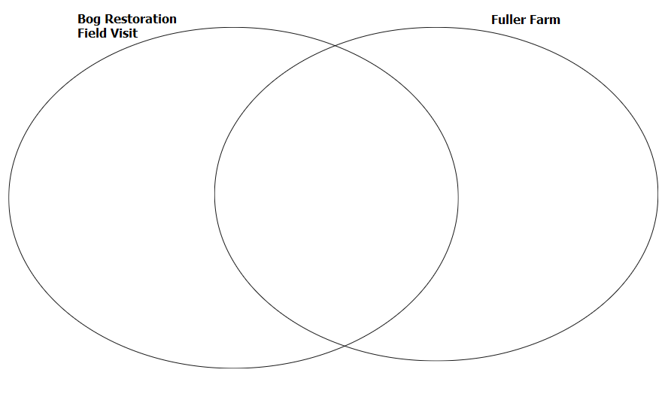

Bog Restoration Project Field Site:

(Insert Aerial Map Image for students to use)

Fuller Farm Field Site:

Outside Station #1: Insect Biodiversity Survey

Students will use waders and nets to walk a 30 foot distance in three different locations to survey which insects are observed in that area.

Which location are you at? | How many total insects collected in the sweep. | How many varieties of insect species collected in the sweep. | Level of biodiversity observed: (Low, moderate, high)

Outside Station #2: Insect Biodiversity Survey

TASK: Find at least two different types of seeds to collect and bring back to the indoor station for observation.

JOURNAL (you pick 3 to make note of):
- Journal one thing about the history of Fuller Farm
- Journal one thing about the future plans of Fuller Farm
- Journal one project that helps restore the natural environment
- Biodiversity anecdotes- did you see 20 different plants? 10? More than 20?
- Biodiversity anecdotes- Did you observe any animal species?
- List one native species Barnstable Land Trust would like to see more of at Fuller Farm.
- List one invasive species name and how Barnstable Land Trust is trying to reduce/eliminate it.

______________________________________________________________________________________________________________________________________________________________________________________________________________________________________________________________________________________________________________________________________________________________________________________________________
Inside station Fuller Farm #3:

Please draw one seed type below using the stereomicroscope to observe. How does the seed shape, size, color, and physical features help it become a plant?

________________________________
________________________________
________________________________
________________________________
________________________________
________________________________
________________________________
________________________________
________________________________
________________________________

Using a fan, which seed type traveled the furthest? ________________________________

