Name: Date:
25

Can a Nutrient be a Pollutant?

Nutrient definition:
a substance that provides nourishment essential for growth and the maintenance of life.

Pollutant definition:
a substance that is a type of chemical, physical, or biological material that contaminates the environment and causes pollution.

Part 1: Looking at these two key terms and their corresponding definitions, fill in the venn diagram below with your own description phrases, examples, or other words that relate to the definitions.

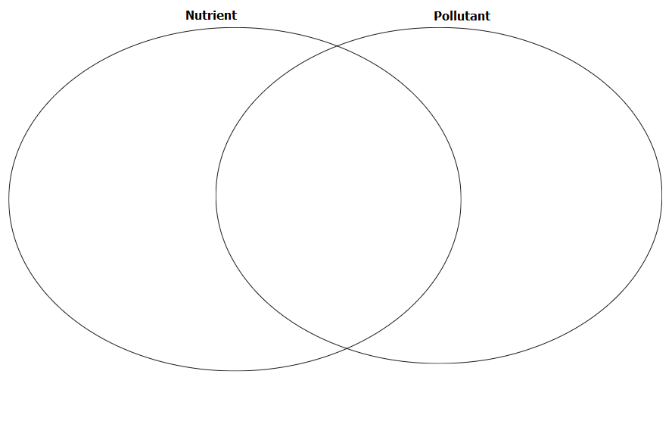

Part 2: Small groups or partners will view different samples, observe, and discuss whether they should be considered a nutrient, a pollutant, or possibly both?

- What sample number do you have for your group to view? ___________

- Do you believe this sample to be a nutrient, pollutant or both? _______________________

- If you think nutrients are in the sample you are observing, what kinds of nutrients?

- Provide a reason for your determination: ______________________________________
__________________________________________________________________________________________________________________________________________________________________________________________________________________________________________

Part 3: Listen to the other groups share out what they had as a sample and how they labeled their samples as nutrients, pollutants, or both. Make a list below to use for follow up questions.

Sample item name | Nutrient, Pollutant, or Both?

Part 4: What happens when too many nutrients are released into an environment?

As a class watch this short video clip from Barnstable Clean Water Coalition:

Overall introduction on cyanobacteria blooms as an indicator of an increase of nitrogen due to Human Impact: LINK HERE (3:17)

Why should we care, restoration plans overview, and watershed of 3 Bays/Marstons Mills River: LINK HERE (3:09)

Listen as we read aloud Monster in the Water: Fighting Back Against Harmful Algal Blooms by Dylan D’Agate.

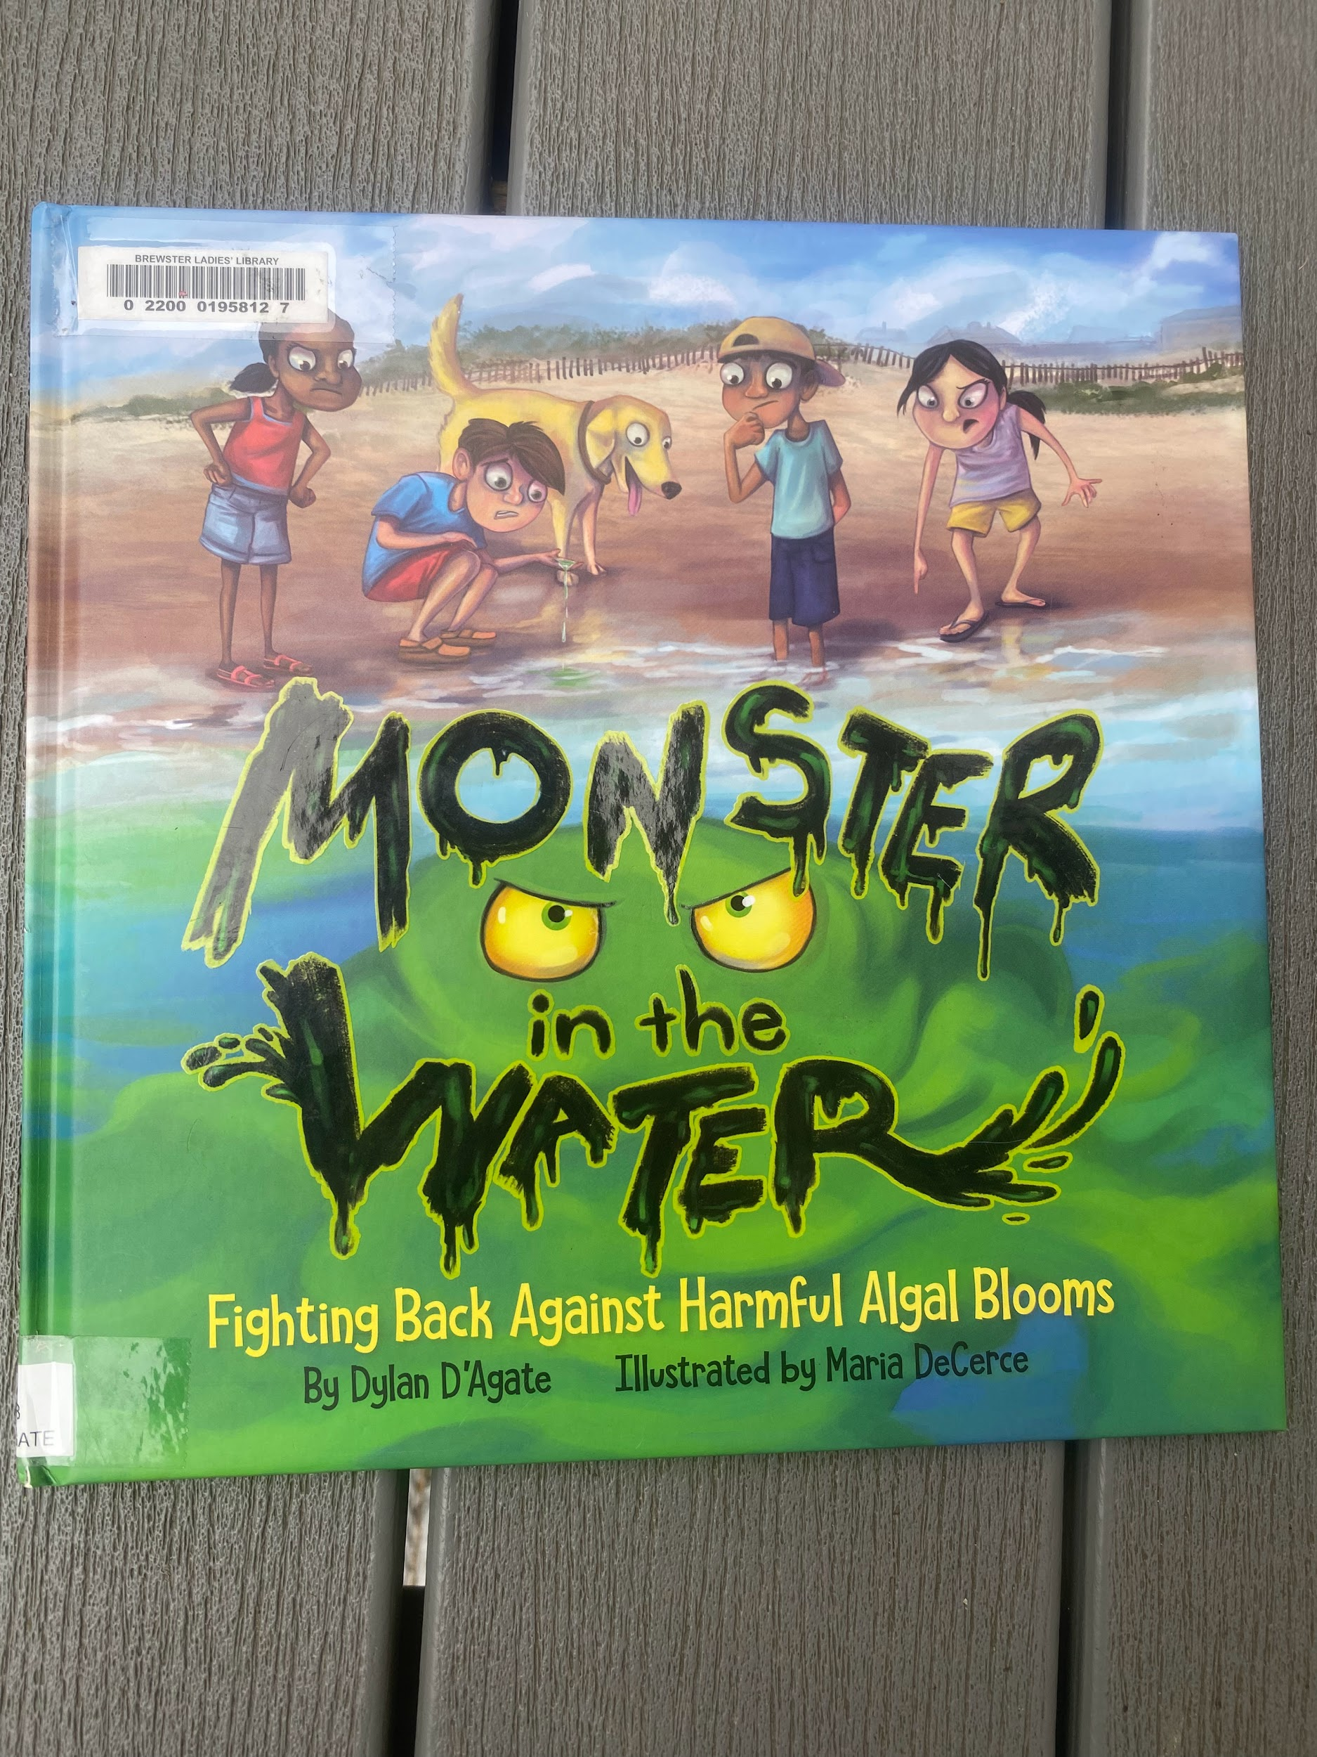

Locally here on Cape Cod, we are having significant issues with water ways (ground water, streams and rivers, bays, and our ocean water).

Barnstable Clean Water Coalition is working to change the Nitrogen loading right around

Shaubel’s pond: Watch this clip here: https://youtu.be/kgt5TYCAhIw

https://bcleanwater.org/what-we-do/mitigate/shubael-pond-project/

Part 5: Reflection Questions

- Which of these items do you think creates the most harmful impact here on Cape Cod?

- What nutrients were discussed today?

- Read the following statement: “An estimated 80 percent of nitrogen loading on Cape Cod stems from the use of traditional backyard septic systems, which are not designed to remove it.” from the EPA website found here.

Reflect: The town you live in is planning a major sewerage and waste water treatment facility. Should this be done?

__________________________________________________________________________________________________________________________________________________________________________________________________________________________________________
__________________________________________________________________________________________________________________________________________________________________________________________________________________________________________

Part 6: Read-Aloud of The Great Stink: How Joseph Bazalgette Solved London’s Poop Pollution Problem by Colleen Paeff and have a class discussion on historical progress of wastewater planning and infrastructure.

