Take a Bite out of Shark Research

Using Atlantic White Shark Conservancy’s White Shark Logbook

as an Educational Tool

Biology-High School

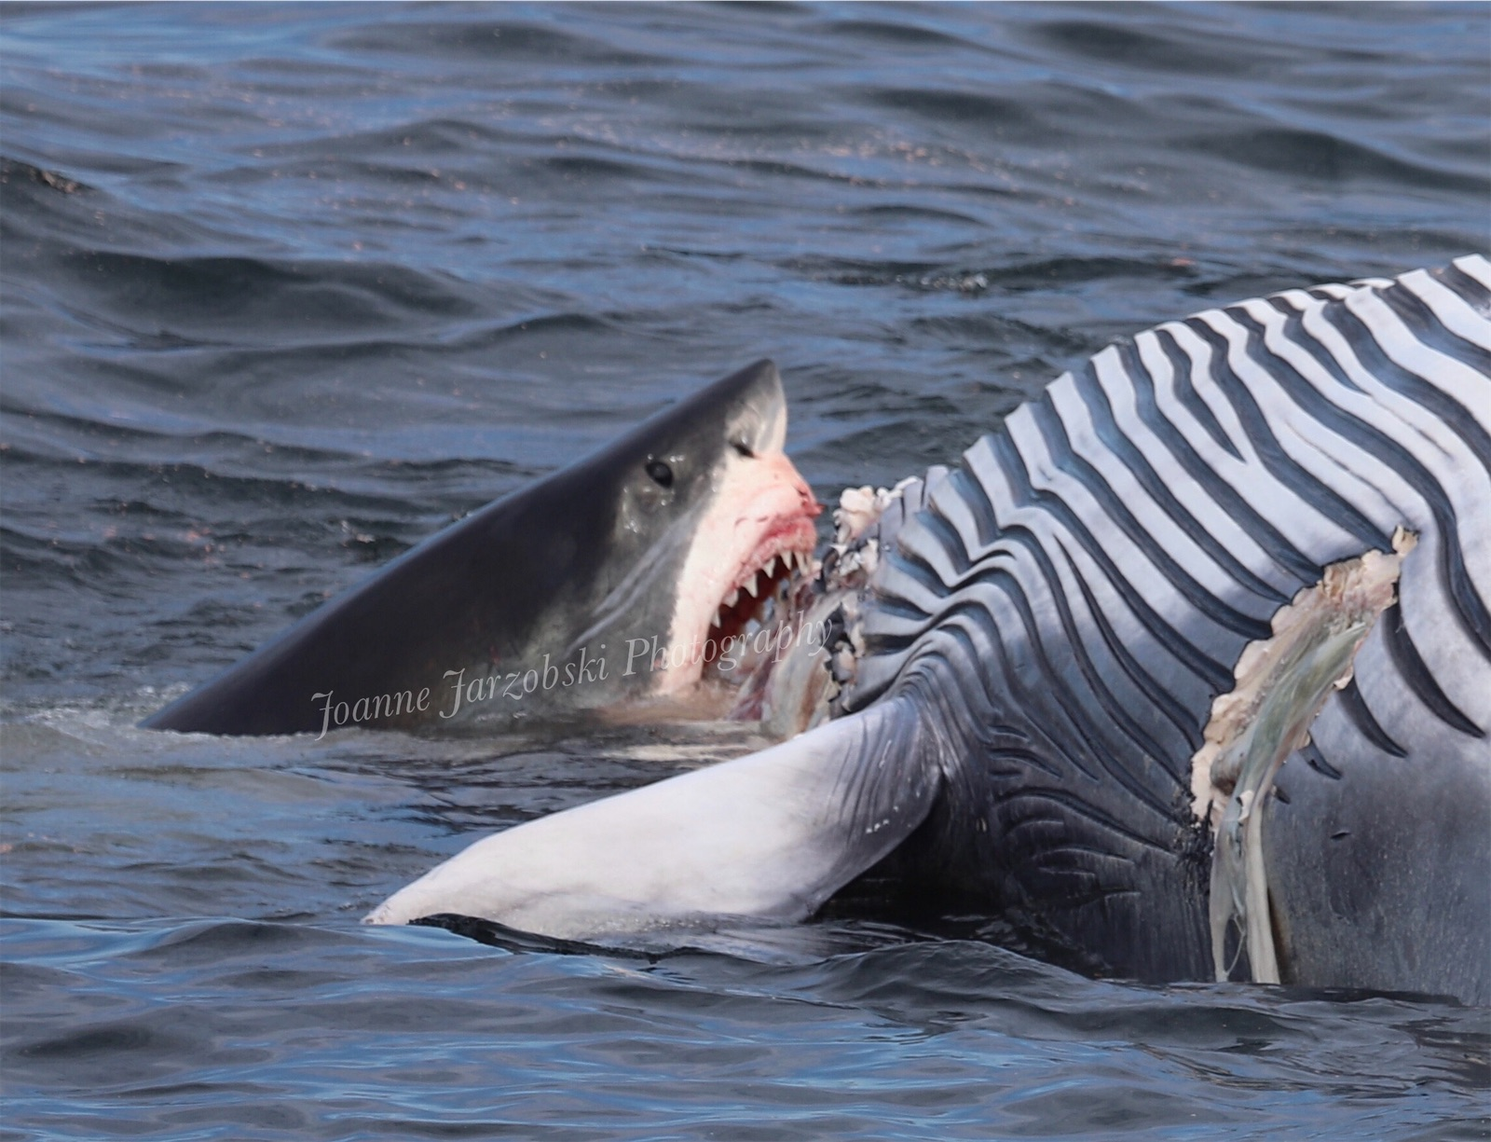 **A collaboration with the Cape Cod Regional STEM Network © 2023**

For personal or classroom use only. Please cite source and use copyright and Cape Cod Regional STEM Network logo when reproducing. Any opinions, findings, conclusions, or recommendations expressed in this material are those of the author(s) and do not necessarily reflect the views of Cape Cod Regional STEM Network or the Brotherton Foundation.

Images and material for this lesson were created using research

and images from the Atlantic White Shark Conservancy

Unless otherwise noted.

# Curriculum Overview

| The following assorted lessons were created for advanced marine biology students in 11 and 12th grade. These lessons were created by Joanne Jarzobski during her 2023 Teacher in Residence weeks with Atlantic White Shark Conservancy in Chatham, MA.  From this experience with AWSC, it is clear they have made much of their data available online via their white shark logbook. My goal was to use this information to create activities with students and get them thinking about the bigger picture of shark research, population studies, mark recapture (capture-recapture) studies, tag data, and public policy initiatives.  Lesson one is looking at how white sharks are identified, as it pertains to capture-recapture (mark-recapture) studies and students will try their hand at matching sharks.  Lesson two and three are linked closely with the when and where of white shark sighitngs. Lesson two is exploring where we find white sharks along the coast of Cape Cod. Lesson three is exploring when we find white sharks along the coast of Cape Cod, with some consideration to size and sex of the sharks sighted.  Lesson four is a field trip to one of AWSC shark centers, in either Chatham or Provincetown.  Students will gain more appreciation for, and understanding of the marine ecosystems, the importance of having a healthy marine ecosystem not only for us on Cape Cod, but for the entire planet, and the resources utilized locally, including whale watching, fishing, recreational sports, etc. In addition, students should see animals they may not see anywhere else in the world, and encourage the responsible use and conservation of coastal and marine ecosystems.  The trip will adhere to the following principles of ocean literacy:  1.the Earth has one big ocean;  2. the ocean shapes the Earth;  3. the ocean is a major influence on weather and climate;  4. the ocean makes Earth livable;  5. the ocean supports a diversity of life and ecosystems;  6. the ocean is connected to us and we are connected to it;  7. the ocean is largely unexplored. |
| --- |

| Stage 1: Desired Results | |
| --- | --- |
| MA State Standards  HS-LS2-6. Analyze data to show ecosystems tend to maintain relatively consistent numbers and types of organisms even when small changes in conditions occur but that extreme fluctuations in conditions may result in a new ecosystem. Construct an argument supported by evidence that ecosystems with greater biodiversity tend to have greater resistance to change and resilience.  HS-LS2-7. Analyze direct and indirect effects of human activities on biodiversity and ecosystem health, specifically habitat fragmentation, introduction of non-native or invasive species, overharvesting, pollution, and climate change. Evaluate and refine a solution for reducing the impacts of human activities on biodiversity and ecosystem health.  Science and Engineering Practices  4. Analyzing and interpreting data  8. Obtaining, evaluating, and communicating information  Ocean Literacy Standard #5  The ocean supports a great diversity of life and ecosystems.  Ocean Literacy Standard #6: the ocean and humans are inextricably interconnected. | Essential Questions  What role do white sharks play in the marine food web?  What role do white sharks play in pubic safety concerns?  How do we study white sharks?  What threats do white sharks face? |
| Enduring Understandings Ocean Literacy Standard #6: the ocean and humans are inextricably interconnected. |
| Transfer  *At the end of this unit, Students will be able to independently use their learning to…*  Use data, evidence, and reasoning to analyze living systems.  Use data, evidence, and reasoning to develop scientific claims and engage in discussions. |

# Lesson 1: Shark ID

| Lesson 1: Overview | |
| --- | --- |
| Lesson Overview:  *Identify individual white sharks through photo ID.*  *Individual identification of white sharks help researchers to determine population size.* | Lesson Objectives:  *At the end of the unit, students will be able to…*   * *Identify individual sharks using natural marks (photo-identification)* * *Use shark ID to help determine how many sharks we have in local waters* |
| Standards:  MA State Standards   * HS-LS2-6. Analyze data to show ecosystems tend to maintain relatively consistent numbers and types of organisms even when small changes in conditions occur but that extreme fluctuations in conditions may result in a new ecosystem. Construct an argument supported by evidence that ecosystems with greater biodiversity tend to have greater resistance to change and resilience.   Ocean Literacy Standard #5   * The ocean supports a great diversity of life and ecosystems. * Ocean Literacy Standard #6: the ocean and humans are inextricably interconnected. | Timing:   * *Total time: 60 minutes*   *please note: this can be lengthened with the AWSC powerpoint and additional sharks to match via the* [*AWSC white shark logbook*](https://shiny.atlanticwhiteshark.org/logbook/)  *If your students are not familiar with shark general anatomy, this lesson may take more time.* |
| Materials:   * Computer access * Internet access (AWSC logbook) * Photos of sharks (laminated) * Optional: powerpoint on ID | Assessment:  [Answer Sheet](https://docs.google.com/document/d/1Jz4u4zgkXSNOUco8tconeKjn0qCkoOhHFziYIAXhiik/copy) (*Student can identify individual sharks correctly)* |

White sharks are a selective, misunderstood predator. They are a vulnerable species that plays a critical role in the marine ecosystem.

Sharks have been in our waters for about 420 million years, including the massive, extinct Megalodon, and the ancestor of the great white shark of today. Throughout history, many sharks have been both feared and revered but very little was known or recorded about them until recently. We are learning more about these elusive apex predators every day through various research efforts, including photo-identification work.

The inshore waters off many Cape Cod and South Shore beaches are preferred feeding grounds for white sharks. White sharks hunt and feed on seals in shallow water close to shore. This presents a risk to those recreating in ocean waters. While white shark bites on humans are rare, they have occurred off Cape Cod. The most recent bite in September of 2018 resulted in a fatality. Local municipalities in the Cape and Islands, and the Cape Cod National Seashore are responsible for beach management and for temporarily closing the beach to swimming when a shark sighting is confirmed.

By identifying individual sharks, understanding their population status, and movements, we can better protect the public. The ability to recognize individual animals, whether through the use of tags, bands, or naturally- occurring marks, facilitates the study of their demography and behavior.

White sharks can be distinguished based on their countershading and fin pigment patterns as well as the dorsal fin profile, which is unique to each individual. Researchers at AWSC use the criteria developed for white sharks at Guadalupe Island, Mexico, to classify pigment pattern types for the gill flaps, the dorsal fin, the pelvic fin region, and the caudal fin. The presence of tags, scars, and evidence of major injuries (e.g. propeller wounds, damaged fins, scoliosis) are also used to help match sharks to previously identified individuals. Since monitoring of the population began in 2014, [AWSC researchers have identified over 800 individuals.](https://shiny.atlanticwhiteshark.org/logbook/)

Matching a photograph to a catalog of individuals takes good observational skills and patience.

Materials/Methods

1. Discuss how we identify individual animals.
   1. Can break students into small groups to brainstorm how individual of different species are identified.
   2. Can be teacher led, I recommend making a slide with images of different species identifying features. (examples: polar bear whiskers, humpback tail flukes, orca dorsal fin/saddle patch, elephant ears, zebra stripes, dolphin fins)
2. Review white shark anatomy. IF your students are not familiar with shark anatomy, please consider using the [AWSC Unit2: The science around us/ Shark anatomy and senses.](https://static1.squarespace.com/static/525d3c81e4b04f0184097802/t/6377b33515a6cb7b55bb362d/1668789045564/PreLearning_SharkAnatomy.pdf)
3. Go over the features used to identify white sharks. Please visit the [AWSC white shark logbook for examples.](https://shiny.atlanticwhiteshark.org/logbook/) Or use this [google slide deck.](https://docs.google.com/presentation/d/1VVTa01thSqtbcN1wypTNvDAxDX06NblmZdk8T1RmH74/copy)

Sharks can be identified by:

* Gill Pigment (white pigment can be on first through the fourth gill flap)
* Dorsal fin pigment (white coloration absent or present)
* Dorsal fin trailing edge (distinguishing features, notches, injuries)
* Pelvic fin pigment (continunous, discontinous)
* Caudal fin pigment (grey, white spot islet, white on leading edge)
* Injuries (face, dorsal, caudal, pectoral, body)

1. Distribute (laminated) [shark photos](https://docs.google.com/presentation/d/18V56mIBgoxQOg6ca4PqoYXugbpso2wvgQboPt7JsBTY/copy) and [worksheet.](https://docs.google.com/document/d/1Jz4u4zgkXSNOUco8tconeKjn0qCkoOhHFziYIAXhiik/copy) 
   1. Students can work individually or in pairs/small groups.
2. At the end of the period, go over the [correct matches.](https://docs.google.com/presentation/d/18V56mIBgoxQOg6ca4PqoYXugbpso2wvgQboPt7JsBTY/copy) Discuss again how individual identicaiton of species can help us to understand them, protect them, and assess population status. (mark recapture studies)
3. Extension: go over the individual sharks using [AWSC white shark logbook.](https://shiny.atlanticwhiteshark.org/logbook/)
   1. Have students find out information about the 7 sharks (can work in groups and present about their shark OR individually). Students could make digital poster about the shark.

| Lesson 1: Activities | | | |
| --- | --- | --- | --- |
| Activity | Teacher is… | Students are… | Materials |
| Opener | Presenting individual ID of sharks google slides | Taking notes and asking questions | Paper, computer, google slide deck |
| During lesson | Circulating among students, helping any with matches | Matching sharks with other students | Laminated shark pictures |
| Closing | Presenting correct matches | Discussing sharks matches and individual sharks | Paper, computer, digital slides |

| Lesson 1: Tips, Strategies, and Suggestions | | | |
| --- | --- | --- | --- |
| *I like to start this lesson with images of whales, polar bears, sharks, elephants, zebras, etc showing the features used to identify individuals. You can find images easily on the internet and put a slide together showing the features before the start of the lesson. A slidedeck with some images is included in the materials above, but can be expanded to include other species quite easily. Also, can start by asking students who you identify individuals of different species and do a brainstorming session prior.*  *It is helpful to laminate the sharks from the google deck, and then you can use them from year to year. I also letter each image, so then you can more easily talk about matches and which shark is which shark. You can create sets and have them on tables or in groups of desks for the students to work together through. Or you can do one set and do a gallery walk.*  *You can do an extension by going to the AWSC logbook and looking up each individual shark.*  *Extension: have them research the individual sharks using AWSC logbook. Students could even present on the shark, make a digital poster, etc.* | | | |

# 

# Lesson 2: Where oh where will you find a white shark (White Shark Receiver Data Analysis)

| Lesson 2: Overview | |
| --- | --- |
| Lesson Overview:  *Using AWSC white shark logbook to determine shark sightings along Cape Cod and the South Shore.*  *This lesson is a follow up to the individual ID lesson 1 on how we know which sharks are where.* | Lesson Objectives:  *At the end of the unit, students will be able to…*   * *Students will describe the movements of sharks tagged off Cape Cod.* * *Students will organize the shark data available on the AWSC white shark logbook* * *Students will interpret the data available on the AWSC white shark logbook* |
| Standards:  MA State Standards   * HS-LS2-6. Analyze data to show ecosystems tend to maintain relatively consistent numbers and types of organisms even when small changes in conditions occur but that extreme fluctuations in conditions may result in a new ecosystem. Construct an argument supported by evidence that ecosystems with greater biodiversity tend to have greater resistance to change and resilience.   Ocean Literacy Standard #5   * The ocean supports a great diversity of life and ecosystems. * Ocean Literacy Standard #6: the ocean and humans are inextricably interconnected. | Timing:   * *Total time: 60 minutes\**   *\*this can be quite variable, slightly shorter (45 min) or maybe even longer (75 min), depending on the students, and how quickly they work.*  *Optional extensions*  Have students compare to different years. Why more in some years than others? Do they notice anything about the individual sharks seen from one year to another?  Have students compare sharks detections at different locations for individual sharks.  Math Extension: have students calculate the shark with most detection % of total percentage at that location. |
| Materials:   * Computer access * Internet (AWSC logbook) | Assessment:  [*Student Handout*](https://docs.google.com/document/u/0/d/1jdlRIrV8gKPFSclN44l4kI_xOISUy5MdXdVEFLSIT5o/edit) |

The inshore waters off many Cape Cod and South Shore beaches are preferred feeding grounds for white sharks. White sharks hunt and feed on seals in shallow water close to shore. This presents a risk to those recreating in ocean waters.

While white shark bites on humans are rare, they have occurred off Cape Cod. The most recent bite in September of 2018 resulted in a fatality. Local municipalities in the Cape and Islands, and the Cape Cod National Seashore are responsible for beach management and for temporarily closing the beach to swimming when a shark sighting is confirmed.

By determining the location of white sharks, researchers can help guide responsible beach management along the coast of Cape Cod and South Shore beaches. Using tags, white sharks can be detected on receivers located along the coast of Cape Cod and southern New England. This receiver buoys can detect both real time data (distributed via the Sharktivity app) and logged data, downloaded form receivers normally on an annual basis.

In this lesson, students will utilize the AWSC white shark log book to analyze shark detections at specific locations along Cape Cod.

Opener: Use AWSC slides to review [shark tagging procedures](https://static1.squarespace.com/static/525d3c81e4b04f0184097802/t/6377bdc636de3949c1831ac5/1668791759328/ScienceAroundUs_PPT.pdf) and watch the 6 min interview with [shark research Megan Winton.](https://www.youtube.com/watch?v=DJsaa9Yv8MQ&list=PL-1bQw1wzkuGmynTsyVaFzjCZ_Cz0bvWI&index=4&t=6s) Please feel free to use these [images](https://docs.google.com/presentation/d/1GZMrmrefGvJ3Y9fwBGwkZl-pFnalygYLIbUiOOqBwM0/copy) to make your own slides or supplement the materials. You can also find images of tagged sharks on AWSC white shark [logbook.](https://shiny.atlanticwhiteshark.org/logbook/)

Using AWSC white shark log book, look at the data detected at different receivers as noted on the [student handout](https://docs.google.com/document/d/1jdlRIrV8gKPFSclN44l4kI_xOISUy5MdXdVEFLSIT5o/copy).

Go to the [AWSC white shark log book](https://shiny.atlanticwhiteshark.org/logbook/).

Set the year to 2022.

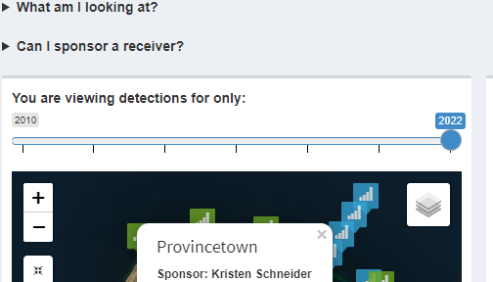

On the left, click white shark detections by receiver.

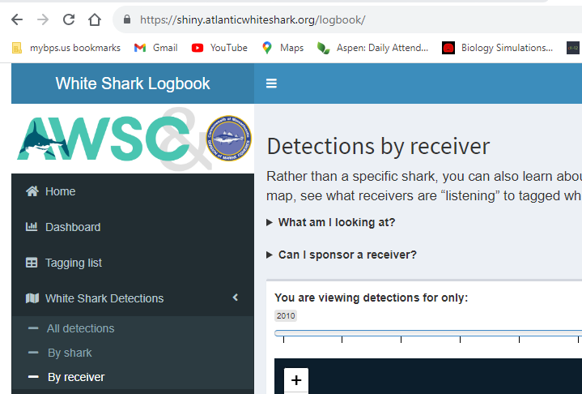

Zoom in on Provincetown. If you don’t know where Provincetown is on this map, open up a map application and look at it to help you find Provincetown.

Click Provincetown receiver. Look at the data available (see image below) and record it in the table below. To find the receiver you want, toggle over the blue or green box and the name of th receiver will appear.

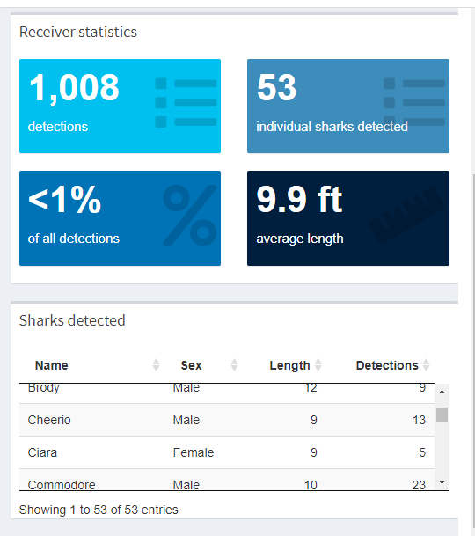

Now, do the same thing for Herring Cove, Race Point, Provincetown airport, Truro, Peaked Hill 1- 4, and Head of the Meadow (10 total receivers).

| Receiver  Location | Number of detections | Number of individual sharks | Percent of all detections | Average Length | Shark with most detections | Number of detections (most detected) |
| --- | --- | --- | --- | --- | --- | --- |
| Pamet North | 430 | 29 | <1% | 9.3 ft | Anchor | 132 |
|  |  |  |  |  |  |  |
|  |  |  |  |  |  |  |
|  |  |  |  |  |  |  |
|  |  |  |  |  |  |  |
|  |  |  |  |  |  |  |
|  |  |  |  |  |  |  |
|  |  |  |  |  |  |  |
|  |  |  |  |  |  |  |
|  |  |  |  |  |  |  |
|  |  |  |  |  |  |  |

Now, using the shark with the most detections at each location, what is their gender and length.

Create a chart below to record this information.

Please note: these questions could be answered as a class, table discussion; as a worksheet or digital document; as a gallery walk. These can be used as a summative assessment.

* Is there anything in common about the shark with the most detections at each location?
* Did one sex (male vs female) dominate over another? What about unknown? Do you remember how we determine the sex of a shark?
* Which location had the most detections? Why do you think that is the case? What do you know about the location?
* Which location had the most shark? Do you think the number of sharks vs number of detections is more important for public safety?
* What about the size of the shark with the most detection compare to the other sharks at that location? Can you make any inferences about this?
* Were any of the sharks from your shark ID activity detected? If so, which ones and at what locations?
* How else could someone use this data?

| Lesson 2: Activities | | | |
| --- | --- | --- | --- |
| Activity | Teacher is… | Students are… | Materials |
| opener | Presenting slides and video | Taking notes from slides and/or watching video | Google slides and/or watch video of M. Winton interview |
| During lesson | Circulating to help students answer questions and find materials online | Analyzing data on white shark logbook | Computer with Internet access |
| closing | Facilitate discussion | Using what they learned to answer question in discussion | Handout of questions |

| Lesson 2: Tips, Strategies, and Suggestions | | | |
| --- | --- | --- | --- |
| *Students could work individually, in pairs or in small groups.*  *You could pick any receivers for this activity and modify it more closely to where you live along the Cape OR one from each area along cape to get an overall representation.*  Extension: have them compare to different years. Why more in some years than others? Do they notice anything about the individual sharks seen from one year to another?  Extension: have them compare sharks detections at different locations for individual sharks.  Math Extension: have them calculated shark with most detection % of total percentage at that location. | | | |

# 

# Lesson 3: When will you find a white shark (White Shark Receiver Data Analysis)

| Lesson 3: Overview | |
| --- | --- |
| Lesson Overview:  *Using AWSC white shark logbook to determine shark sightings along Cape Cod and the South Shore.*  *This lesson is a follow up to lesson 2 on where we find sharks.* | Lesson Objectives:  *At the end of the unit, students will be able to…*   * *Students will describe the movements of sharks tagged off Cape Cod.* * *Students will organize the shark data available on the AWSC white shark logbook* * *Students will interpret the data available on the AWSC white shark logbook* |
| Standards:  MA State Standards   * HS-LS2-6. Analyze data to show ecosystems tend to maintain relatively consistent numbers and types of organisms even when small changes in conditions occur but that extreme fluctuations in conditions may result in a new ecosystem. Construct an argument supported by evidence that ecosystems with greater biodiversity tend to have greater resistance to change and resilience.   Ocean Literacy Standard #5   * The ocean supports a great diversity of life and ecosystems. * Ocean Literacy Standard #6: the ocean and humans are inextricably interconnected. | Timing:   * *Total time: 60 minutes\** * *Optional: could choose a few years through range from 2010-2022 instead of all of them to*   *\*this can be quite variable, slightly shorter (45 min) or maybe even longer (75 min), depending on the students, and how quickly they work.* |
| Materials:   * Computer access * Internet (AWSC logbook) | Assessment:  [*Student handout*](https://docs.google.com/document/u/0/d/1mH23eCKo-z2j_QEVMDKGLlKBQhgydPer08OVbXKmqhU/edit) |

Over the course of the last decade, it has become clear through research efforts (including photo id capture- recapture aka mark recapture studies, tagging studies, and receiver data) that white sharks have some seasonality to their residency off the coast of Cape Cod and South Shore beaches. The work of AWSC and other researches has shown there is a pattern to the appearance of white sharks off our coast. This research has also discounted previous theories that white sharks were not seen along Cape Cod shores during cooler months (ie. November, December).

Understanding the movements, seasonality, and residency of white shark populations off the coast of Cape Cod is of importance for public safety. By using AWSC white shark log boo, students will explore when and where sharks have been detected.

Using AWSC white shark log book, look at the data detected at different receivers as noted on the [student handout.](https://docs.google.com/document/d/1mH23eCKo-z2j_QEVMDKGLlKBQhgydPer08OVbXKmqhU/copy)

Go to the [AWSC white shark log book](https://shiny.atlanticwhiteshark.org/logbook/).

Please go to [AWSC logbook](https://shiny.atlanticwhiteshark.org/logbook/).

Please click the All detections tab.

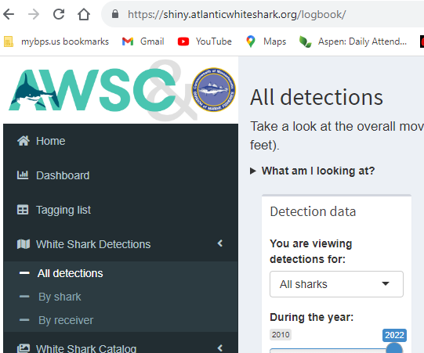

Once you’ve gone to all detections, please make sure you have the tab set to ALL SHARKS and the toggle to 2022, and leave the length the maximum range allowed.

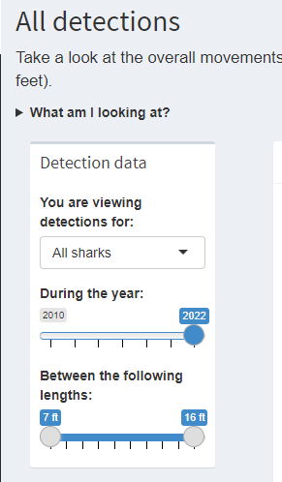

To the right, a box will appear with a map of cape cod and colored circles. You have three options–overall, animation or by month, which will be set to the year, sex, and length you’ve chosen in the previous step above (or box to the right). In the layers, make sure to have detections and legend check. Receivers should be unchecked.

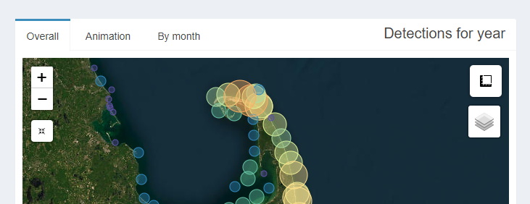

Now, let’s take a bite ouf of the data.

First, set the year to 2022, we are going to work back from most recent to least. Please note, you can zoom in and out on the map image.

View the overall map. What do the colors represent? What do the size of circle represent? What happens when yhou move your curser over a circle? Now click on the circle for details? What kind of information are you provided with?

Looking at this visual, where are the most sharks detected (what area of the Cape Cod)?

Now change the year to 2021. Do you notice a difference? You can click back and forth between years if needed.

What stands out to you about 2020?

Click through each year back until 2010. What is the biggest change you noticed? What are some explanations for these changes?

Now set the year back on 2022 and click the animation option.



What is the date range of the animation? How would you describe this data to someone?

Look at the animation for each year. How would you compare the past with the present? Be thoughtful in your description. And please take a look at the scale on the left. Is it the same for each year?

Now set to by month. Complete the chart with detections by month per year. Move your mouse over the colored column of each month for the exact number each month.

|  | J | F | M | A | M | J | J | A | S | O | N | D |
| --- | --- | --- | --- | --- | --- | --- | --- | --- | --- | --- | --- | --- |
| 2010 |  |  |  |  |  |  |  | 316 | 270 | 77 | 6 |  |
| 2011 |  |  |  |  |  |  |  |  |  |  |  |  |
| 2012 |  |  |  |  |  |  |  |  |  |  |  |  |
| 2013 |  |  |  |  |  |  |  |  |  |  |  |  |
| 2014 |  |  |  |  |  |  |  |  |  |  |  |  |
| 2015 |  |  |  |  |  |  |  |  |  |  |  |  |
| 2016 |  |  |  |  |  |  |  |  |  |  |  |  |
| 2017 |  |  |  |  |  |  |  |  |  |  |  |  |
| 2018 |  |  |  |  |  |  |  |  |  |  |  |  |
| 2019 |  |  |  |  |  |  |  |  |  |  |  |  |
| 2020 |  |  |  |  |  |  |  |  |  |  |  |  |
| 2021 |  |  |  |  |  |  |  |  |  |  |  |  |
| 2022 |  |  |  |  |  |  |  |  |  |  |  |  |

When you look at over a decades worth of data as presented above, what could you do to make this chart easier to view? (hint–what did they do on the graphic?)

What patterns do you notice?

How can you use this information to inform public policy and safety measures?

Are there months that do not have any confirmed white shark sightings/detections? What months are those? What do you think is the reason for this (lack of sightings/detections)?

Now go back and and click the layers box and uncheck sightings and legend; check receivers. Click through from 2010 to 2022. What did you notice? How does this relate the above chart with detections? Why is it important to make notes about this?



If you were advising family and friends, what would you tell them with regard to when white sharks are present off Cape Cod? Write an informed response (or have students do a discussion/debate).

| Lesson 3: Activities | | | |
| --- | --- | --- | --- |
| Activity | Teacher is… | Students are… | Materials |
| Opener | Leading session on what they know about when sharks show up here | brainstorming | White board |
| During lesson | Circulating and helping students find data online | analyzing data on white shark logbook | Computer with internet access (AWSC logbook) |
| closing | facilitate | debating/discuss | n/a |

| Lesson 3: Tips, Strategies, and Suggestions | | | |
| --- | --- | --- | --- |
| *Have students make a key to color code the shark numbers per year. Perhaps pick similar colors the ones in the logbook. I recommend just picking 6 and having a key for which month has most to the least (please note: the data has a huge range as more receivers were installed so using a number 100+, 1000+, 10,000+ for colors will not work well).* | | | |

# 

# 

# 

# Lesson 4: Field Trip to AWSC Chatham or Ptown Center

| Lesson 4: Overview | |
| --- | --- |
| Lesson Overview:  *Field trip to AWSC shark center in Chatham or Ptown* | Lesson Objectives:  *At the end of the unit, students will be able to…*   * *Students will describe the movements of sharks tagged off Cape Cod.* * *Identify individual sharks using natural marks (photo-identification)* * *Use shark ID to help determine how many sharks we have in local waters* * *Understand predator/prey relationships* * *Demonstrating an awareness for their global responsibility, particular focused on the impacts of humans on oceans and the flora and fauna found on Cape Cod and the international issues facing sharks and shark conservation and shark interactions with humans.* * *Students will gain more appreciation for, and understanding of the marine ecosystems, the importance of having apex predators in a marine ecosystem , the resources utilized locally by researchers to better understand sharks and therefore better protect humans who interact with them through recreational activities.* |
| Standards:  Ocean Literacy Standard #5   * The ocean supports a great diversity of life and ecosystems. * Ocean Literacy Standard #6: the ocean and humans are inextricably interconnected.   Students will gain more appreciation for, and understanding of the marine ecosystems, the importance of having a healthy marine ecosystem not only for us on Cape Cod, but for the entire planet, and the resources utilized locally, including whale watching, fishing, recreational sports, etc. In addition, students should see animals they may not see anywhere else in the world, and encourage the responsible use and conservation of coastal and marine ecosystems.  The trip will adhere to the following principles of ocean literacy:  1.the Earth has one big ocean;  2. the ocean shapes the Earth;  3. the ocean is a major influence on weather and climate;  4. the ocean makes Earth livable;  5. the ocean supports a diversity of life and ecosystems;  6. the ocean is connected to us and we are connected to it;  7. the ocean is largely unexplored. | Timing:   * *Total time: 6-7 hrs with travel to Ptown* * *3-4 hrs witChatham* |
| Materials:   * Transportation/Bus * Fees for visit to center * [Form for field trip request to school](https://docs.google.com/document/d/1ShqJHrIoi3NW3jU0XNr1DKzKPsqMlw3Y1rYAIw50Wc8/copy) | Assessment:  *Student reflection post field trip* |

Shark Field Trip: AWSC Chatham

The field trip adheres to the BHS mission statement and BHS student expectations in a variety of ways, including:

### Partnership with the local researchers and NGO’s, learning about research in the field and the apex predators that live in our waters, is a critical component to becoming an educated citizen from Cape Cod. Sharks are awesome, and tend to get a lot of attention in the media. However, they are often misrepresented and misunderstood. AWSC is working to change that by providing shark education and outreach to school age children as well as the general public. Educating the community and engaging children in learning opportunities connects people to one of the keystone species in our ocean’s ecosystem. Their programs not only help protect white sharks, they also provide information that helps people live harmoniously with nature.The Chatham Shark Center™ offers an in-depth look at one of the ocean's most magnificent and misunderstood species: the Great White Shark! Through interactive exhibits, videos, displays, and virtual reality experiences, the center offers many ways to learn about groundbreaking research and one of Cape Cod's most captivating summer residents. Students will also get to go on a receiver tour in Chatham Harbor and pull receiver data.

Demonstrating an awareness for their global responsibility, particular focused on the impacts of humans on oceans and the flora and fauna found on Cape Cod and the international issues facing sharks and shark conservation and shark interactions with humans.

Students will gain more appreciation for, and understanding of the marine ecosystems, the importance of having apex predators in a marine ecosystem , the resources utilized locally by researchers to better understand sharks and therefore better protect humans who interact with them through recreational activities. In addition, students will see some of the equipment used by AWSC/DMF to study sharks and have a presentation by staff from AWSC.

* Students will be respectful, responsible and safe while on this field trip.
* think critically
* speak clearly
* attain, evaluate and apply information properly
* listen actively
* exhibit local and global responsibility
* maintain physical, social and emotional wellness

The trip will adhere to the following principles of ocean literacy:

1. the Earth has one big ocean;   
2. the ocean shapes the Earth;   
3. the ocean is a major influence on weather and climate;   
4. the ocean makes Earth livable;   
5. the ocean supports a diversity of life and ecosystems;   
6. the ocean is connected to us and we are connected to it;   
7. the ocean is largely unexplored.

Student Reflection ideas:

What was the most surprising thing you learned today about white sharks in local waters?

Has you willingness to engage in water recreational activities locally changed at all? If so, how?

| Lesson 4: Activities | | | |
| --- | --- | --- | --- |
| Activity | Teacher is… | Students are… | Materials |
| Opener | Providing details of field trip, handing out forms | Completing the forms with parents | Field trip permission slip |
| Field trip | Checking off students, suprvising | Engaging with AWSC staff/interns | n/a |

| Lesson 4: Tips, Strategies, and Suggestions | | | |
| --- | --- | --- | --- |
| *I have taken students to both the Chatham and Provincetown Shark Centers. I like both equally. The virtually reality “game” in Chatham is a big hit with students and the receiver tour is fun as they can see seals too typically.. In Provincetown, we combine our trip with Center for Coastal Studies visit and can see seals sometimes from the pier and/or we go to the beach to look for whales. It just depends on the season. We do bagged lunches and usually eat a a beach.* | | | |

# 