Name:_______________________________Date:_____________Block/Period:_____

When Do White Sharks Show Up Around Cape Cod

Background:

“White sharks were designated as a protected species in most federal waters in 1997 and in Massachusetts state waters in 2005. Beforehand, white sharks were hunted and considered a trophy hunt for recreational fisheries. In the past decade, white shark sightings and catch records in the broader Northwest Atlantic have increased, which suggests some level of population recovery, but stock status remains uncertain. The increased presence of white sharks close to shore off of Cape Cod has been tied to increases in seal populations. While increases in the local abundance of both seals and sharks are considered a conservation succes story, conflicts related to seal and shark poppulations threaten continued conservaiton of both species.” ~AWSC

Please go to [AWSC logbook](https://shiny.atlanticwhiteshark.org/logbook/).

Please click the All detections tab.

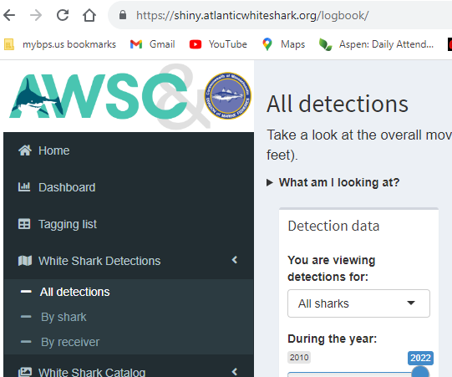

Once you’ve gone to all detections, please make sure you have the tab set to ALL SHARKS and the toggle to 2022, and leave the length the maximum range allowed.

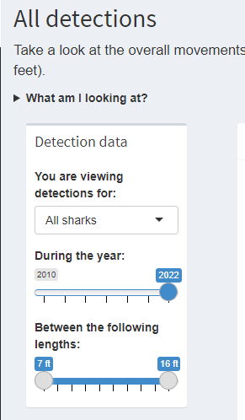

To the right, a box will appear with a map of cape cod and colored circles. You have three options–overall, animation or by month, which will be set to the year, sex, and length you’ve chosen in the previous step above (or box to the right). In the layers, make sure to have detections and legend check. Receivers should be unchecked.

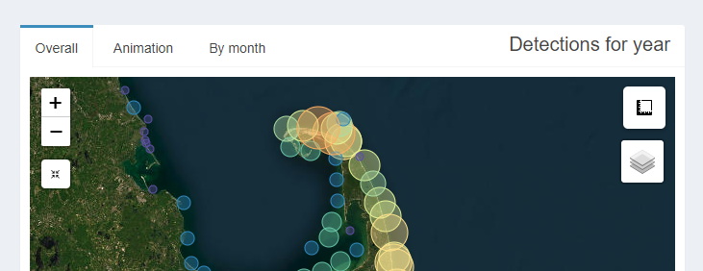

Now, let’s take a bite ouf of the data.

First, set the year to 2022, we are going to work back from most recent to least. Please note, you can zoom in and out on the map image.

View the overall map. What do the colors represent? What do the size of circle represent? What happens when yhou move your curser over a circle? Now click on the circle for details? What kind of information are you provided with?

Looking at this visual, where are the most sharks detected (what area of the Cape Cod)?

Now change the year to 2021. Do you notice a difference? You can click back and forth between years if needed.

What stands out to you about 2020?

Click through each year back until 2010. What is the biggest change you noticed? What are some explanations for these changes?

Now set the year back on 2022 and click the animation option.



What is the date range of the animation? How would you describe this data to someone?

Look at the animation for each year. How would you compare the past with the present? Be thoughtful in your description. And please take a look at the scale on the left. Is it the same for each year?

Now set to by month. Complete the chart with detections by month per year. Move your mouse over the colored column of each month for the exact number each month.

|  | J | F | M | A | M | J | J | A | S | O | N | D |
| --- | --- | --- | --- | --- | --- | --- | --- | --- | --- | --- | --- | --- |
| 2010 |  |  |  |  |  |  |  | 316 | 270 | 77 | 6 |  |
| 2011 |  |  |  |  |  |  |  |  |  |  |  |  |
| 2012 |  |  |  |  |  |  |  |  |  |  |  |  |
| 2013 |  |  |  |  |  |  |  |  |  |  |  |  |
| 2014 |  |  |  |  |  |  |  |  |  |  |  |  |
| 2015 |  |  |  |  |  |  |  |  |  |  |  |  |
| 2016 |  |  |  |  |  |  |  |  |  |  |  |  |
| 2017 |  |  |  |  |  |  |  |  |  |  |  |  |
| 2018 |  |  |  |  |  |  |  |  |  |  |  |  |
| 2019 |  |  |  |  |  |  |  |  |  |  |  |  |
| 2020 |  |  |  |  |  |  |  |  |  |  |  |  |
| 2021 |  |  |  |  |  |  |  |  |  |  |  |  |
| 2022 |  |  |  |  |  |  |  |  |  |  |  |  |

When you look at over a decades worth of data as presented above, what could you do to make this chart easier to view? (hint–what did they do on the graphic?)

What patterns do you notice?

How can you use this information to inform public policy and safety measures?

If you were advising family and friends, what would you tell them with regard to when white sharks are present off Cape Cod?

Are there months that do not have any confirmed white shark sightings/detections? What months are those? What do you think is the reason for this (lack of sightings/detections)?

Now go back and and click the layers box and uncheck sightings and legend; check receivers. Click through from 2010 to 2022. What did you notice? How does this relate the above chart with detections? Why is it important to make notes about this?

